Math 20-1 Final Exam Weighting
The Information Bulletin Mathematics 30-1 for 2019-2020 states the following:
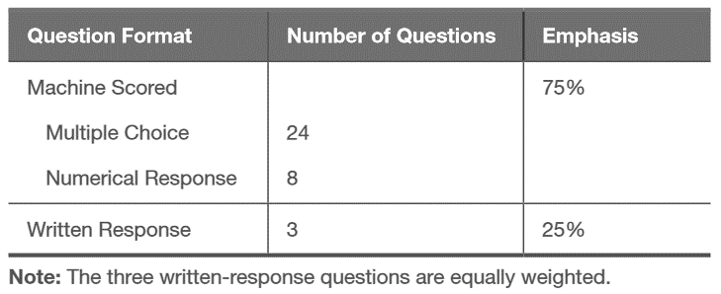
The Mathematics 20-1 Final Exam will be approximately two-thirds of the length, and 20% of grade:
Question Format | Number of Questions | Emphasis
Multiple Choice | 16 | 75% (21 marks)
Numerical Response | 5 | 75% (21 marks)
Written Response | 3 | 25% (7 marks)
By giving the final exam the same weighting as the Course Outline, with the restriction that we maintain only three Written Response questions, we get the following questions per Competency:
 | Multiple Choice | Numerical Response | Written Response | Marks by Competency
Algebra – 64% | 10 | 3 | 5 | 18
Graphing – 20% | 3 | 1 | 2 | 6
Trig – 16% | 3 | 1 | 0 | 4
Marks by Question Type | 16 | 5 | 7

By giving each Chapter the same weightings as the weightings within each Competency on the Course Outline, we get the following number of questions per chapter:
Calculated number of questions Number of questions on the exam, by unit.
(with very unrealistic partial questions) (This is the final version that will match the exam)
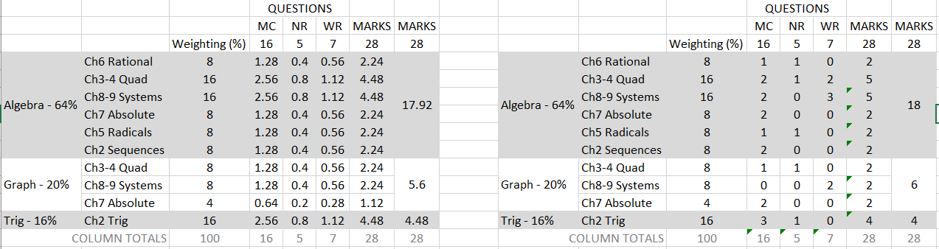
So, for example, Chapter 6 Rational Expressions will have 1x MC and 1x NR questions on the final exam, whereas Chapter 3-4 Quadratics will have 2x MC, 1xNR, and 1x WR (worth 2 marks).

