L01 – 4.1 Square Roots and Cube Roots
Part 1 – Review of Squares
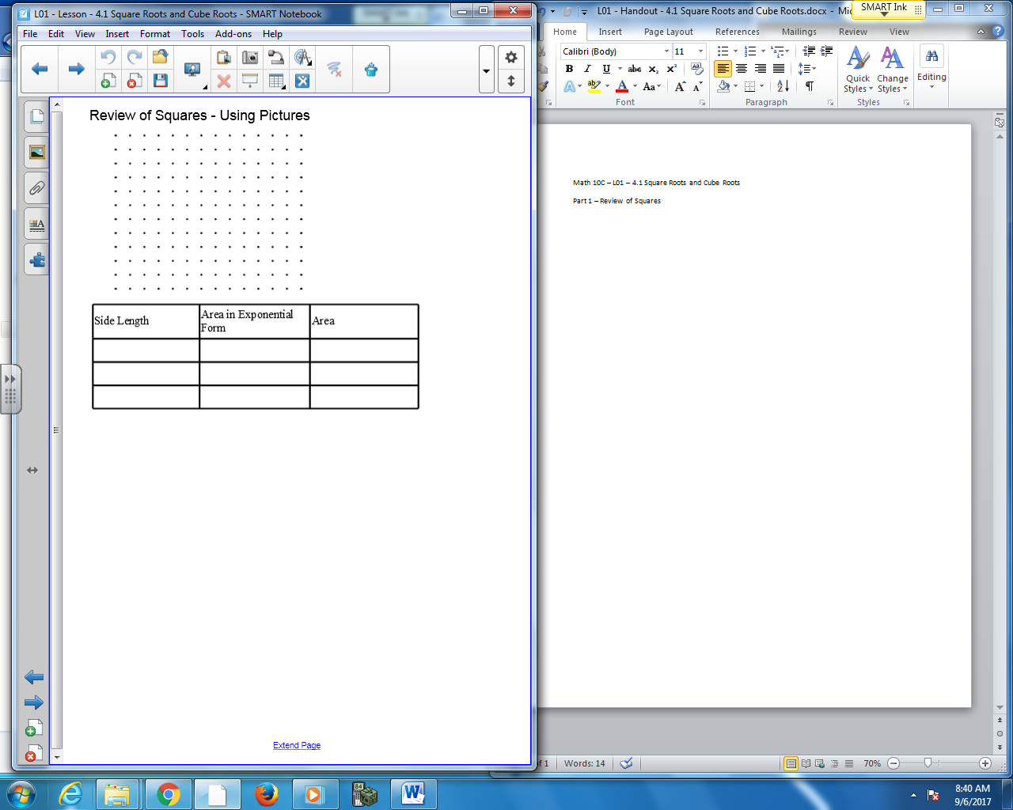
What is a Perfect Square?

Part 2 – Review of Cubes
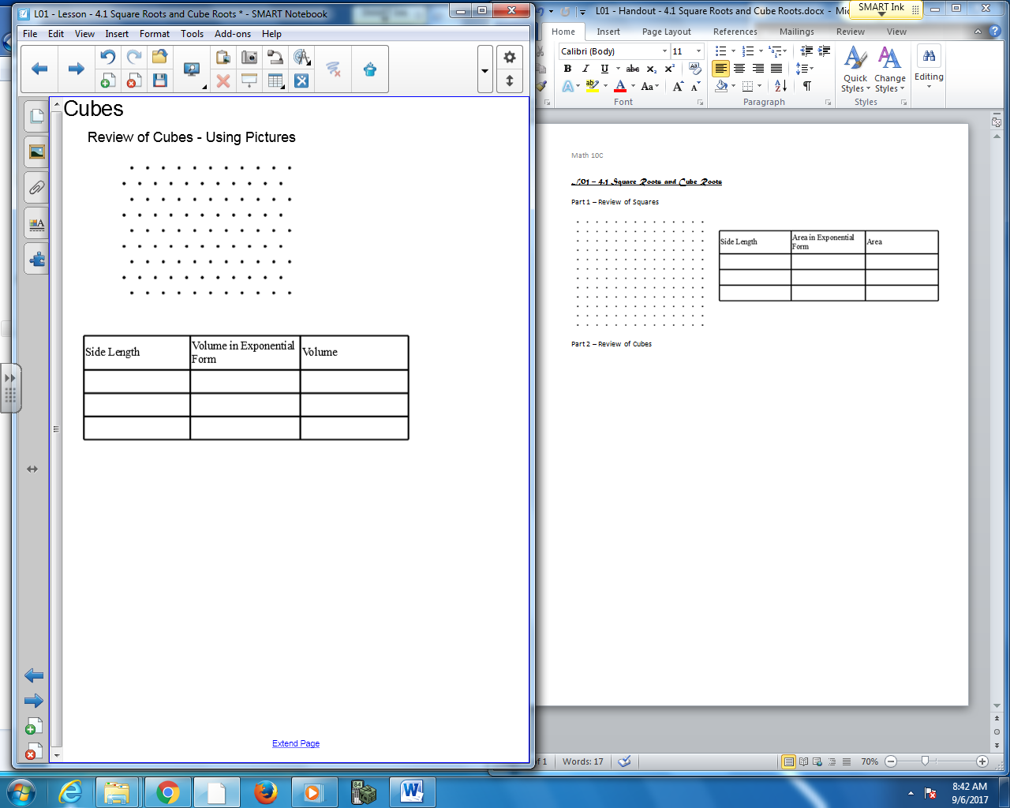
What is a Perfect Cube?

Part 3 – Using your calculator to Square and Cube a Number
The calculator button… find one of the following buttons on your calculator.
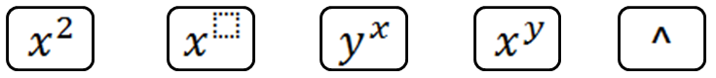
Example: What is 3²?
3 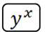2 = 9
Q1: Try to answer the following questions. Write down how you enter them into your calculator.

5² 7² 5³ 16³

Part 4 – Square Roots
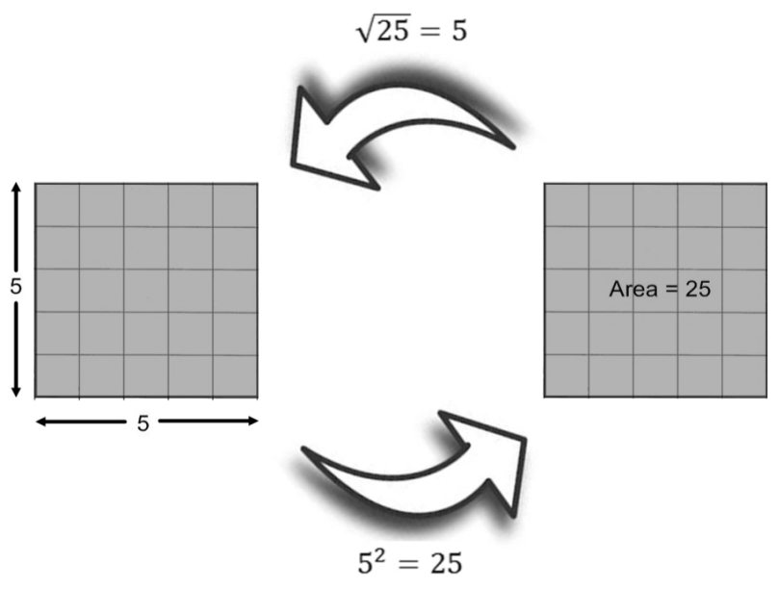
Q2: What is the side length of the square?
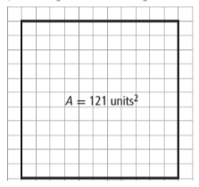
Q3: Calculate the unknown value in each case: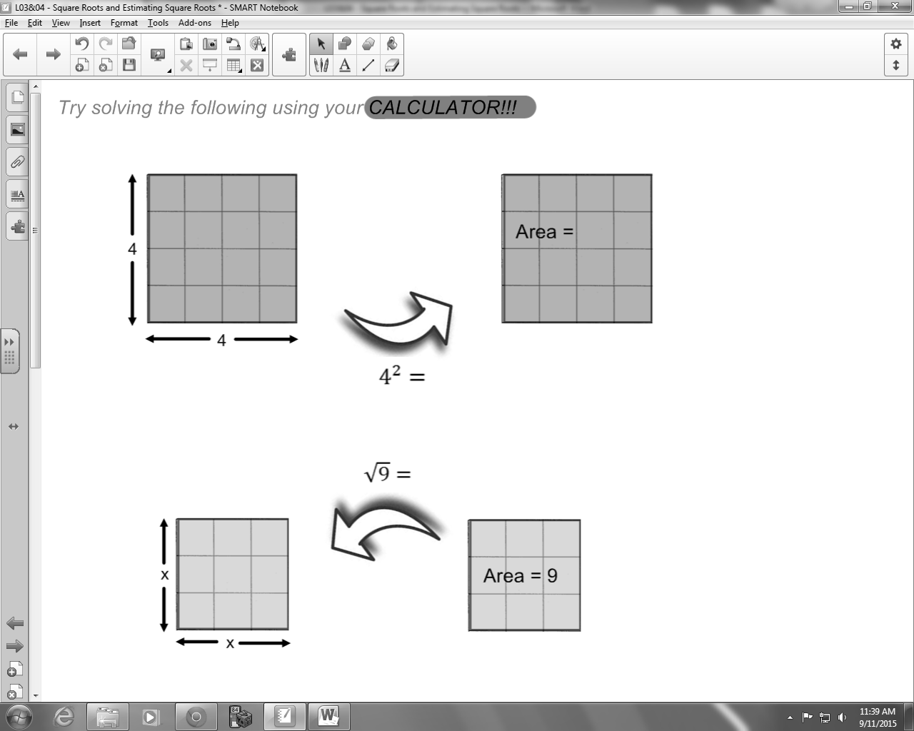

Q4: Complete the following tables:
Side Length of Square | Area of Square |  | Side Length of Square | Area of Square
5 |  |  | 2
 | 49 |  |  | 27
 | 8.1 |  |  | 54

Part 5 – Cube Roots
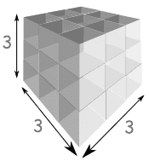
$3^{3}=27$

$$\sqrt[3]{27}=3$$

Q5: Complete the following tables:
Side Length of Square | Area of Square |  | Side Length of Cube | Area of Cube
4 |  |  | 3.1
 | 36 |  |  | 27
5.2 |  |  |  | 52

Part 6 – Factor Trees
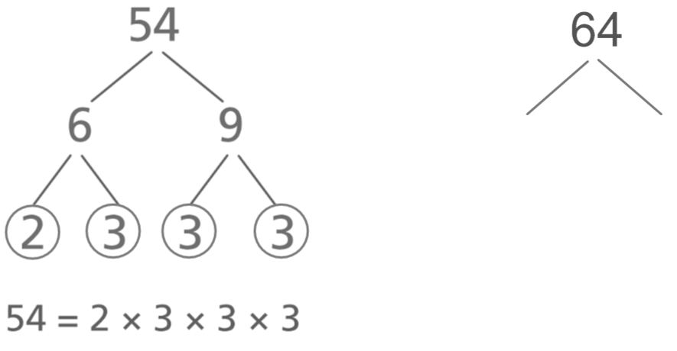

Q6: Prime factoring the following numbers:
22 36 81 48

Part 7 – Combination Questions
Q7: In the equation $5x^{2}+2=50$ , what is the value of x?
(Record your three digit answer in the Numerical Response boxes below)

Q8: Using Pythagoras Theorem, $a^{2}+b^{2}=c^{2}$ , how long is the diagonal of the rectangle, in feet?
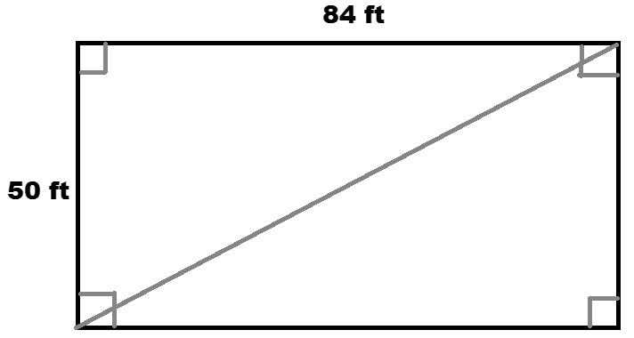
(Record your three digit answer in the Numerical Response boxes below)

Q9: A cube has a volume of 729 cm³. What is the area of a single face of the cube?
(Record your three digit answer in the Numerical Response boxes below)

Use the following information to answer Q10:
Venn Diagram for Perfect Squares and Perfect Cubes
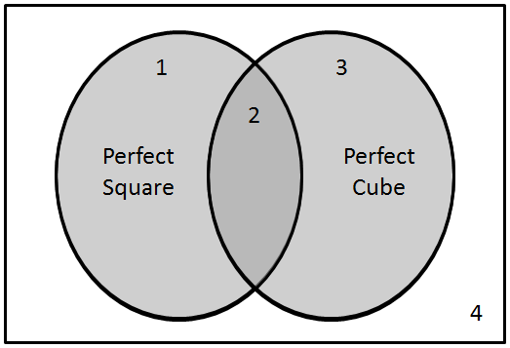
Descriptions
1 – Perfect Square only
2 – Both
3 – Perfect Cube only
4 – Neither

Q10: Use prime factorization to determine if the following numbers are Perfect Squares, Perfect Cubes, both, or neither.
Region: __________ __________ __________ __________
Number: 121 14 64 27
(Record your four digit answer in the Numerical Response boxes below)

Part 8 – Exponent Laws Review
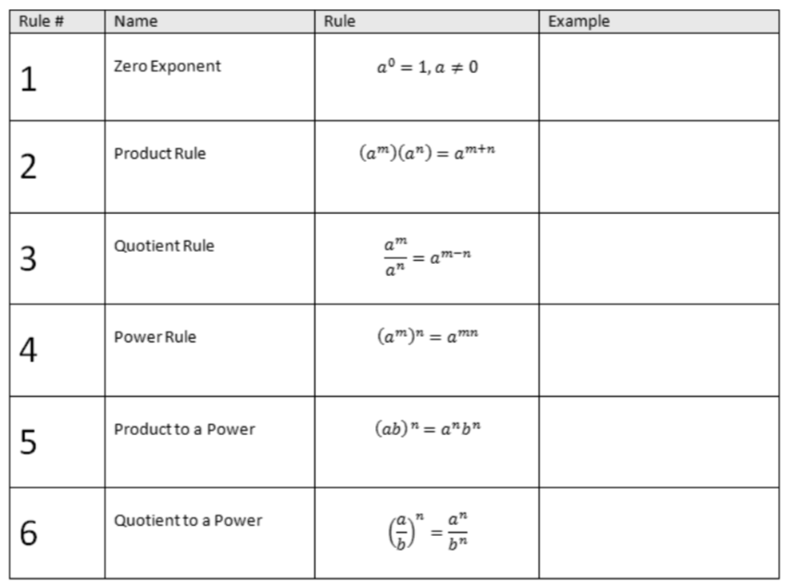
For all questions, simplify. Leave in exponential form.
Q11: ${(3xy)}^{4}$ Q15: ${\left(\frac{x}{5}\right)}^{3}$

Q12: ${(2^{3})}^{5}$ Q16: $\left(5x^{2}\right)\left({3x}^{5}\right)$

Q13: $\frac{x^{8}}{x^{5}}$ Q17: ${(2x^{3}*x^{5})}^{6}$

Q14: ${(\frac{x}{y^{8}})}^{0}$ Q18: $\frac{(x^{4}*x^{3})}{{\left(x^{2}\right)}^{3}}$

