L01 – Introduction to Vernier Calipers, Net Diagrams, SA and VOL
Today’s lesson will be conducted in two parts:
- First Half: Direct Instruction
- Second Half: Students rotating between stations
Part 1 – Vernier Calipers
http://www.stefanelli.eng.br/en/en-vernier-caliper-pachymeter-calliper-simulator-millimeter-05-mm.html
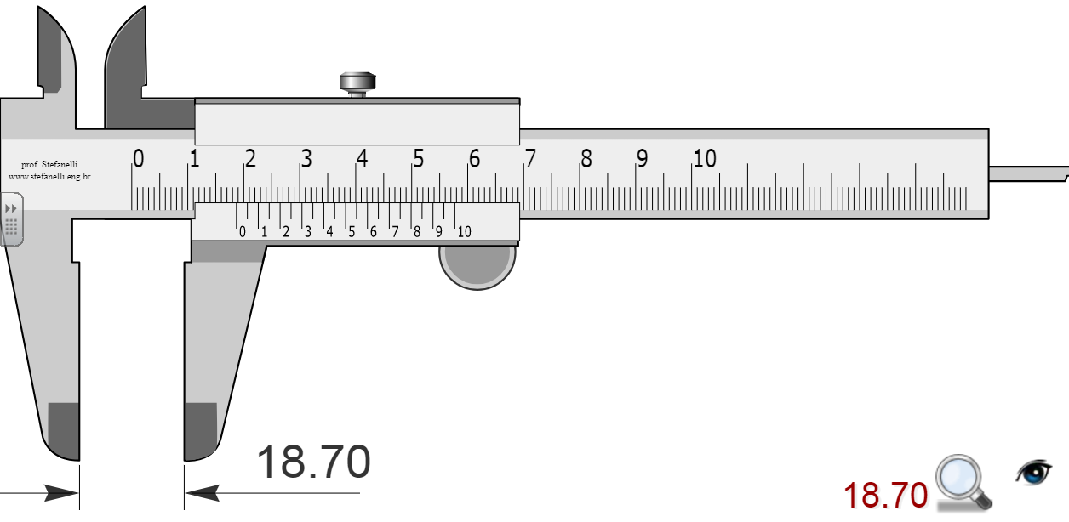
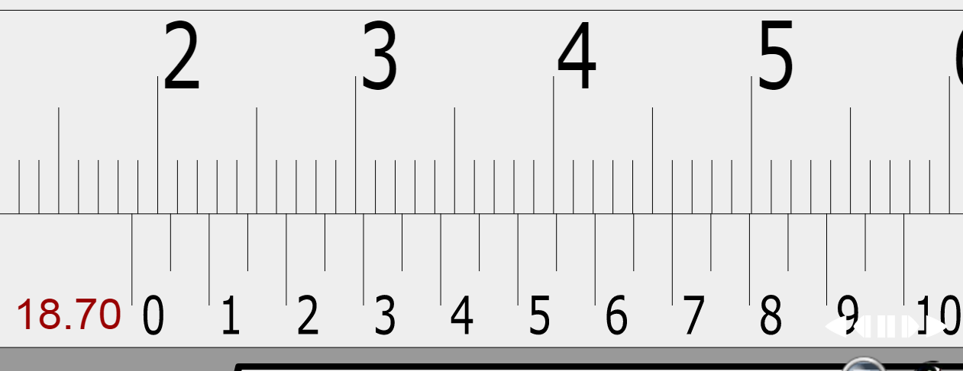

Q1: What is the measurement?
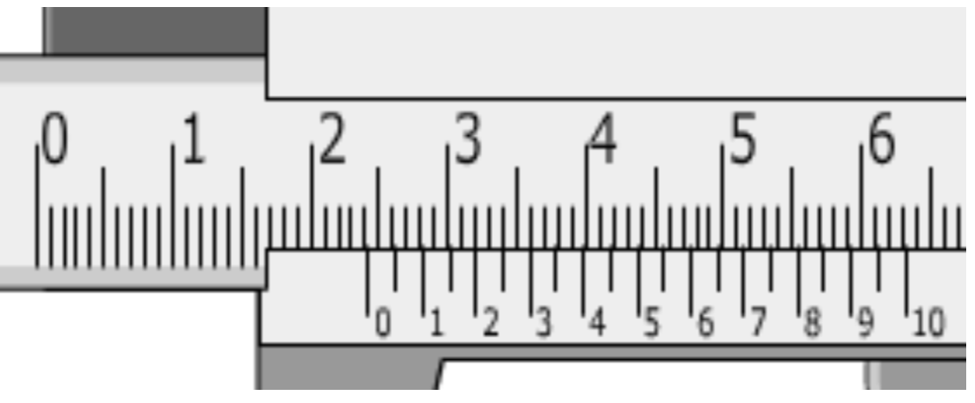
Q2: What is the measurement?
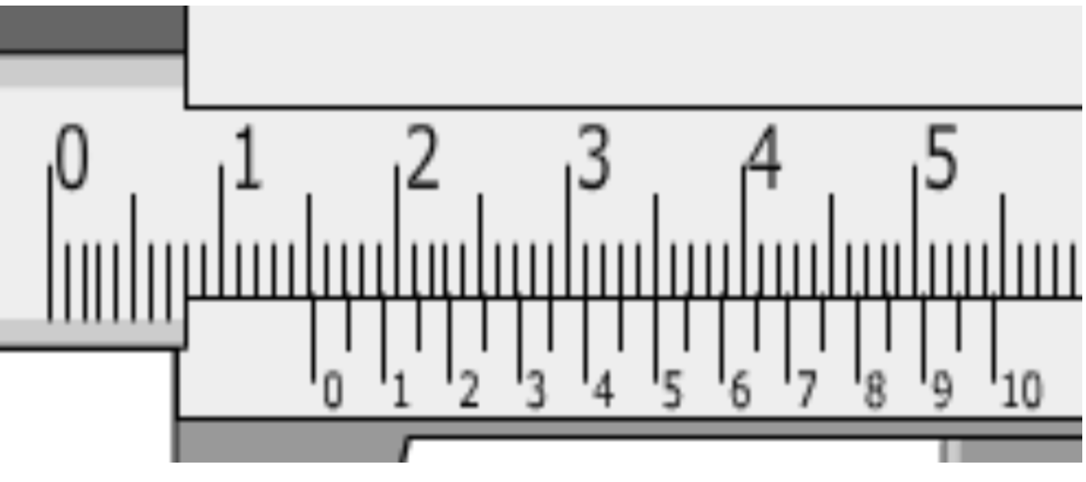
Q3: What is the measurement?
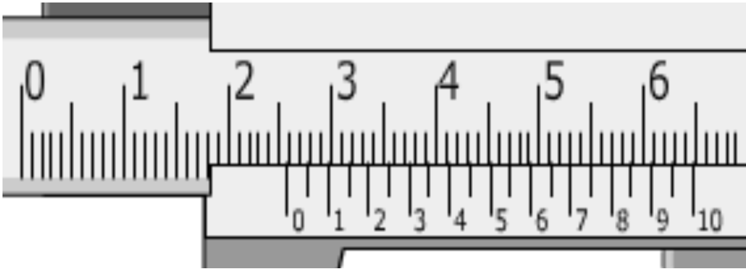
Part 2 – Net Diagrams and Magformers
Magformers are a magnetic toy that can be used to quickly construct Net Diagrams and fold them into three dimensional shapes.
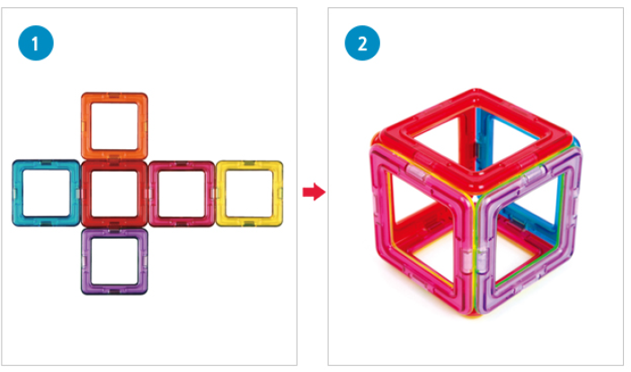
Part 3 – Review of Surface Area and Volume
Q4: A composite shape is made up of five identical cubes, with side lengths of 1 unit. Determine its surface area and volume.
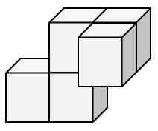

Station #1 – Vernier Calipers
Q5: Using the Vernier Calipers, determine the measure of the five dimensions (labelled) of a single Math Cube. Give your measurements in millimeters, to the nearest tenth of a millimeter.
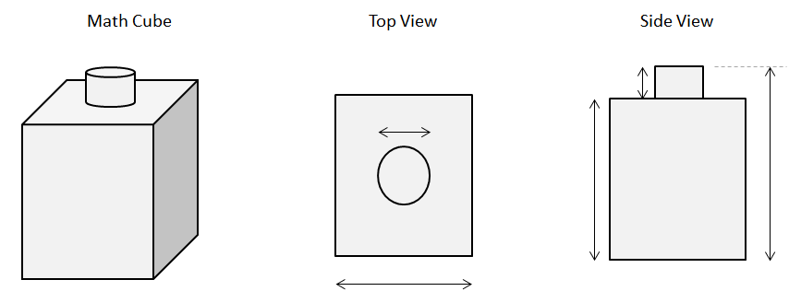

Station #2 – Net Diagrams and Magformers
Q6: Create each of the following net diagrams (1), and fold them into their 3-D shape (2).
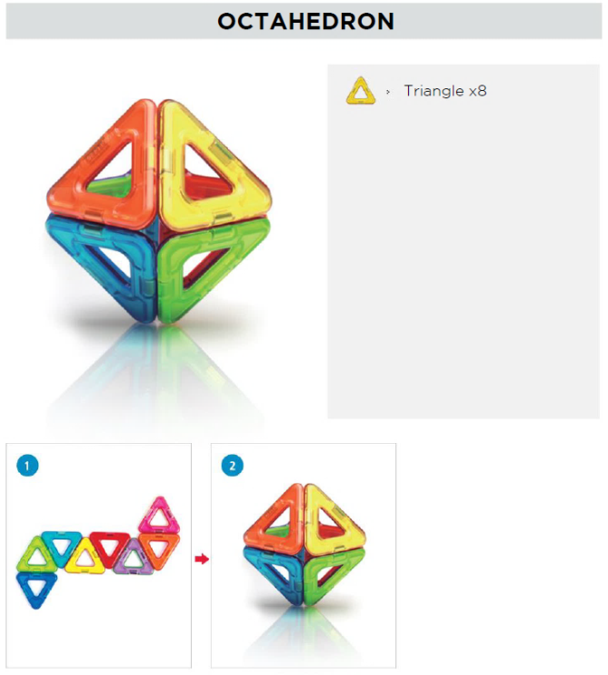
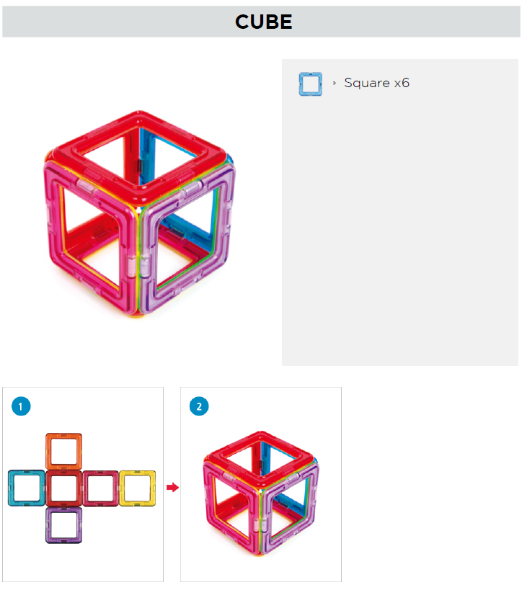

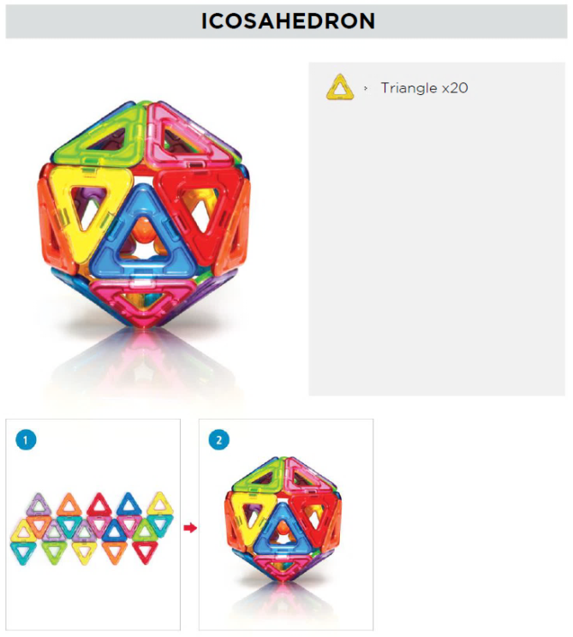
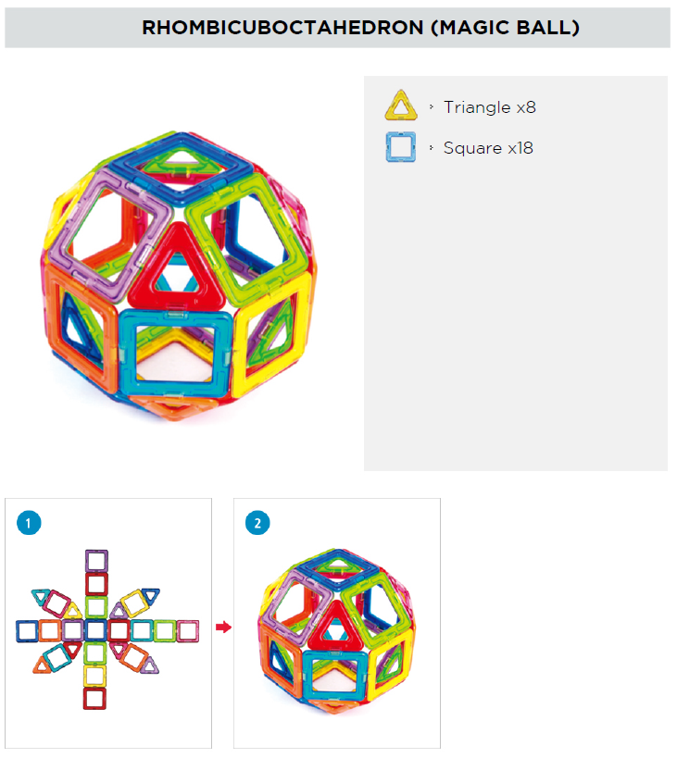

Station #3 – Net Diagrams of Cubes and Magformers
Q7: Use the Magformers to determine which of the following nets will successfully for a cube.
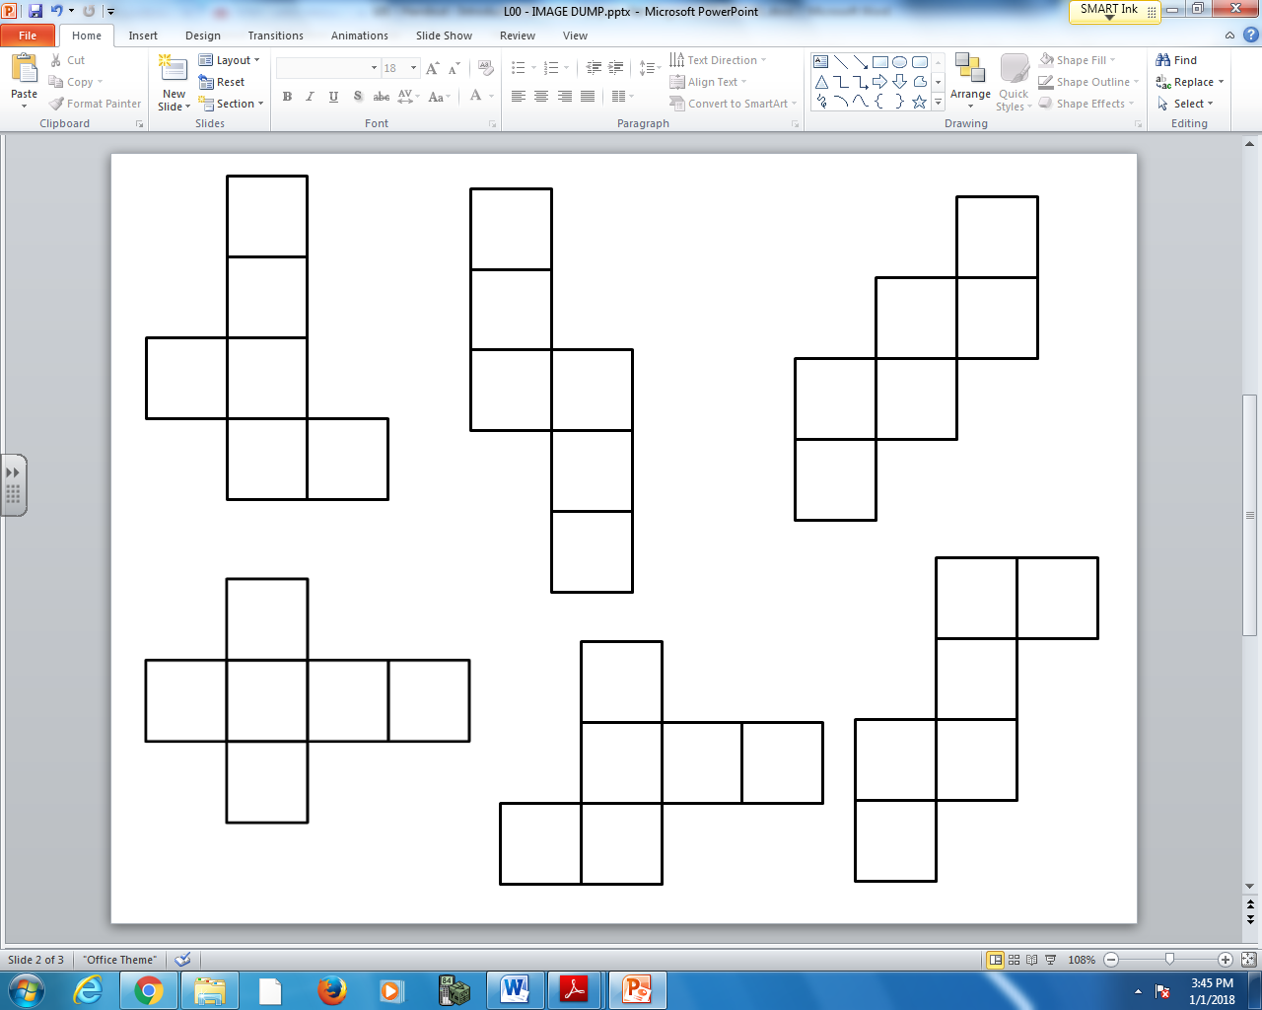
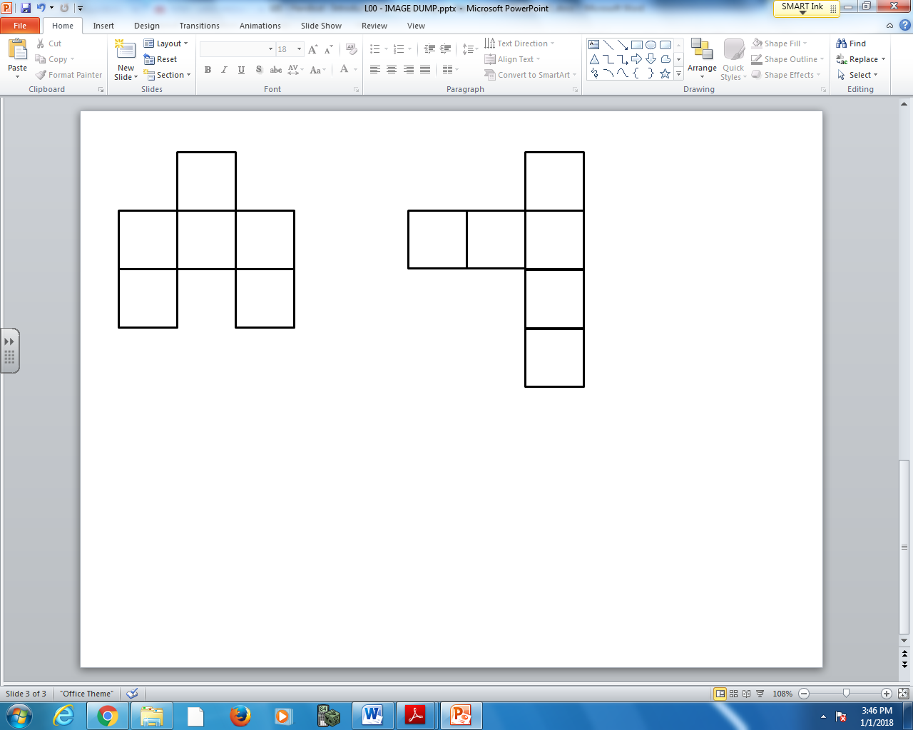
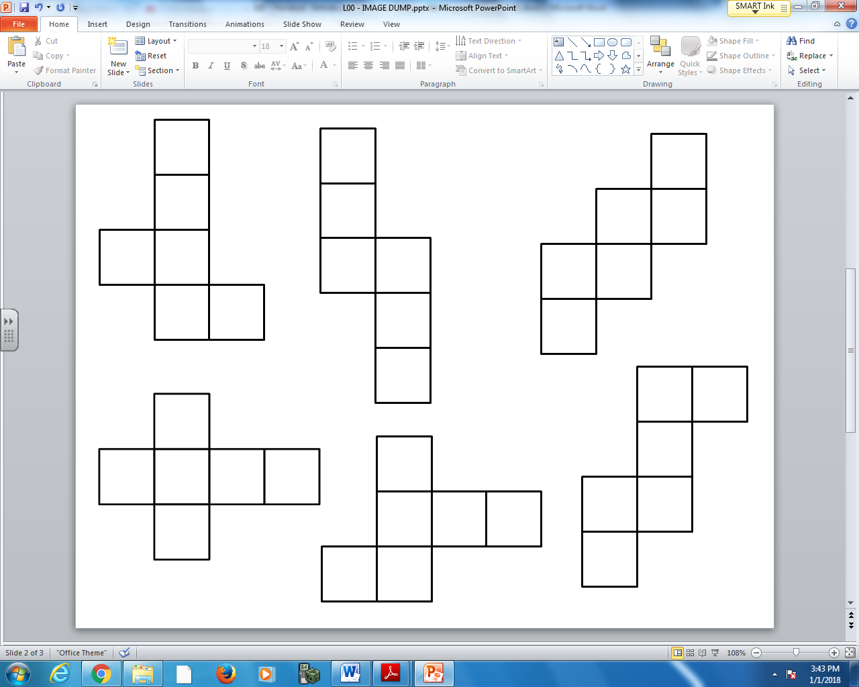

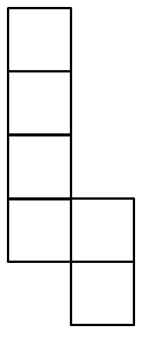
Station #4 – Surface Area
Q8: Using the Math Cubes, determine the surface area of the composite cubes. Each cube has sides of 1 unit.
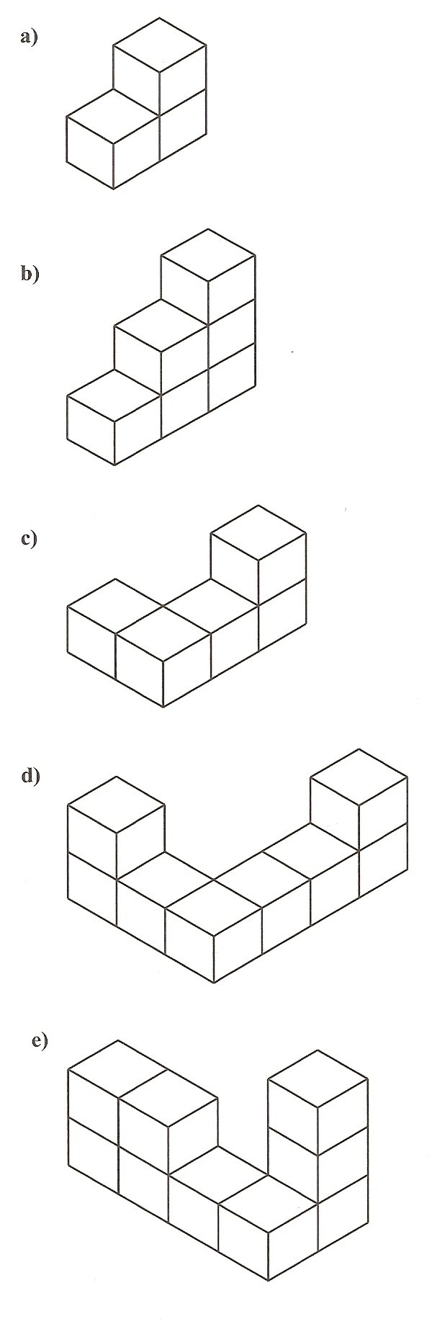
Station #5 – Volume
Q9: Using the Math Cubes, determine the volume of the composite cubes. Each cube has sides of 1 unit.
Station #6 – Brain Teasers
Q10: A die is a cube such that the top and bottom fo the die must add to seven. Complete the missing numbers.
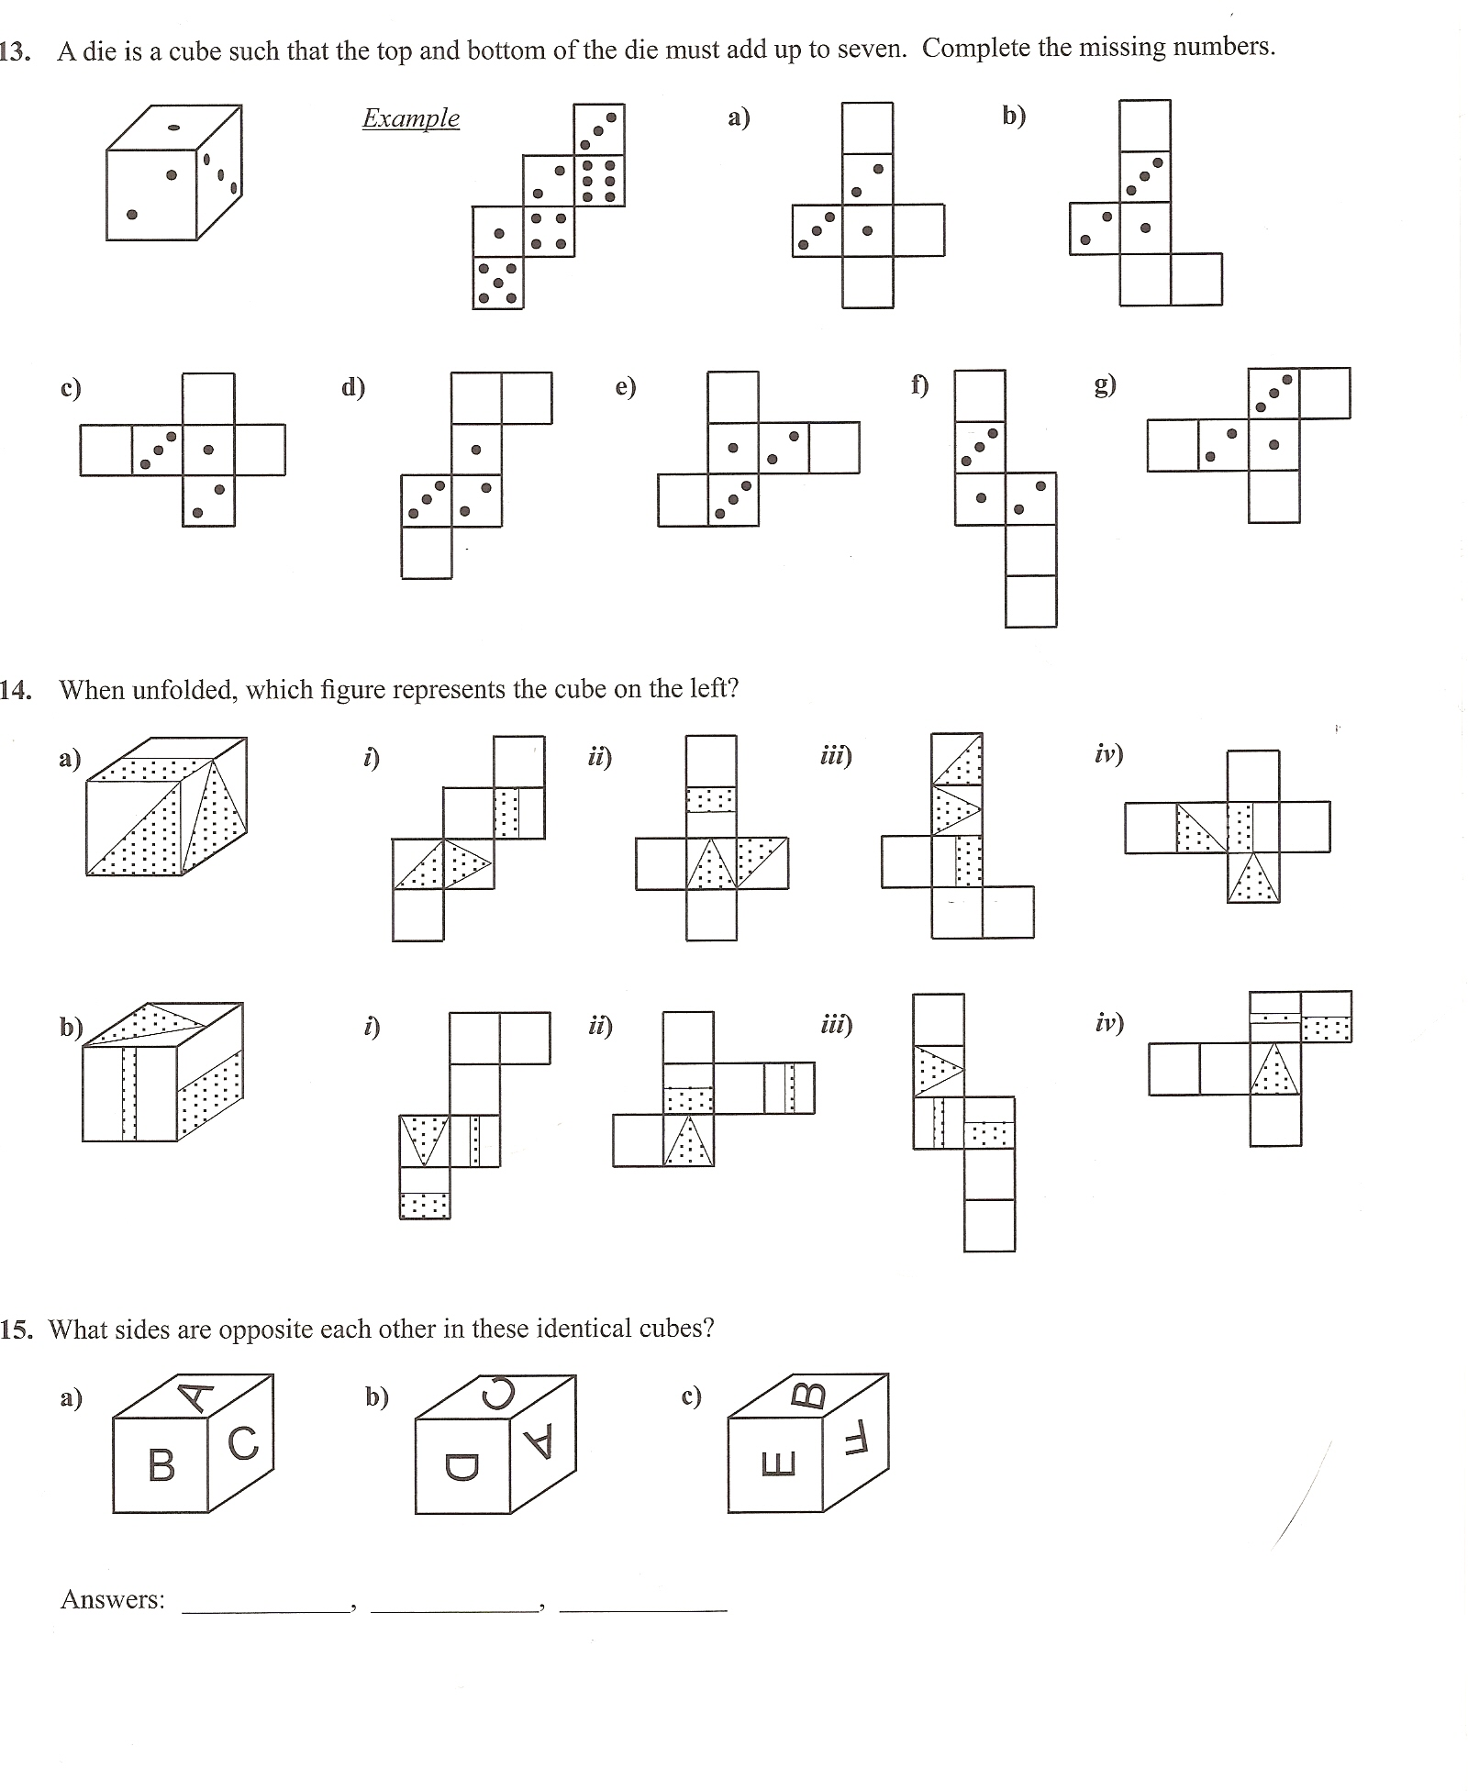

Q11: When unfolded, which figure represents the cube on the left?

Q12: Which figure on the right will the unfolded cube become?
