First Name:____________________________ Last Name:______________________________

L02 - FQ – Trig Ratios

Use the following information to answer Q1:
Labelling the Sides of a Triangle
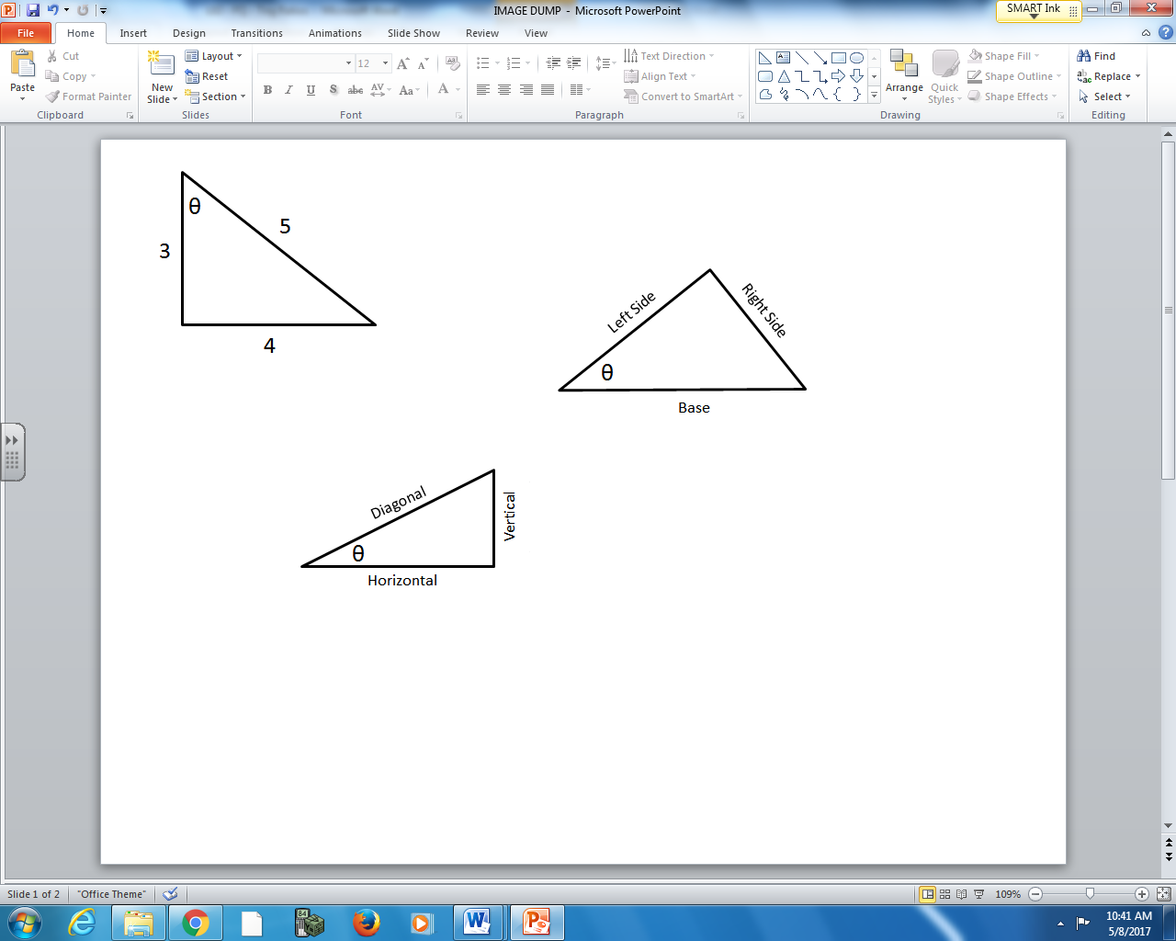
Side Orientation
1 – Diagonal
2 – Horizontal
3 – Vertical

Q1: Use the numbers above to identify each side of the triangle.

Orientation: __________ __________ __________
Description: Adjacent Hypotenuse Opposite

(Record your three-digit answer in the Numerical Response boxes below)

Use the following information to answer Q2-Q4:
Trig Ratios for a 7-24-25 Triangle
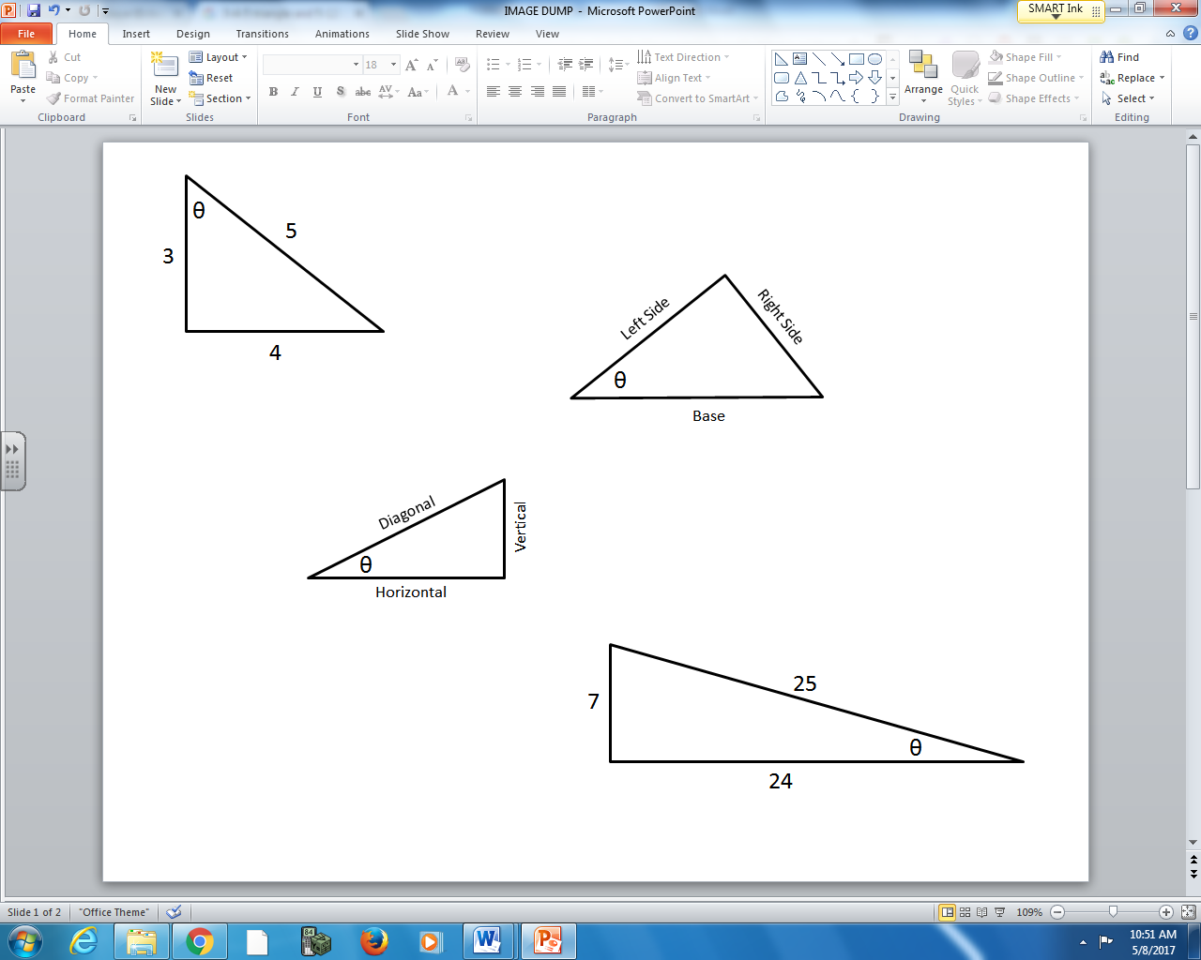

Q2: $Sin θ=\frac{a}{bc}$ where the integers a, b, and c are ___, ___, and ___.
(Record your three digit answer in the Numerical Response boxes below)

Q3: What is the value of $Cos θ$, to the nearest hundredth?
(Record your answer in the Numerical Response boxes below)

Q4: $Tan θ$ is a.bc x 10^{-d}, where a, b, c, and d are ___, ___, ___, and ___.
(Record your four-digit answer in the Numerical Response boxes below)

MARKING:
Beginning 0 – 1.5
Progressing 2 – 2.5
Competent 3 – 3.5
Exemplary 4

