First Name:____________________________ Last Name:______________________________
L02 - FQ – Vernier Calipers
Use the following information to answer Q1:
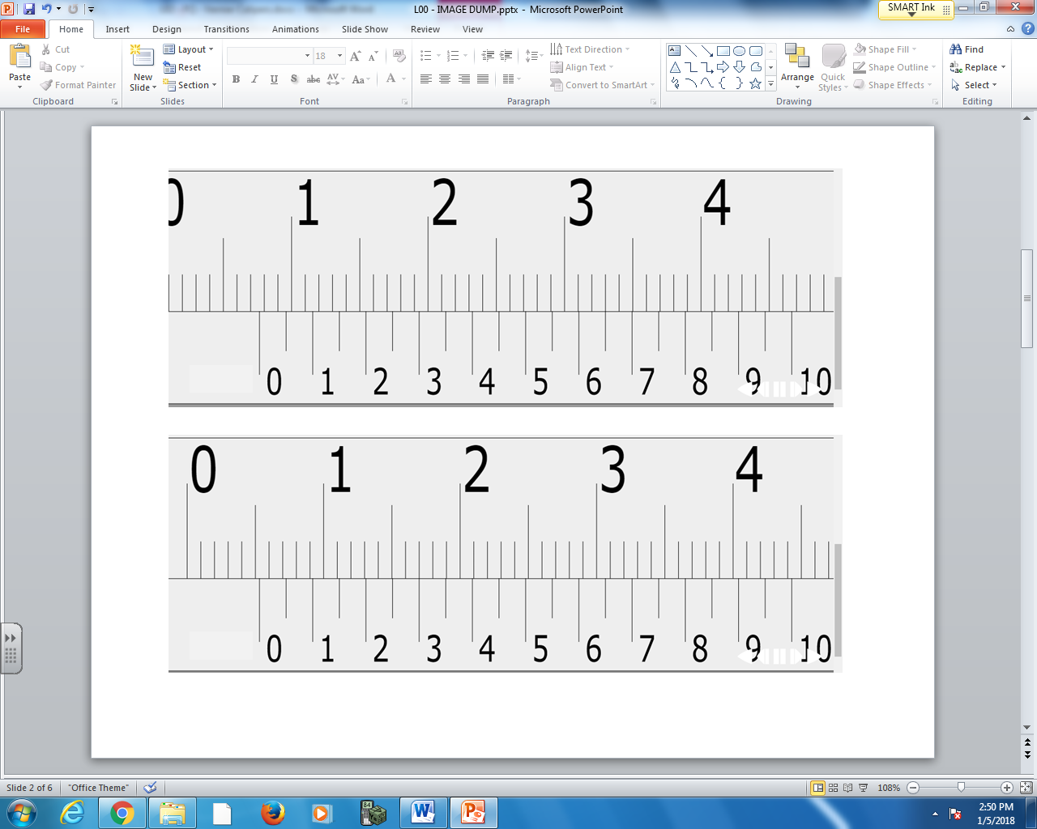

Q1: What is the measurement of the Vernier Caliper, to the nearest 0.05mm?

Use the following information to answer Q2:

Q2: What is the measurement of the Vernier Caliper, to the nearest 0.05mm?

MARKING:
Beginning 0 – 0.5
Progressing 1.0
Competent 1.5
Exemplary 2.0

