L02 – Linear Unit Conversions
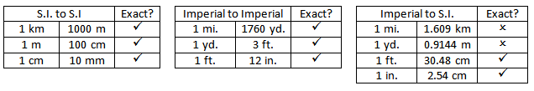
Part 1 – Measurement Referents
A referent is a reference for a specific measurement. For example, the outside length of Mr. Bayer’s Size 10 running shoe is approximately “1 foot” in length.
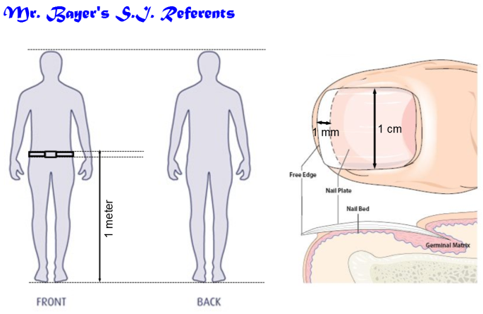
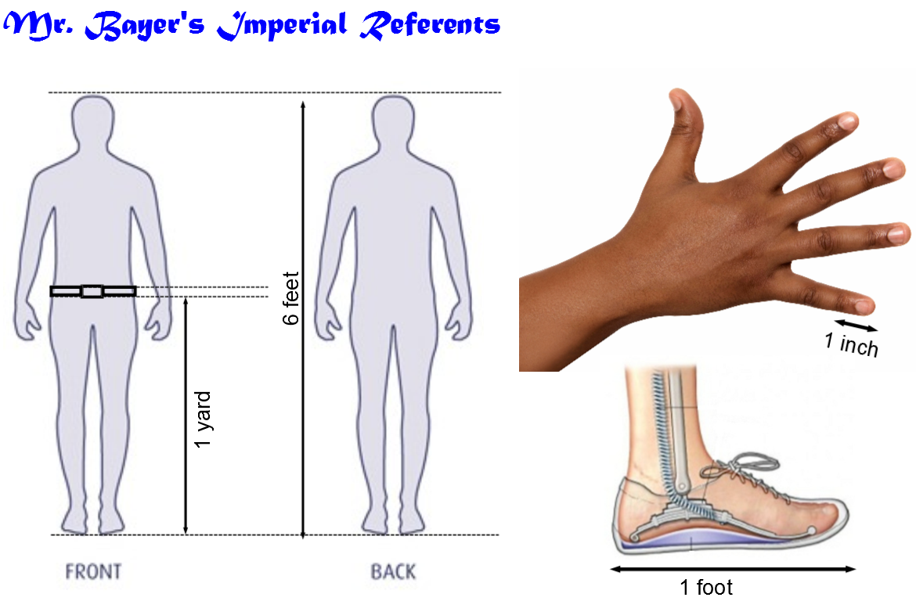
Part 2 – S.I. to S.I. Conversions (Proportional Reasoning)
Q1: Convert 2.4km to meters. Q2: Convert 346cm to meters.

Part 3 – S.I. to S.I. Conversions (Unit Analysis)
Q3: Convert 2.4km to meters. Q4: Convert 346cm to meters.

Part 4 – Imperial to Imperial Conversions (Proportional Reasoning)
Q5: Convert 2000 yards to miles. Q6: Convert 7.8 yards to feet.

Part 5 – Imperial to Imperial Conversions (Unit Analysis)
Q7: Convert 2000 yards to miles. Q8: Convert 7.8 yards to feet.

Part 6 – Imperial to S.I. Conversions (Proportional Reasoning)
Q9: Convert 2.5 miles to kilometers. Q10: Convert 1000 cm to inches.

Part 7 – Imperial to S.I. Conversions (Unit Analysis Reasoning)
Q11: Convert 2.5 miles to kilometers. Q12: Convert 1000 cm to inches.

Part 8 – Multi-Step Conversions (Proportional Reasoning)
Q13: Convert 0.50 miles to meters.

Q14: Convert 10,000 inches to meters.

Part 9 – Multi-Step Conversions (Unit Analysis)
Q15: Convert 0.50 miles to meters.

Q16: Convert 10,000 inches to meters.

Part 10 – Velocity Conversions (Unit Analysis)
Q17: Convert 100 km/h to m/s.

Q18: Convert 50 cm/s to km/h.

