First Name:____________________________ Last Name:______________________________
L02 - Worksheet – Linear Unit Conversions
Part 1 – Vernier Calipers
Use the following information to answer Q1:
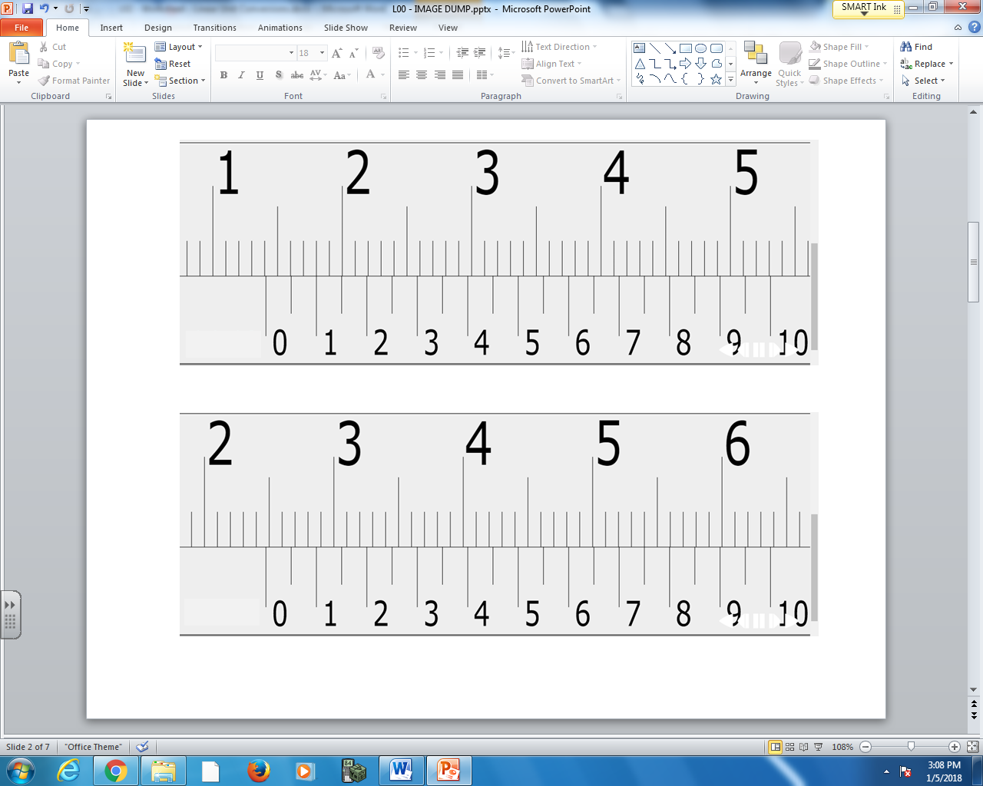

Q1: What is the measurement of the Vernier Caliper, to the nearest 0.05mm?

Use the following information to answer Q2:

Q2: What is the measurement of the Vernier Caliper, to the nearest 0.05mm?

Part 2 – Proportional Reasoning
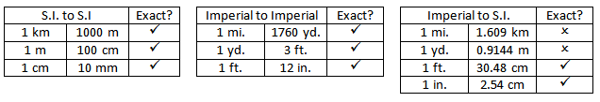
Q3: Convert 585 cm to meters. Q4: Convert 3000 yards to miles.

Q5: Convert 200 yards to meters. Q6: Convert 3.2 miles to yards.

Q7: Convert 2 km to yards.

Q8: Convert 20,000 inches to km.

Part 3 – Unit Analysis
Q9: Convert 3.5 km to meters. Q10: Convert 200 feet to yards.

Q11: Convert 5 miles to km. Q12: Convert 300 inches to feet.

Q13: Convert 500 inches to yards.

Q14: Convert 2500 yards to kilometers.

