L03 – FQ - 6.1 Rational Expressions
Q1: What are the non-permissible values for the rational expression $\frac{(x+2)(x-3)}{\left(x+4\right)(x-5)}$ ?
- x≠ -2,3
- x ≠ 2,-3
- x≠ -4,5
- x ≠ 4,-5

Q2: The rational expression $\frac{x^{2}+8x+15}{x^{2}-x-12}$ simplifies to $\frac{x+a}{x-b}$ , where x≠ c, x≠ -d. The values of a, b, c, and d are ___, ___, ___, and ___.
(Record your four-digit answer in the Numerical Response boxes below)

Q3: (Long Answer) Simplify the expression $\frac{2x^{2}+6x-20}{2x^{2}-x-6}$ and state any non-permissible values. (2 marks)

Q4: A triangle has a base of 4x+8 and a height of 3x+6. The hypotenuse is ax+bc, where a, b and c are ___ , ___, and ___.
(Record your three-digit answer in the Numerical Response boxes below)

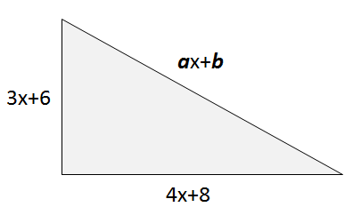

Q5: (Long Answer) A box has a height of $x+5$ before being disassembled and laid flat as a net diagram. The area of one side is $x^{2}+13x+40$ and the area of the other side is $x^{2}+7x+10.$ Determine the area of the base, and state any non-permissible values. (4 marks)
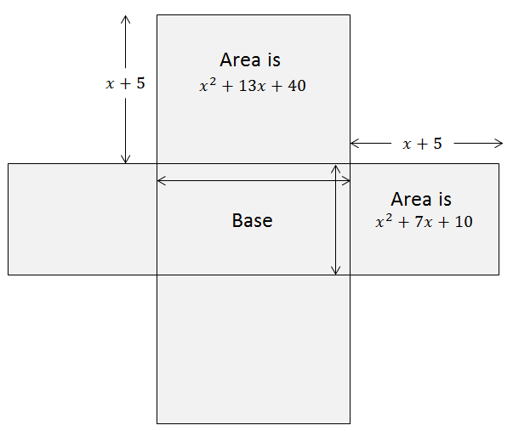
MARKING:
Beginning 0.0 – 4.0
Progressing 4.5 – 6.5
Competent 7.0 – 8.5
Exemplary 9.0

