First Name:____________________________ Last Name:______________________________
L03 - FQ – Linear Unit Conversions
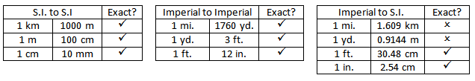
Q1: Convert 15 meters to yards.
- 13.7 yd.
- 14.1 yd.
- 15.9 yd.
- 16.4 yd.
Q2: Convert 18 inches to millimeters, to the nearest millimeter.
(Record your answer in the Numerical Response boxes below)

Q3: Using Proportional Reasoning, convert 18 yards to cm. (2 marks)

Q4: Using Unit Analysis, convert 20 inches to meters. (2 marks)

MARKING:
Beginning 0.0 – 2.5
Progressing 3.0 – 4.0
Competent 4.5 – 5.5
Exemplary 6.0

