First Name:____________________________ Last Name:______________________________

L03 - Formative Quiz – Solving for Angles

Use the following information to answer Q1-Q3:
Trig Ratios for a 3-4-5 Triangle
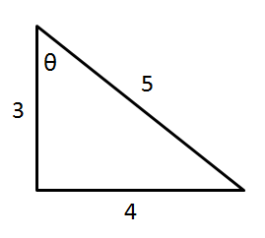

Q1: For the triangle above, the ratio $Tan θ=\frac{d}{e}$ where the integers d and e are ___ and ___.
(Record your two digit answer in the Numerical Response boxes below)

Q2: What is the value of $Tan θ$, to the nearest hundredth?
(Record your answer in the Numerical Response boxes below)

Q3: What is the value $θ$?
(Record your two digit answer in the Numerical Response boxes below)

Q4: Solve for the angle β. (2 marks)
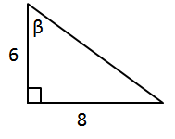

Q5: Solve for the angle ∠C. (2 marks)
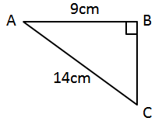

MARKING:
Beginning 0.0 –3.0
Progressing 3.5 – 4.5
Competent 5.0 – 6.0
Exemplary 6.5 – 7.0

