L03 – Surface Area and SA Unit Conversions
Data Sheet – Measurement Conversion Charts
S.I. to S.I |  | Exact? |  | Imperial to Imperial |  | Exact? |  | Imperial to S.I. |  | Exact?
1 km | 1000 m |  |  | 1 mi. | 1760 yd. |  |  | 1 mi. | 1.609 km
1 m | 100 cm |  |  | 1 yd. | 3 ft. |  |  | 1 yd. | 0.9144 m
1 cm | 10 mm |  |  | 1 ft. | 12 in. |  |  | 1 ft. | 30.48 cm
 |  |  |  |  |  |  |  | 1 in. | 2.54 cm

Data Sheet – Geometric Formulas
Surface Area
Sphere $SA=4πr^{2}$
Cylinder$SA=2πr^{2}+2πrh$
Cone $SA=πr^{2}+πrs$
Prism $SA=2lw+2lh+2wh$

Area
$$Circle A=πr^{2}$$
$$Triangle A=\frac{b×h}{2}$$
Parallelogram $A=b×h$
Trapezoid $A=h\left(\frac{\left(b_{1}+b_{2}\right)}{2}\right)$

Volume
$$Sphere V=\frac{4}{3}πr^{3}$$
$$Cylinder V=πr^{2}h$$
Prism $V=B×h$
Cone $V=\frac{1}{3}πr^{2}h$
Pyramid $V=\frac{B×h}{3}$

Part 1 – Surface Area of Basic Shapes (with Conversions)
Q1: What is the surface area of the rectangular prism, to the nearest m²?
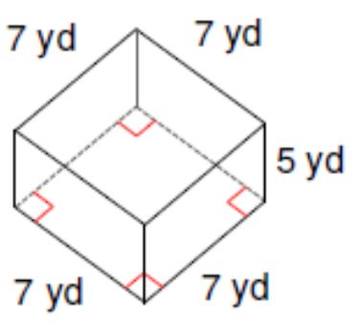

Q2: What is the surface area of the triangular prism, to the nearest mi²?
$$Triangle A=\frac{b×h}{2}$$

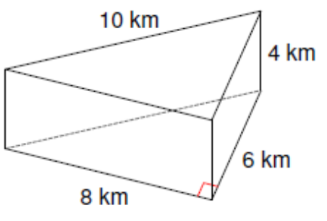

Q3: What is the surface area of the triangular prism, to the nearest square meter?
$$Triangle A=\frac{b×h}{2}$$

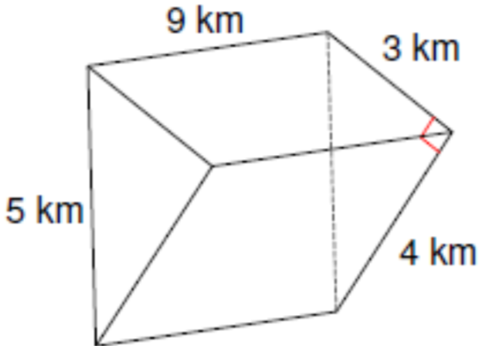

Q4: What is surface area of the cylinder, to the nearest mi²?
Cylinder$SA=2πr^{2}+2πrh$

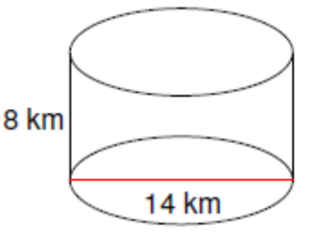

Q5: What is the surface area of the trapezoidal prism, to the nearest m²?
Trapezoid $A=h\left(\frac{\left(b_{1}+b_{2}\right)}{2}\right)$

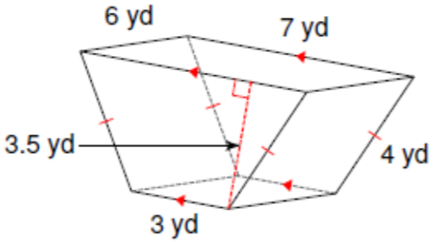

Part 2 – Surface Area of Simple Composite Shapes (with Conversions)
Q6: Each cube has a side length of 2cm. What is the surface area of the composite object, in square inches? Hint: This object can be made using 4 cubes.
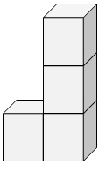

Q7: Each cube has a side length of 2in. What is the surface area of the composite object, in square centimeters? Hint: This object can be made using 10 cubes.
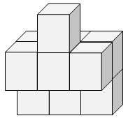

Q8: Each cube has a side length of 3cm. What is the surface area of the composite object, in square inches? Hint: This object can be made using 7 cubes.
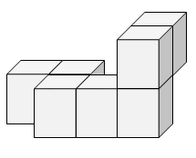

Q9: Each cube has a side length of 2 feet. What is the surface area of the composite object, in square yards? Hint: This object can be made using 6 cubes.
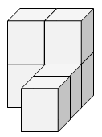

Part 3 – Surface Area of Complex Composite Shapes (with Conversions)
Q10: What is the surface area of the composite shape, to the nearest in²?
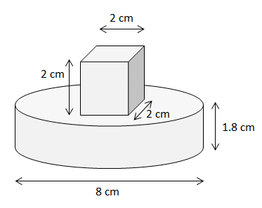

Q11: What is the surface area of the composite shape, to the nearest in²?
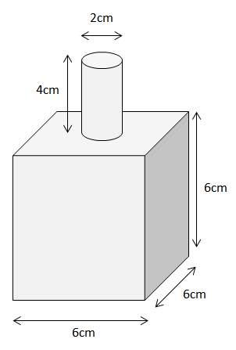
Q12: What is the surface area of the composite shape, to the nearest in²?
