First Name:_____________________________ Last Name:______________________________

L03 – Worksheet – Surface Area and SA Unit Conversions

Q1: What is the area of the shape, in m² ?
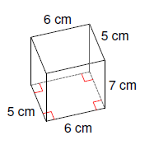

Q2: What is the area of the shape, in km² ?
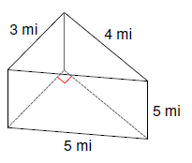

Q3: What is the area of the shape, in mi² ?
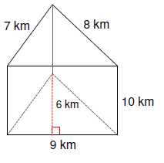
Q4: What is the area of the shape, in cm² ?
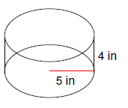

Q5: What is the area of the shape, in m² ?
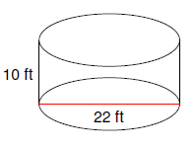

Q6: What is the area of the shape, in in² ?
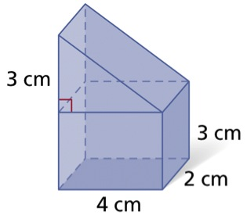

Q7: What is the area of the shape, in cm² ?
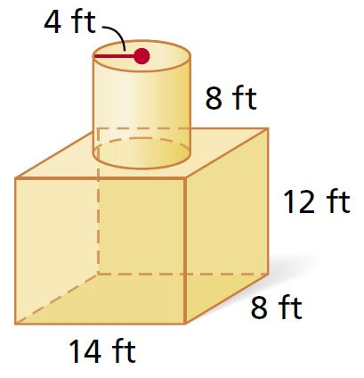

Q8: What is the area of the shape, in in² ?
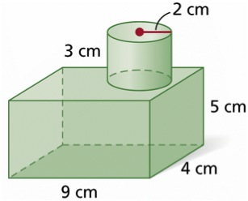

Q9: What is the area of the shape, in mm² ?
