L04 – FQ - 6.1 Rational Expressions 2

Use the following information to answer Q1:
A student is working on a Rational Expressions question. Their work is shown below.
Line 1 $\frac{x^{2}+2x-15}{x^{2}+11x+30}$
Line 2 $\frac{(x+5)(x-3)}{(x+5)(x+6)}$
Line 3 $\frac{(x-3)}{(x+6)}$ , where x≠ -6

Q1: What mistake did the student make?
- The student factored the numerator incorrectly.
- The student factored the denominator incorrectly.
- The student simplified the expression incorrectly.
- The student incorrectly stated the Non-Permissible Value(s).

Q2: (Long Answer) Determine the height of the rectangle, and state any non-permissible values. (2 marks)
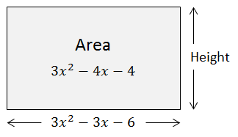

MARKING:
Beginning 0.0 – 1.0
Progressing 1.5 – 2.0
Competent 2.5
Exemplary 3.0

