First Name:____________________________ Last Name:______________________________

L04 - Formative Quiz – Solving for Sides and Angles

Use the following information to answer Q1-Q2:
Solving for ∠A
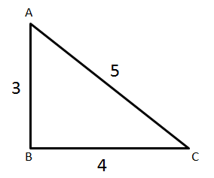
Trigonometric Ratio
1 – Sin
2 – Cos
3 – Tan

Q1: To solve the triangle above for ∠A, we will use a trigonometric ratio d from the text box above. The value of this ratio is $\frac{e}{f}$ , where d, e, and f are ___, ___, and ___.
(Record your three digit answer in the Numerical Response boxes below)

(Multiple correct answers will be accepted)

Q2: What is the value of ∠A?
(Record your three digit answer in the Numerical Response boxes below)

Use the following information to answer Q3-Q4:
Solving for Side “b”
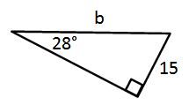

Q3: To solve the triangle above for side b, we will use which trigonometric ratio?
- Sin
- Cos
- Tan
- All of the above

Q4: What is the value of b, to the nearest tenth?
(Record your answer in the Numerical Response boxes below)

MARKING:
Beginning 0.0 – 1.5
Progressing 2.0 – 2.5
Competent 3.0 – 3.5
Exemplary 4.0

