First Name:_____________________________ Last Name:______________________________
L04 – FQ – Surface Area and SA Unit Conversions
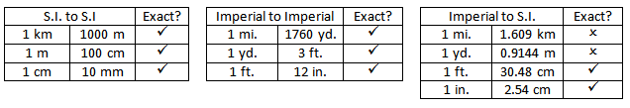
Q1: A hole is drilled through a rectangular prism. Calculate the surface area, in square feet. (3 marks)
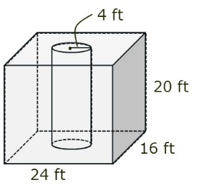

Q2: Another figure has a surface area of 200 m². What is the surface area in yards²?
(Record your answer in the Numerical Response boxes below)

MARKING:
Beginning 0 – 1.5
Progressing 2 – 2.5
Competent 3 – 3.5
Exemplary 4

