L04 – Volume and Vol Unit Conversions
Data Sheet – Measurement Conversion Charts
S.I. to S.I |  | Exact? |  | Imperial to Imperial |  | Exact? |  | Imperial to S.I. |  | Exact?
1 km | 1000 m |  |  | 1 mi. | 1760 yd. |  |  | 1 mi. | 1.609 km
1 m | 100 cm |  |  | 1 yd. | 3 ft. |  |  | 1 yd. | 0.9144 m
1 cm | 10 mm |  |  | 1 ft. | 12 in. |  |  | 1 ft. | 30.48 cm
 |  |  |  |  |  |  |  | 1 in. | 2.54 cm

Data Sheet – Geometric Formulas
Surface Area
Sphere $SA=4πr^{2}$
Cylinder$SA=2πr^{2}+2πrh$
Cone $SA=πr^{2}+πrs$
Prism $SA=2lw+2lh+2wh$

Area
$$Circle A=πr^{2}$$
$$Triangle A=\frac{b×h}{2}$$
Parallelogram $A=b×h$
Trapezoid $A=h\left(\frac{\left(b_{1}+b_{2}\right)}{2}\right)$

Volume
$$Sphere V=\frac{4}{3}πr^{3}$$
$$Cylinder V=πr^{2}h$$
Prism $V=B×h$
Cone $V=\frac{1}{3}πr^{2}h$
Pyramid $V=\frac{B×h}{3}$

Part 1 – Surface Area versus Volume Unit Conversions
Q1: Calculate the Surface Area and Volume of the shape:
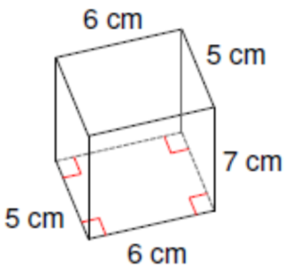
Surface Area Volume

Q2: Convert the Surface Area to in². How many times do we need to apply the conversion?

Q3: Convert the Volume to in³. How many times do we need to apply the conversion?
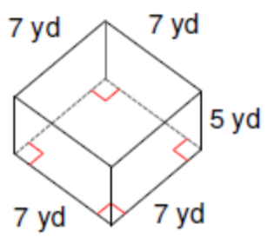
Q4: Calculate the Surface Area and Volume of the shape:
Surface Area Volume

Q5: Convert the Surface Area to m². How many times do we need to apply the conversion?

Q6: Convert the Volume to m³. How many times do we need to apply the conversion?

Q7: Calculate the Surface Area and Volume of the shape:
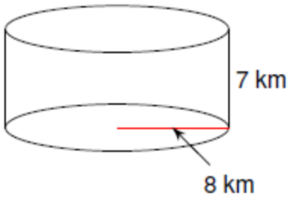
Surface Area Volume

Q8: Convert the Surface Area to mi². How many times do we need to apply the conversion?

Q9: Convert the Volume to mi³. How many times do we need to apply the conversion?

Q10: Calculate the Volume of the shape in yd³.
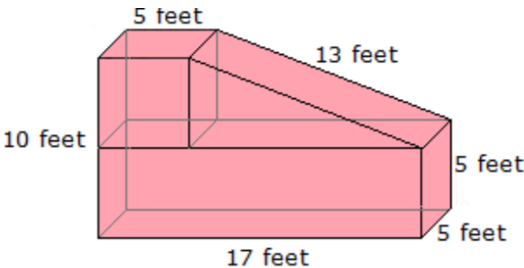

Part 2 – Volume of Prisms and Cylinders versus Pyramids and Cones (i.e. “Pointy Things”)
Q11: Calculate the volume of a Rectangular Prism (left) and a Rectangular Pyramid (right), in cubic yards.
Rectangular Prism Rectangular Pyramid (“Pointy”)
Prism $V=B×h$ Pyramid $V=\frac{B×h}{3}$
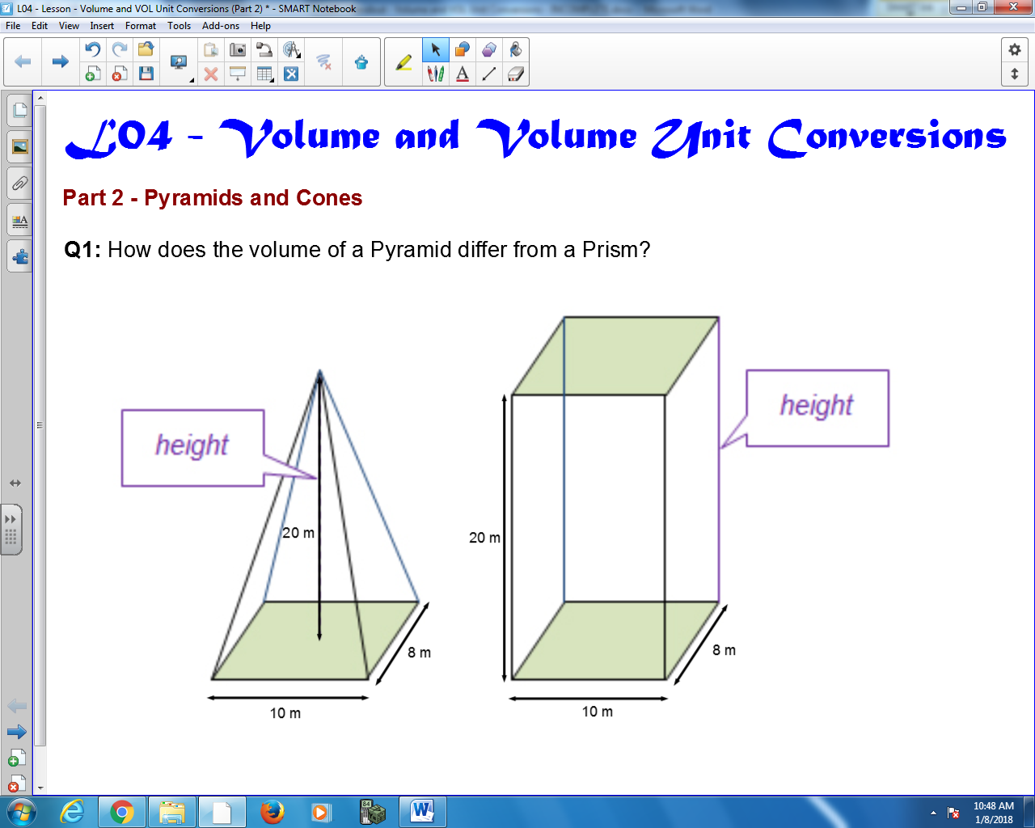

Q12: Calculate the volume of a Cylinder (left) and a Rectangular Pyramid (right), in cubic yards.
Cylinder Cone (“Pointy”)
$Cylinder V=πr^{2}h$ Cone $V=\frac{1}{3}πr^{2}h$

