L04 – Worksheet - 6.2 Multiplying and Dividing Rational Expressions
Pg 327 #8abc: Express each quotient in simplest form. Identify all non-permissible values.
$\frac{2w^{2}-w-6}{3w+6}÷\frac{2w+3}{w+2}$ $\frac{v-5}{v}÷\frac{v^{2}-2v-15}{v^{3}}$ $\frac{9x^{2}-1}{x+5}÷\frac{3x^{2}-5x-2}{2-x}$

Pg 327 #9: Explain why the non-permissible values in the quotient $\frac{x-5}{x+3}÷\frac{x+1}{x-2}$ are -3, -1, 2.

Pg 327 #10: The height of a stack of plywood is represented by $\frac{n^{2}-4}{n+1}$ . If the number of sheets is defined by $-2$ , what expression could be used to represent the thickness of one sheet? Express your answer in simplest form.

Pg 328 #11c: Simione is shipping his carving to a buyer in Winnipeg. He makes a rectangular box with a length of $(2x-3)$ meters and width of $(x+1)$ meters. The volume of the box is $(x^{2}+2x+1)$ cubic meters. What is an expression for the height of the box?

Pg 328 #16: What is an expression for the area of ΔPQR? Give your answer in simplest form.
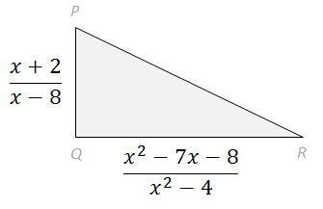

Pg 329 #18: The volume, V, of a gas increases or decreases with its temperature, T, according to Charles’ law by the formula $\frac{V_{1}}{V_{2}}=\frac{T_{1}}{T_{2}}$ . Determine $V_{1}$ if $V_{2}=\frac{n^{2}-16}{n-1}$ , $T_{1}=\frac{n-1}{3}$ , and $T_{2}=\frac{n+4}{6}$ . Express your answer in simplest form.

