First Name:_______________________________ Last Name:______________________________

L04 – Worksheet – Volume and Volume Unit Conversions

Q1: Calculate the volume of the composite shape, to the nearest cubic foot.
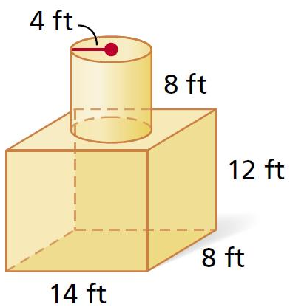

Q2: Calculate the volume of the composite shape, to the nearest cubic centimeter.
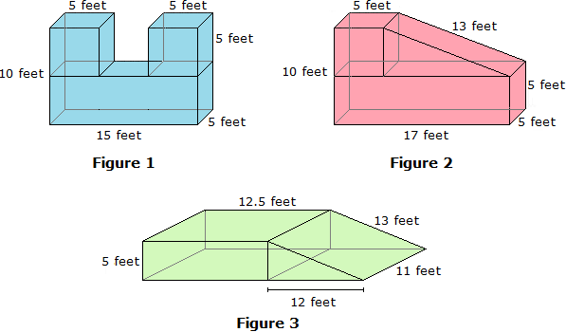

Q3: Calculate the volume of the composite shape, to the nearest cubic meter.

Q4: Calculate the volume of the composite shape, to the nearest cubic millimeter.
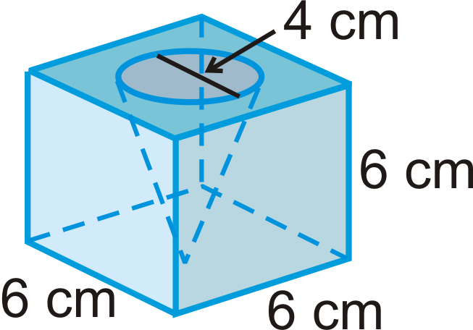

Q5: Calculate the volume of the composite shape, to the nearest cubic centimeter.
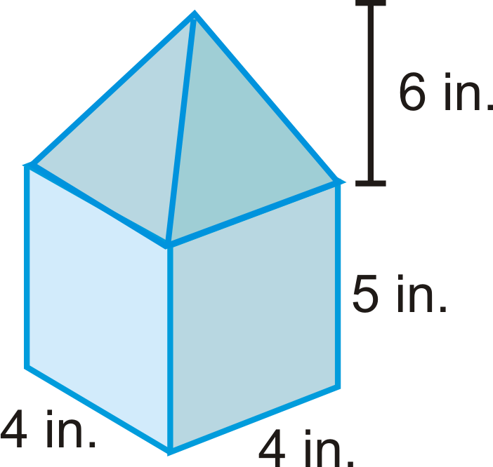

Q6: Calculate the volume and surface area of the composite shape.
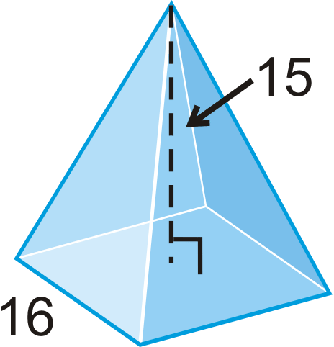

Q7: Calculate the surface area and volume of the composite shape to the nearest square inch and cubic inch, respectively.
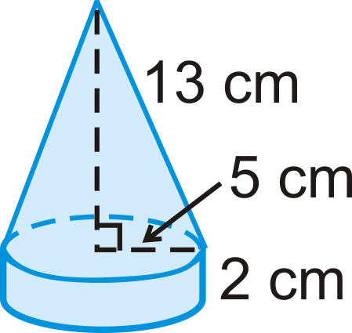

Q8: Calculate the surface area and volume of the composite shape to the nearest square meter and cubic meter, respectively.
