L05 – FQ – 6.2 Multiplying and Dividing Rational Expressions

Use the following information to answer Q1-Q3:
Expression A Expression B
$\frac{x^{2}-3x-18}{x^{2}+6x+8}*\frac{x^{2}-3x-10}{x^{2}+4x+3}$ $\frac{(x-5)(x+2)}{(x-3)(x+3)}÷\frac{(x-3)(x-5)}{(x+3)(x+2)}$

Q1: Using the expressions above, Expression A has ___ non-permissible values. Expression B has ___ non-permissible values.
(Record your two-digit answer in the Numerical Response boxes below)

Q2: Expression A simplifies to $\frac{(x-a)(x-b)}{(x+c)(x+d)}$ , where a, b, c, and d are ___, ___, ___, ___.
(Multiple correct answers exist)
(Record your four-digit answer in the Numerical Response boxes below)

Q3: (Long Answer) Simplify Expression B. State the Non-Permissible Values (NPV). (3 marks)

Use the following information to answer Q4:
The area of a rectangle is $x^{2}-x-6$. The height of the rectangle is $x^{2}-2x-3$.
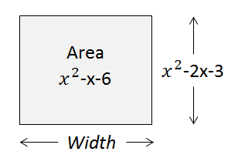

Q4: An expression for the width of the rectangle is $\frac{(x+a)}{(x+b)}$ , where $x≠c, -d$. The values of a, b, c, and d are ___, ___, ___, and ___.
(Record your four-digit answer in the Numerical Response boxes below)

MARKING:
Beginning 0.0 – 2.5
Progressing 3.0 – 4.0
Competent 4.5 – 5.5
Exemplary 6.0

