First Name:_____________________________ Last Name:______________________________

L05 – FQ – Volume and Volume Unit Conversions

Q1: A hole is drilled through a rectangular prism. Calculate the volume, in cubic feet. (3 marks)
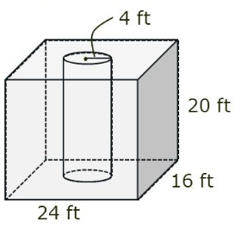

Q2: Another figure has a volume of 200 m³. What is the volume in yards³? (1 mark)

MARKING:
Beginning 0 – 1.5
Progressing 2 – 2.5
Competent 3 – 3.5
Exemplary 4

