L05 – 4.4 Entire to Mixed Radicals
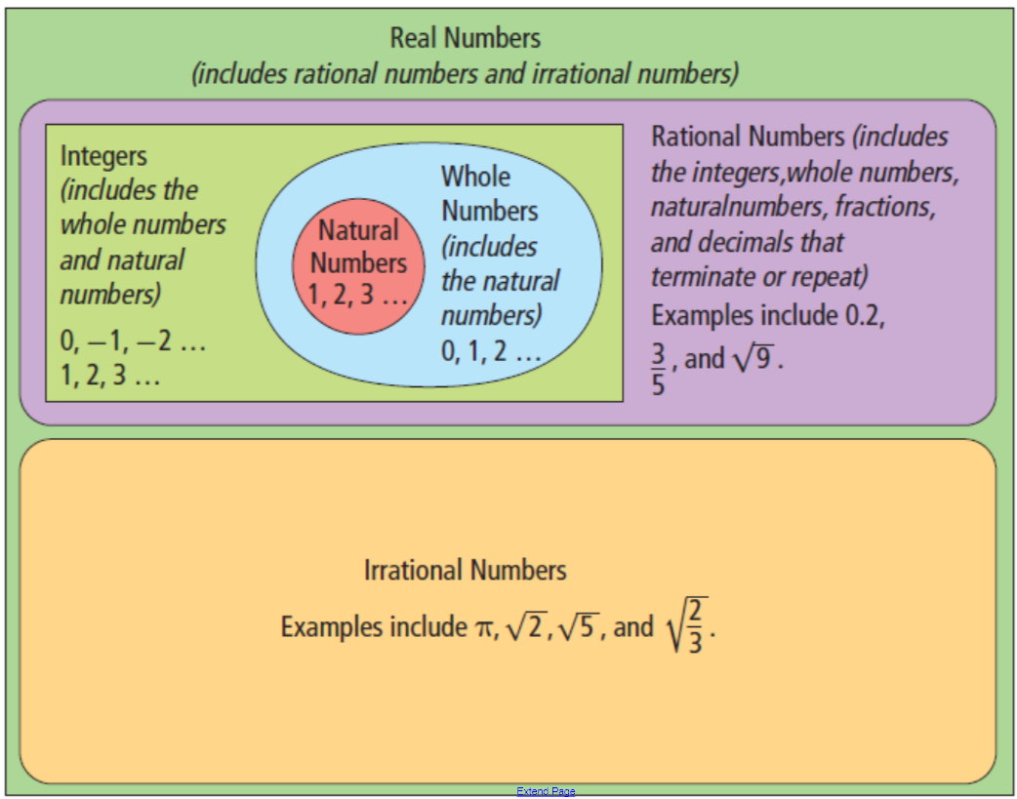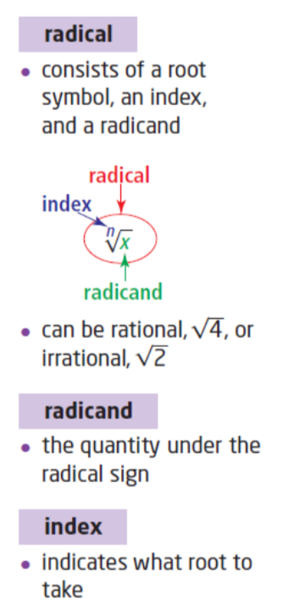
Part 1 – Prime Factoring
Q1: Prime factor the following:
32 75 84

Part 2 – Prime Factoring Under Radicals
Q2: Prime factor the following:
$\sqrt{32}$ $\sqrt{75}$ $\sqrt{84}$

Part 3 –Entire to Mixed Radicals (Square Roots)
Q3: Convert the following to Mixed Radicals:
$\sqrt{32}$ $\sqrt{75x^{5}}$

$\sqrt{84x^{2}y^{7}z}$ $\sqrt{98x^{3}y^{4}}$

$\sqrt{24x^{5}y^{3}z^{4}}$ $\sqrt{18x^{2}y^{6}}$

Part 4 – Entire to Mixed Radicals (Cube Roots)
Q4: Convert the following to Mixed Radicals:
$\sqrt[3]{32}$ $\sqrt[3]{75x^{5}}$

$\sqrt[3]{84x^{2}y^{7}z}$ $\sqrt[3]{98x^{3}y^{4}}$

$\sqrt[3]{24x^{5}y^{3}z^{4}}$ $\sqrt[3]{18x^{2}y^{6}}$

