First Name:_____________________________ Last Name:______________________________

L05 – Project - How High is the Football Tower

Goal: Students must use trigonometry to calculate the height of the Wm. E. Hay football tower.
Requirements: Students must label all diagrams and show all calculations.
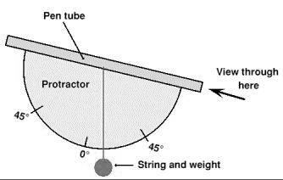
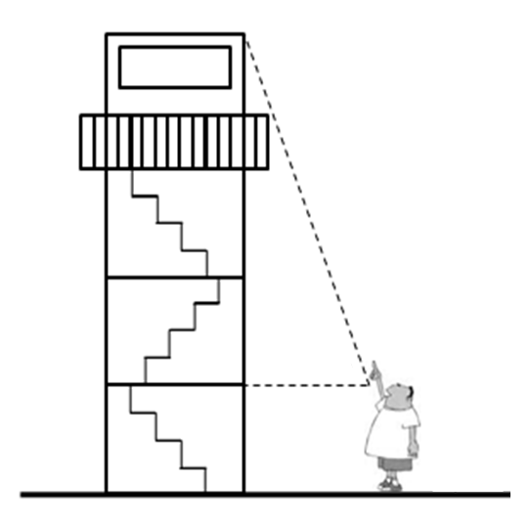
Diagram and Measurements at Distance 1 Diagram and Measurements at Distance 2

Calculations and Conclusion at Distance 1 Calculations and Conclusion at Distance 2

Self-Assessment ___ / 9 marks
 | Total | Weighting Multiplier | 3 | 2 | 1 | 0
Ability to apply trigonometry to a new situation. |  | x2 | I was able to follow the instructions to independently complete the task. | I required some clarification and additional help to complete the task. | I required significant help from peers or the teacher to complete the task. | I do not understand how to use trigonometry to set up this task.
Ability to use trigonometric ratios to solve a problem. |  | x1 | I was able to independently and correctly calculate the height of the football tower. | I was able to correctly calculate the height of the football tower with some help from peers or the teacher. | I was able to correctly calculate the height of the football tower with significant help from peers or the teacher. | I do not know how to solve the trigonometric ratio for the height of the football tower.

