First Name:___________________________ Last Name:______________________________

L05 – Worksheet – Trigonometry Problems

Q1: A Physics 20 student needs to break a vector into components. To do this, they draw a triangle, and solve for the sides labelled x and y.
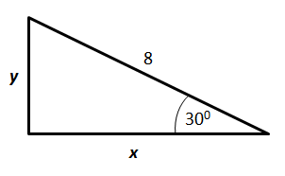
The length of side x is a.b units, and the length of side y is c.d units, where a, b, c, and d are ___, ___, ___, and ___.
(Record your four digit answer in the Numerical Response boxes below)

Q2: A student standing on top of a small building looks across at a taller skyscraper.
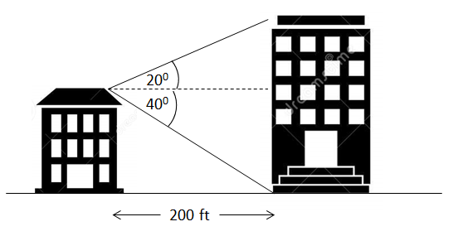
How tall is the larger building, in feet?

Q3: An air hockey table is usually 90 inches by 50 inches.
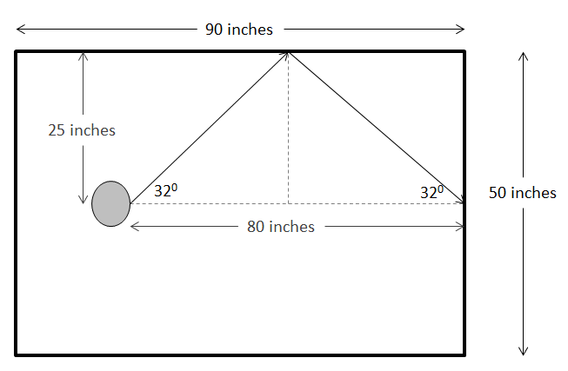
Given the pucks current position, how much additional distance, in inches, does the puck travel if it is banked off the side, rather than shot straight in?
(Record your two digit answer in the Numerical Response boxes below)

Q4: A student is lying on the ground an unknown distance, x, from a tree, and looks up at an angle of elevation of 20⁰ to the top of the tree.
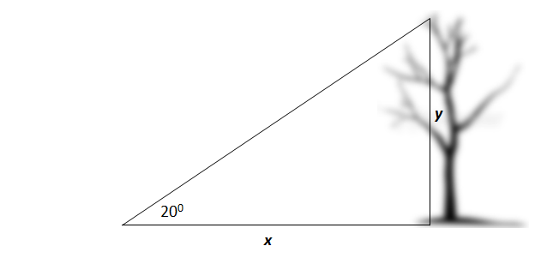
The student then backs up 10m and looks up again, this time at an angle of inclination of 18⁰.
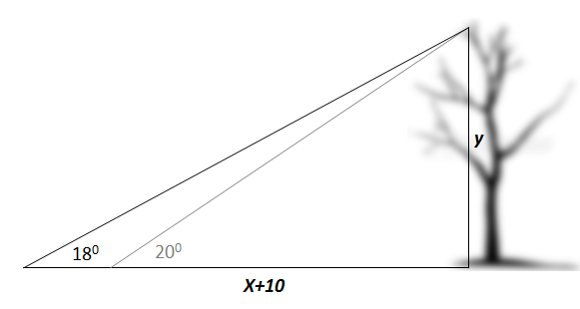
How tall is the tree?

