L07 – FQ – 6.3 Adding and Subtracting Rational Expressions

Use the following information to answer Q1-2:
A rectangle has the following dimensions:
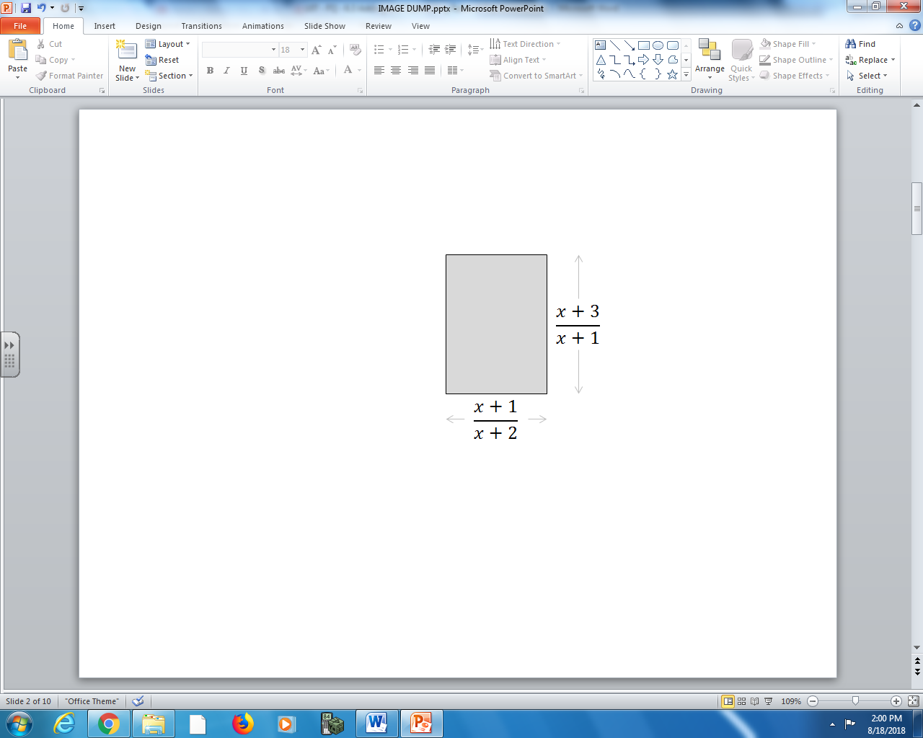

Q1: The area of the rectangle can be simplified as $\frac{x+a}{x+b}$ , where $x≠-c,-d$. The values of a, b, c, and d are ___, ___, ___, and ___.
(Multiple answers exist)
(Record your four-digit answer in the Numerical Response boxes below)

Q2: The perimeter of the rectangle can be simplified as $\frac{2(ax^{2}+bx+c)}{(x+1)(x+2)}$ , where a, b, and c are ___, ___, and ___.
(Record your three-digit answer in the Numerical Response boxes below)

Q3: The expression $\frac{x+1}{x-2}+\frac{x+1}{x+2}$ simplifies to $\frac{2x(x+a)}{(x-b)(x+c)}$ . The values of a, b, and c are ___, ___, and ___.
(Record your three-digit answer in the Numerical Response boxes below)

Q4: (Long Answer) Given the expression $\frac{2x-3}{x+2}+\frac{2x-3}{2x+3}$ , simplify and factor fully. Identify all non-permissible values. (3 marks)

MARKING:
Beginning 0.0 – 2.5
Progressing 3.0 – 4.0
Competent 4.5 – 5.5
Exemplary 6.0

