First Name:__________________________ Last Name:__________________________
L07 – Worksheet - 4.4 Exponents and Radicals /30 marks
L01 – 4.1 Square Roots and Cube Roots
Q1: What is the cube root of 25?
(Record your three digit answer in the Numerical Response boxes below)

Q2: What is the square root of 0.65?
(Record your three digit answer in the Numerical Response boxes below)

Use the following information to answer Q3-Q4:
Radicals and Number Lines
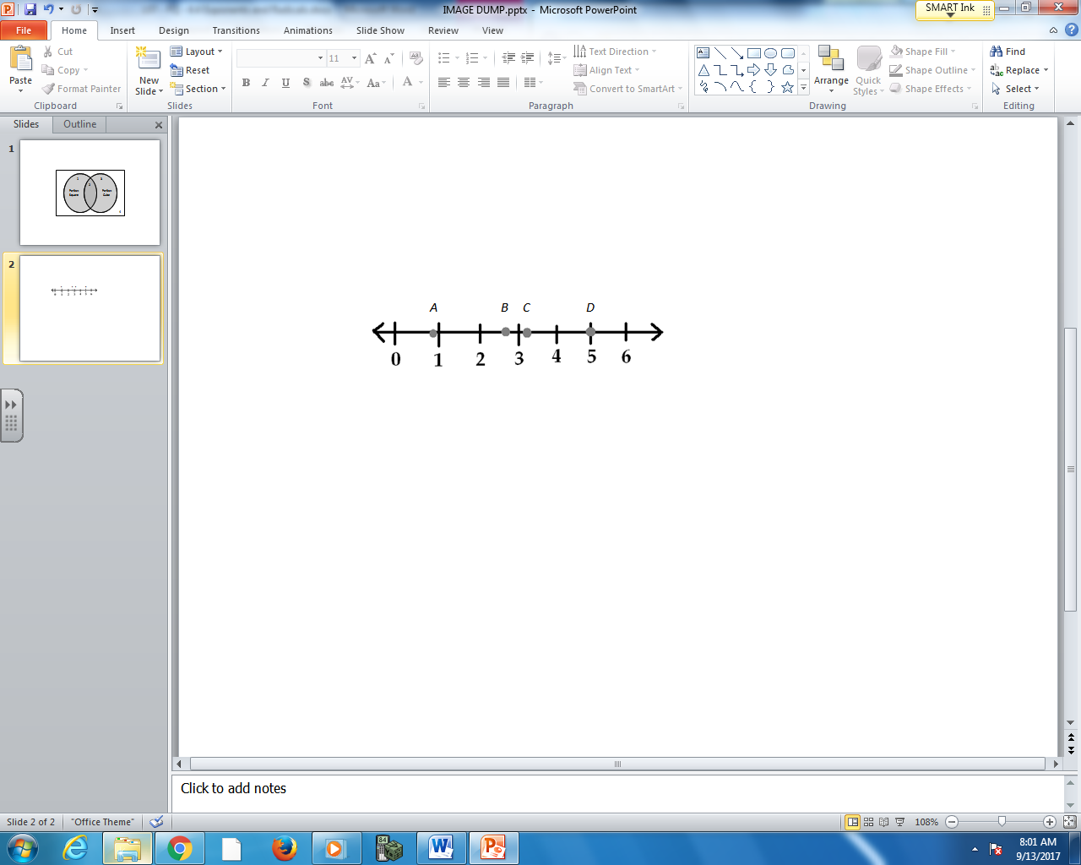

Q3: Where on the number line does the radical $\sqrt{\frac{27}{4}}$ fall?
- Position A
- Position B
- Position C
- Position D
Q4: Where on the number line does the radical $\sqrt{\frac{81}{100}}$ fall?
- Position A
- Position B
- Position C
- Position D

L01 – 4.1 Exponent Rules
Q5: The expression $x^{4}x^{8}$ simplifies to $x^{ab}$ , and the expression ${\left(x^{3}\right)}^{8}$ simplifies to $x^{cd}$. The values of a, b, c, and d are ___, ___, ___, and ___.
(Record your four digit answer in the Numerical Response boxes below)

Q6: The expression $\frac{{\left(x^{2}*x^{3}\right)}^{4}}{x^{5}}$ simplifies to
- $x^{4}$
- $x^{5}$
- $x^{15}$
- $x^{19}$

Q7: The expression $\frac{{\left(x^{4}y^{2}* x^{2}\right)}^{3}}{{\left(x^{3}\right)}^{3}}$ can be simplified to $x^{a}y^{b}$, where a and b are ___ and ___.
(Record your two digit answer in the Numerical Response boxes below)

L02 – 4.2 Integral Exponents
Use the following information to answer Q8-Q9:
The expression $\frac{{\left(x^{2}\right)}^{-3}{*x}^{8}}{x^{-2}}$ can be simplified.

Q8: The expression simplifies to $x^{a}$, where a is ____.
(Record your one digit answer in the Numerical Response boxes below)

Q9: When x = 4, what does the expression evaluate to?
(Record your three digit answer in the Numerical Response boxes below)

Q10: The expression $\frac{{\left(x^{2}y^{-3}\right)}^{4}*x^{3}z^{2}}{{\left({xy}^{2}\right)}^{-4}}$ simplifies to $\frac{x^{ab}z^{d}}{y^{c}}$ , where a, b, c, and d are ___, ___, ___, and ___.
(Record your four digit answer in the Numerical Response boxes below)

L04 – 4.3 Rational Exponents
Q11: The expression $x^{\frac{8}{3}}*x^{\frac{5}{9}}$ simplifies to $x^{\frac{ab}{c}}$ , where a, b, and c are ___, ___, and ___.
(Record your three digit answer in the Numerical Response boxes below)

Use the following information to answer Q12-Q14:
The expression $\frac{x^{\frac{2}{3}}*x^{\frac{3}{5}}}{{\left(x^{\frac{1}{4}}\right)}^{\frac{3}{2}}}$ can be simplified.

Q12: The numerator of the fraction simplifies to:
- $x^{\frac{5}{8}}$
- $x^{\frac{6}{15}}$
- $x^{\frac{19}{15}}$
- $x^{\frac{90}{225}}$
Q13: The denominator of the fraction simplifies to $x^{\frac{a}{b}}$ , where a and b are ___ and ___.
(Record your two digit answer in the Numerical Response boxes below)

Q14: (Long Answer) What does the entire expression simplify to, using positive exponents? (2 marks)
Q15: The expression $\frac{{\left(x^{3}\right)}^{\frac{1}{4}}}{x^{- \frac{2}{3}}}$ simplifies to $x^{\frac{ab}{cd}}$ , where a, b, c and d are ___, ___, ___ and ___.
(Record your four digit answer in the Numerical Response boxes below)

Q16: (Long Answer) Simplify the expression $\frac{{\left(x^{\frac{1}{4}}y^{-\frac{2}{3}}\right)}^{-\frac{5}{2}}}{{xy}^{-\frac{1}{4}}}$ with only positive exponents. (2 marks)

L05 – Entire to Mixed Radicals
Q17: The entire radical $\sqrt{50}$ can be converted to a mixed radical in the form $a\sqrt{b}$ , where a and b are ___ and ___.
(Record your two digit answer in the Numerical Response boxes below)

Q18: The entire radical $\sqrt{50x^{6}}$ can be converted to a mixed radical in the form ${ax}^{c}\sqrt{b}$ , where a, b and c are ___, ___ and ___.
(Record your three digit answer in the Numerical Response boxes below)

Q19: The entire radical $\sqrt[3]{24x^{8}}$ can be converted to a mixed radical in the form $ax^{b}\sqrt[3]{cx^{d}}$ , where a, b, c, and d are ___, ___, ___, and ___.
(Record your three digit answer in the Numerical Response boxes below)

Q20: (Long Answer) Convert the entire radical $\sqrt{60x^{7}y^{3}z}$ to a mixed radical. (2 marks)

L06 – Mixed to Entire Radicals
Q21: The mixed radical $x^{3}\sqrt{5x}$ can be written as an entire radical in the form $\sqrt{5x^{a}}$ , where a is ___.
(Record your one digit answer in the Numerical Response boxes below)

Q22: The mixed radical ${2x}^{2}y^{3}\sqrt{2x}$ can be written as an entire radical in the form $\sqrt{ax^{b}y^{c}}$ , where a, b, and c are ___, ___, and ___.
(Record your three digit answer in the Numerical Response boxes below)

Q23: (Long Answer) Convert the mixed radical $15x^{2}y^{3}z\sqrt[3]{2x^{2}z}$ to an entire radical. (2 marks)
L07 – Exponents to Radicals
Q24: The expression ${\left(x^{\frac{9}{4}}\right)}^{\frac{2}{3}}$ , when simplified, can be written as the entire radical $\sqrt[a]{x^{b}}$ , where a and b are ___ and ___.
(Record your two digit answer in the Numerical Response boxes below)

Q25: (Long Answer) Simplify the expression ${5x}^{- \frac{3}{2}}*{\left({2x}^{\frac{1}{3}}\right)}^{8}$ and write as a mixed radical. (2 marks)

