L08 – FQ – 6.4 Rational Equations

Q1: Determine the solution to $\frac{x+1}{x+2}=\frac{x+5}{x+7}$ and record your answer, to the nearest whole number, in the Numerical Response boxes below.

Q2: The solution to the equation $\frac{1}{x-2}+\frac{1}{x^{2}-7x+10}=\frac{6}{x-2}$ can be written as $x=\frac{ab}{c}$ , where a, b, and c are ___, ___, and ___.
(Record your three-digit answer in the Numerical Response boxes below)

Use the following information to answer Q3:
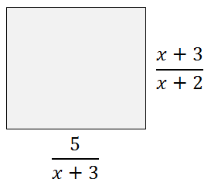

Q3: (Long Answer) If the perimeter of the object is $\frac{11}{x+2}$ , then determine the length of each side. (4 marks)

MARKING:
Beginning 0.0 – 2.5
Progressing 3.0 – 4.0
Competent 4.5 – 5.5
Exemplary 6.0

