L10 – 3.2 Standard Form
Key Ideas
Definitions:
- Quadratic Function: A function “f” whose value f(x) is given by a polynomial of degree two.
- Parabola: The symmetrical curve of the graph of a quadratic function.
- Vertex (of a Parabola): The lowest point of the graph when the graph opens upwards, or the highest point of the graph when the graph opens downwards.
- Minimum value of the function: The lowest value on the Range of a function. For a quadratic function that opens upwards, this would be the y-coordinate of the vertex.
- Maximum value of the function: The greatest value in the range of a function.
- Axis of Symmetry: A line through the vertex that divides the graph of a quadratic function into 2 congruent halves. The x-coordinate of the vertex defines the equation of the axis of symmetry.
Part 1 – Quadratic Functions Introduction
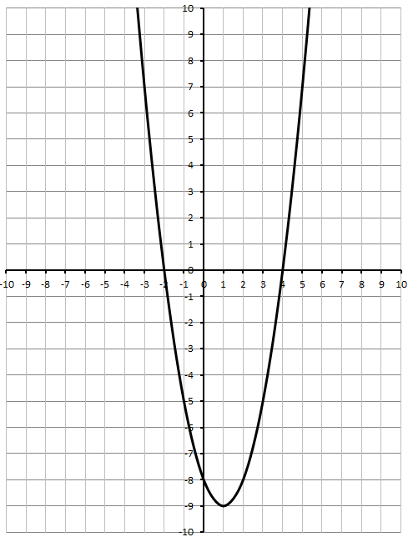
In the quadratic function $f\left(x\right)=x^{2}-2x-8$, what are the important points that you would need if you were to sketch the graph?

Part 2 – Standard Form Transformations
In the equation $\left(x\right)=ax^{2}+bx+c$ , what do adjusting a, b, and c actually do to the graph?
https://phet.colorado.edu/sims/html/graphing-quadratics/latest/graphing-quadratics_en.html
a –
b –
c –
Part 3 – Identifying Zeroes, Vertex, y-Intercept, and Axis of Symmetry from a Graph
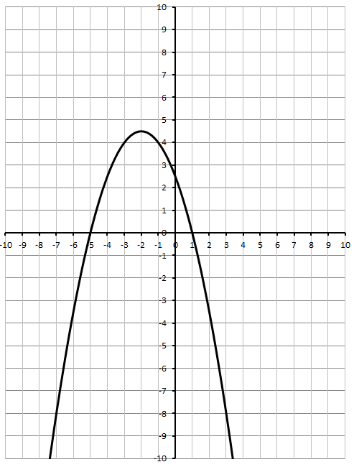
Zeroes:

Vertex:

y-Intercept:

Axis of Symmetry:
Maximum:

Part 4 – Domain and Range of a Quadratic Function
Domain: Range:

Part 5 – Identifying Zeroes, Vertex, y-Intercept, and Axis of Symmetry from a Graph (your turn)
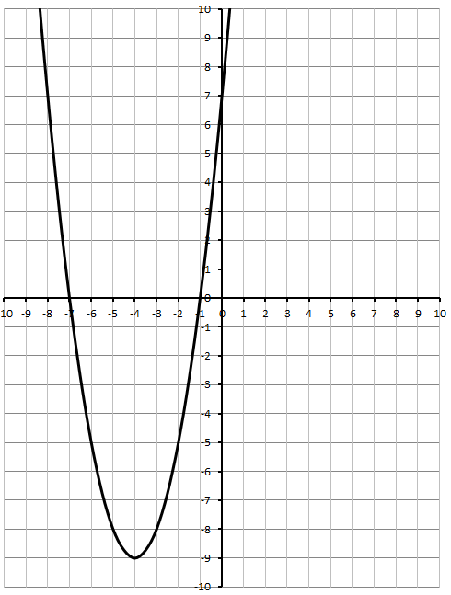
Zeroes:

Vertex:

y-Intercept:

Axis of Symmetry:

Minimum:

Part 6 – Domain and Range of a Quadratic Function (your turn)
Domain: Range:

Part 7 – Using a T.I. Calculator to find Vertex and Zeroes
- With your calculator, graph $f\left(x\right)=x^{2}-3x+4$
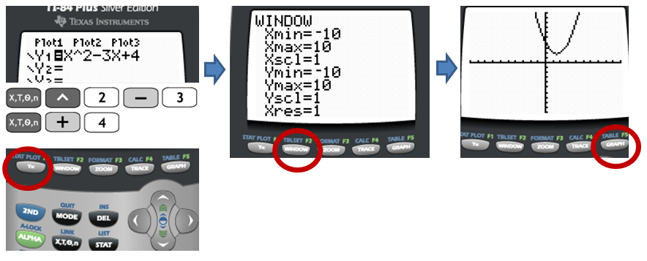
- Find the Max/Min/Vertex
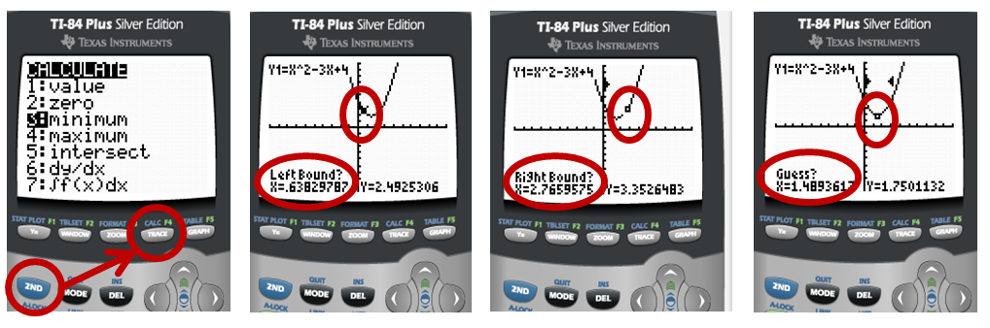
- Find the Zeroes
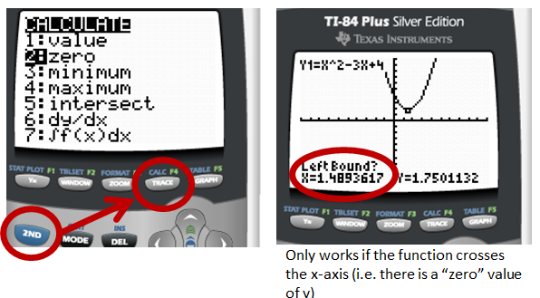

Using your T.I. Calculator, and given the function $\left(x\right)=-x^{2}-9x-18$ , find
- The Vertex
- The Maximum value of f(x)
- The Zeroes
- The equation for the Axis of Symmetry
Sketch a quick graph below using these values.
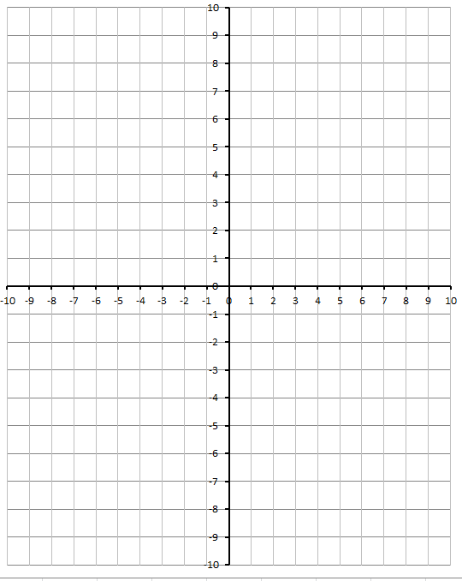
Part 8 – Using Factoring to Find Zeroes
In the quadratic function $f\left(x\right)=x^{2}-2x-8$, for what value of y are the “zeroes” found? Can we determine these values algebraically using factoring?

What is the equation for the axis of symmetry?

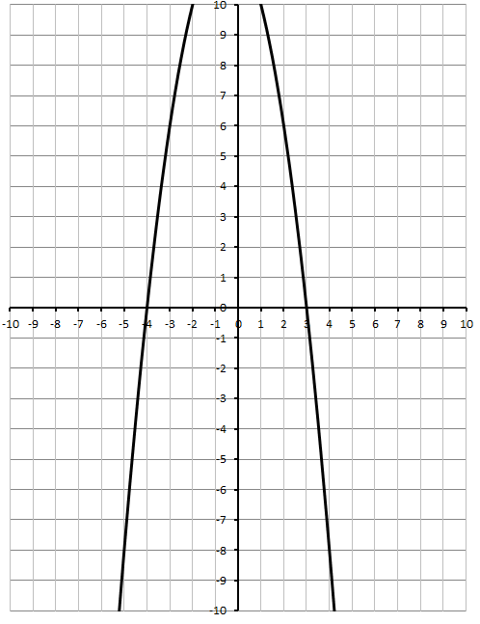
In the quadratic function $\left(x\right)=-x^{2}-x+12$ , for what value of y are the “zeroes” found? Can we determine these values algebraically using factoring?

What is the equation for the axis of symmetry?
Part 9 – Using Calculus to Find Vertex (Optional – Will not be assessed)
$$y=ax^{2}+bx+c$$
$$y=2x^{2}-5x-3$$
Step #1: Take the derivative using Math 31 techniques.
The derivative of $ax^{n} +bx^{n-1} +…+yx+z$
is $\left(n\right)ax^{n-1} +\left(n-1\right)bx^{n-2}+…+y$
$$y^{'}=4x-5$$
Step #2: This is our slope equation, where $y^{'} is our slope$. Set the slope, $y^{'}$, equal to zero.
$$0=4x-5$$
$x=\frac{5}{4}$
Step #3: We now know the x-value at which our tangent’s slope is zero. This occurs at the vertex. So
plug this value back into the original equation to find the y-coordinate of the vertex too.
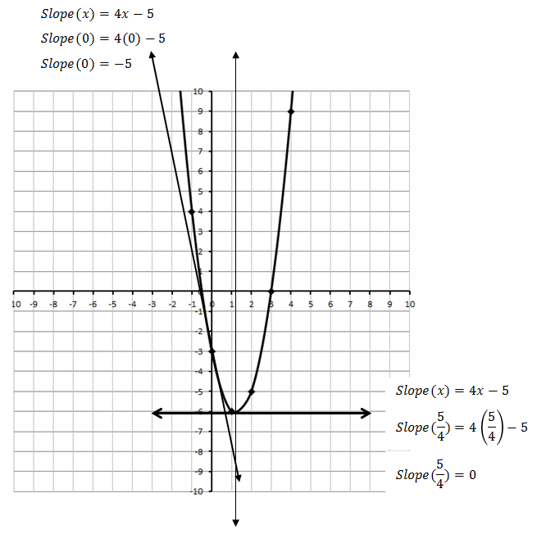
$y=2x^{2}-5x-3$
$y=2{\left(\frac{5}{4}\right)}^{2}-5\left(\frac{5}{4}\right)-3$
$y=2\left(\frac{25}{16}\right)-5\left(\frac{5}{4}\right)-3$
$y=\frac{25}{8}-\frac{25}{4}-3$
$y=-\frac{49}{8}$
So the vertex is along the axis of symmetry, located at $\left(\frac{5}{4},-\frac{49}{8}\right)$, or approximately (1.25, -6.125).

Part 10 – Putting it all together
Given the equation $f\left(x\right)=x^{2}-4x-5$ ,
- Use factoring to determine the Zeroes.

- Use the zeroes to determine the axis of symmetry.

- Use the method of your choice to determine the coordinates of the vertex.
  - Option #1: Use your T.I. Calculator
  - Option #2: Use the x-coordinate (from the axis of symmetry) to find y.
  - Option #3: Use calculus to find the x-value, then solve for the y-value.

- Sketch a graph of the function, with clearly labelled (i) vertex, (ii) zeroes, (iii) axis of symmetry, and (d) y-intercept value.
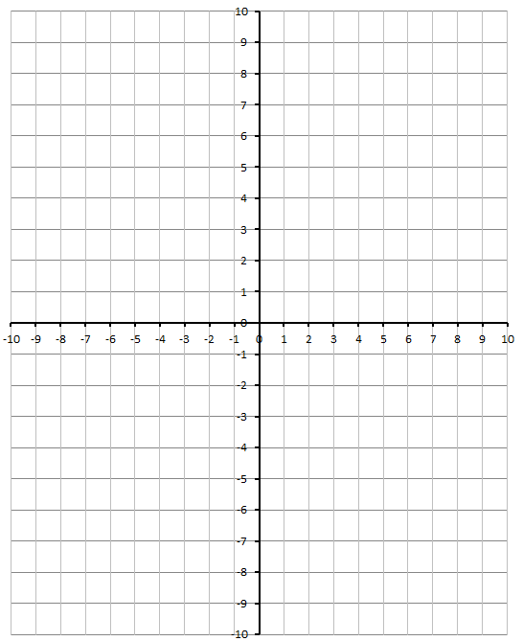
- State the Domain and Range for the function.

