Graphing a Quadratic Function using a Calculator
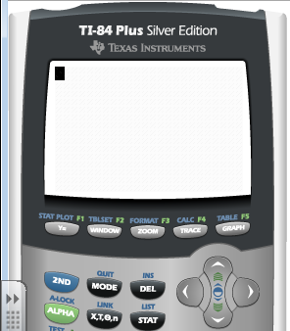
Step 1: Press ‘Y=’

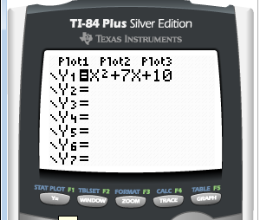
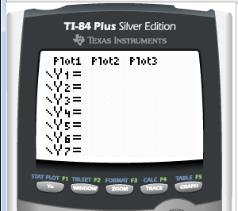
Step 2: Type the function in Y₁

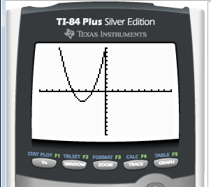
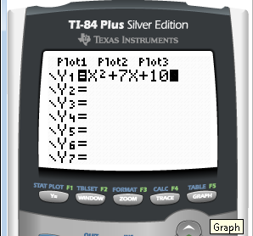
Step 3: Press ‘GRAPH’

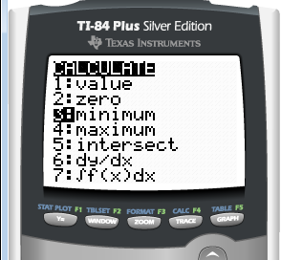
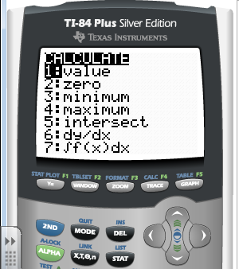
Step 4: Press ‘2nd’ ‘TRACE’
Select ‘3: minimum’
Press ‘ENTER’

Step 5: Move the cursor to the left so that it is on the left side of the vertex. Press ‘ENTER’
Move the cursor to the right so that it is on the right side of the vertex. Press ‘ENTER’
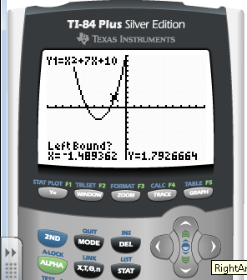
Press ‘ENTER’ a third time to calculate the minimum.
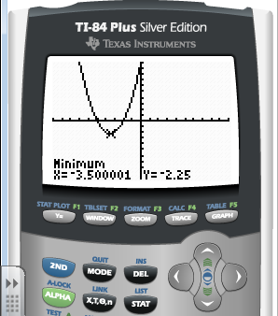
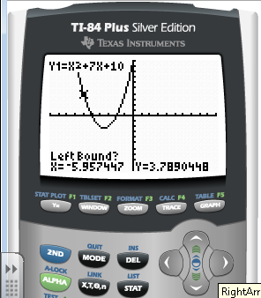

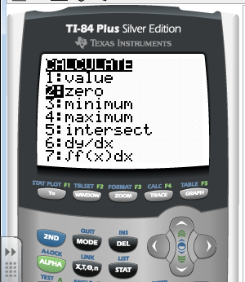
Step 6: Finding the x-intercepts:
Press ‘2nd’ ‘TRACE’
Scroll down to ‘2: zero’
Press ‘ENTER’

Step 7: Move the cursor to the left so that it is on the left side of the x-intercept. Press ‘ENTER’
Move the cursor to the right so that it is on the right side of the x-intercept. Press ‘ENTER’
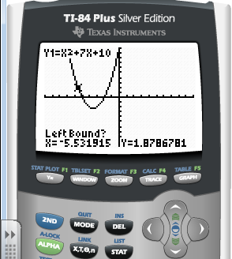
Press ‘ENTER’ a third time to calculate the zero.
