Working with Standard Form
$$y=ax^{2}+bx+c$$
$$y=2x^{2}-5x-3$$
Finding the Zeroes
$x=\frac{-b±\sqrt{b^{2}-4ac}}{2a}$ $=\frac{-(-5)±\sqrt{5^{2}-4(2)(-3)}}{2(2)}=\frac{5±\sqrt{25+24}}{4}=\frac{5±\sqrt{49}}{4}$
$x_{1}=\frac{5+7}{4}=3$ $x_{2}=\frac{5-7}{4}=-\frac{1}{2}$
(3,0) (-½,0)

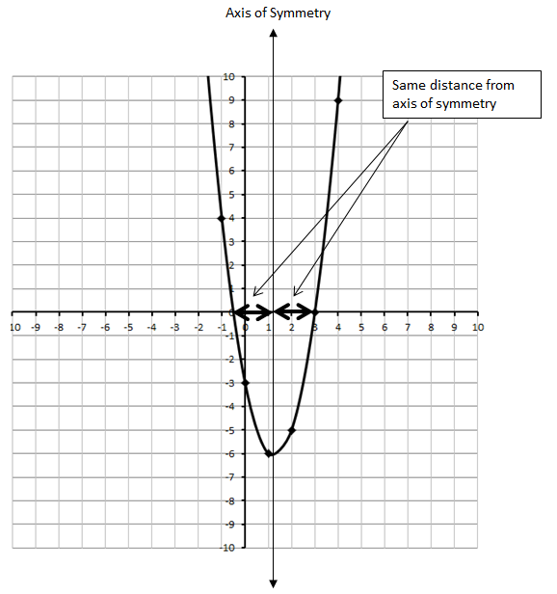
Finding the Vertex
Axis of symmetry is exactly halfway between the zeroes. Average the two points.
$x_{sym}=\frac{\left(3\right)+(-\frac{1}{2})}{2}=\frac{5}{4}$
Now plug this x-value back into the original equation to get the y-value of the vertex coordinate.
$y=2x^{2}-5x-3$
$y=2{\left(\frac{5}{4}\right)}^{2}-5\left(\frac{5}{4}\right)-3$
$y=2\left(\frac{25}{16}\right)-5\left(\frac{5}{4}\right)-3$
$y=\frac{25}{8}-\frac{25}{4}-3$
$y=-\frac{49}{8}$
So the vertex is along the axis of symmetry, located at $\left(\frac{5}{4},-\frac{49}{8}\right)$, or approximately (1.25, -6.125).

Conversions from Standard Form
$$y=ax^{2}+bx+c$$
$$y=2x^{2}-5x-3$$
Converting to Vertex Form
$$y=2x^{2}-5x-3$$
Step #1: Group the first two terms.
$$y=(2x^{2}-5x)-3$$
Step #2: Factor out the “a” coefficient.
$y=2\left(x^{2}-\frac{5}{2}x\right)-3$
Step #3: Split the second term into two equal parts.
$y=2\left(x^{2}-\frac{5}{4}x-\frac{5}{4}x\right)-3$ where $\left(x-\frac{5}{4}\right) \left(x-\frac{5}{4}\right)=x^{2}-\frac{5}{4}x-\frac{5}{4}x+\frac{25}{16}$
Step #4: It sure would be nice if the stuff in the brackets were factorable. So add a $\frac{25}{16}$ into the brackets.
But remember… we actually added $2\left(\frac{25}{16}\right)$, so we need to subtract the same amount of $\frac{25}{8}$ from the
end.
$y=2\left(x^{2}-\frac{5}{4}x-\frac{5}{4}x+\frac{25}{16}\right)-3-\frac{25}{8}$
Step #5: Now simplify to finish converting to Vertex Form.
$y=2{\left(x-\frac{5}{4}\right)}^{2}-\frac{49}{8}$

Converting to Factored Form
$y=2x^{2}-5x-3$
+1 -6
□ + □ = -5
□ + □ = -6
Step #1: Factor using the method of your choice. I used decomposition.
$$y=2x^{2}+1x-6x-3$$
$$y=\left(2x^{2}+1x\right)+(-6x-3)$$
$$y=x\left(2x+1\right)-3(2x+1)$$
$$y=(2x+1)(x-3)$$
Working with Vertex Form
$$y=a{\left(x-h\right)}^{2}+k$$
$y=2{\left(x-\frac{5}{4}\right)}^{2}-\frac{49}{8}$
Finding Zeroes
Zeroes (or x-intercepts) occur when y=0. So start by setting y=0, then solve for your x-value(s).
$0=2{\left(x-\frac{5}{4}\right)}^{2}-\frac{49}{8}$
$\frac{49}{8}=2{\left(x-\frac{5}{4}\right)}^{2}$
$\frac{49}{16}={\left(x-\frac{5}{4}\right)}^{2}$
$\sqrt{\frac{49}{16}}=\sqrt{{\left(x-\frac{5}{4}\right)}^{2}}$
$±\frac{7}{4}=x-\frac{5}{4}$
$x_{1}=+\frac{7}{4}+\frac{5}{4}=$ 3 $x_{2}=-\frac{7}{4}+\frac{5}{4}=-\frac{1}{2}$
(3,0) (-½,0)

Finding the Vertex
$$y=a{\left(x-h\right)}^{2}+k$$
$y=2{\left(x-\frac{5}{4}\right)}^{2}-\frac{49}{8}$
The vertex is located at $\left(\frac{5}{4},-\frac{49}{8}\right)$, or approximately (1.25, -6.125).

Conversions from Vertex Form
$$y=a{\left(x-h\right)}^{2}+k$$
$y=2{\left(x-\frac{5}{4}\right)}^{2}-\frac{49}{8}$
Converting to Standard Form
$y=2{\left(x-\frac{5}{4}\right)}^{2}-\frac{49}{8}$
Step #1: Simplify the brackets.
$y=2\left(x-\frac{5}{4}\right)\left(x-\frac{5}{4}\right)-\frac{49}{8}$
$y=2\left(x^{2}-\frac{5}{4}x-\frac{5}{4}x+\frac{25}{16}\right)-\frac{49}{8}$
$y=2\left(x^{2}-\frac{5}{2}x+\frac{25}{16}\right)-\frac{49}{8}$
Step #2: Multiply through the brackets.
$y=\left(2x^{2}-5x+\frac{25}{8}\right)-\frac{49}{8}$
Step #3: Simplify.
$y=2x^{2}-5x-3$

Converting to Factored Form
Step #1: Convert to Standard Form.
$y=2x^{2}-5x-3$
+1 -6
□ + □ = -5
□ + □ = -6
Step #2: Factor using the method of your choice. I used decomposition.
$$y=2x^{2}+1x-6x-3$$
$$y=\left(2x^{2}+1x\right)+(-6x-3)$$
$$y=x\left(2x+1\right)-3(2x+1)$$
$$y=(2x+1)(x-3)$$

Working with Factored Form
$$y=a(bx+c)(dx+e)$$
$$y=1(2x+1)(x-3)$$
Finding the Zeroes
Zeroes (or x-intercepts) occur when y=0. So start by setting y=0, then solve for your x-value(s).
$$0=(2x+1)(x-3)$$
This happens when either $\left(2x+1\right)=0$ or when $\left(x-3\right)=0$.
$\left(2x+1\right)=0$ $\left(x-3\right)=0$
$2x=-1$ $x=3$
$x=-\frac{1}{2}$
(-½,0) (3,0)

Finding the Vertex
Axis of symmetry is exactly halfway between the zeroes. Average the two points.
$x_{sym}=\frac{\left(3\right)+(-\frac{1}{2})}{2}=\frac{5}{4}$
Now plug this x-value back into the original equation to get the y-value of the vertex coordinate.
$y=2x^{2}-5x-3$
$y=2{\left(\frac{5}{4}\right)}^{2}-5\left(\frac{5}{4}\right)-3$
$y=2\left(\frac{25}{16}\right)-5\left(\frac{5}{4}\right)-3$
$y=\frac{25}{8}-\frac{25}{4}-3$
$y=-\frac{49}{8}$
So the vertex is along the axis of symmetry, located at $\left(\frac{5}{4},-\frac{49}{8}\right)$, or approximately (1.25, -6.125).

Conversions from Factored Form
$$y=a(bx+c)(dx+e)$$
$$y=1(2x+1)(x-3)$$
Converting to Standard Form
$$y=(2x+1)(x-3)$$
Step #1: Multiply the binomials.
$$y=2x^{2}-6x+1x-3$$
$$y=2x^{2}-5x-3$$

Converting to Vertex Form
Step #1: First convert to Standard Form.
$$y=2x^{2}-5x-3$$
Step #2: Group the first two terms.
$$y=(2x^{2}-5x)-3$$
Step #3: Factor out the “a” coefficient.
$y=2\left(x^{2}-\frac{5}{2}x\right)-3$
Step #4: Split the second term into two equal parts.
$y=2\left(x^{2}-\frac{5}{4}x-\frac{5}{4}x\right)-3$ where $\left(x-\frac{5}{4}\right) \left(x-\frac{5}{4}\right)=x^{2}-\frac{5}{4}x-\frac{5}{4}x+\frac{25}{16}$
Step #5 It sure would be nice if the stuff in the brackets were factorable. So add a $\frac{25}{16}$ into the brackets.
But remember… we actually added $2\left(\frac{25}{16}\right)$, so we need to subtract the same amount of $\frac{25}{8}$ from the
end.
$y=2\left(x^{2}-\frac{5}{4}x-\frac{5}{4}x+\frac{25}{16}\right)-3-\frac{25}{8}$
Step #6: Now simplify to finish converting to Vertex Form.
$y=2{\left(x-\frac{5}{4}\right)}^{2}-\frac{49}{8}$

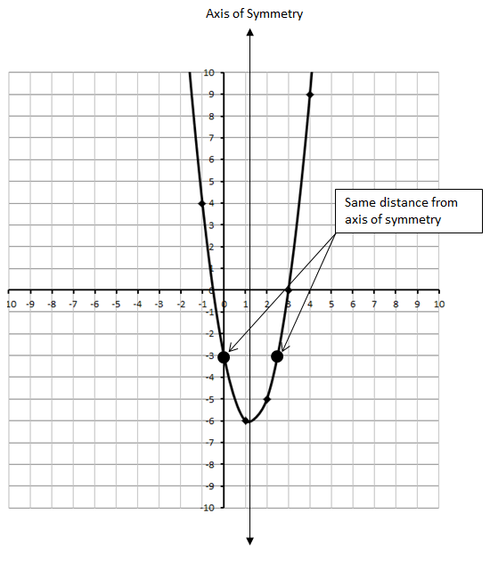
Alternate Methods of finding the Vertex
$$y=ax^{2}+bx+c$$
$$y=2x^{2}-5x-3$$
Partial Factoring
$$y=2x^{2}-5x-3$$
Step #1: Group the first two terms.
$$y=\left(2x^{2}-5x\right)-3$$
Step #2: Common factor the brackets.
$$y=x\left(2x-5\right)-3$$
Step #3: When the “x(2x-5)” term is zero, y=-3. This occurs twice… once at x=0, and second time
elsewhere. Find these two locations where y=-3 by setting “x(2x-5)” equal to zero.
$$x\left(2x-5\right)=0$$
Option #1: Option #2:
$x=0$ $2x-5=0$
$x=\frac{5}{2}$
Step #4: So we now have to symmetrical data points: (0,-3) and $\left(\frac{5}{2},-3\right)$. The vertex should be exactly
halfway between these data points. Average their x-values.
$x_{sym}=\frac{\left(0\right)+(\frac{5}{2})}{2}=\frac{5}{4}$
Now plug this x-value back into the original equation to get the y-value of the vertex coordinate.
$y=2x^{2}-5x-3$
$y=2{\left(\frac{5}{4}\right)}^{2}-5\left(\frac{5}{4}\right)-3$
$y=2\left(\frac{25}{16}\right)-5\left(\frac{5}{4}\right)-3$
$y=-\frac{49}{8}$
So the vertex is along the axis of symmetry, located at $\left(\frac{5}{4},-\frac{49}{8}\right)$, or approximately (1.25, -6.125).

Calculus
$$y=ax^{2}+bx+c$$
$$y=2x^{2}-5x-3$$
Step #1: Take the derivative using Math 31 techniques.
The derivative of $ax^{n} +bx^{n-1} +…+yx+z$
is $\left(n\right)ax^{n-1} +\left(n-1\right)bx^{n-2}+…+y$
$$y^{'}=4x-5$$
Step #2: This is our slope equation, where $y^{'} is our slope$. Set the slope, $y^{'}$, equal to zero.
$$0=4x-5$$
$x=\frac{5}{4}$
Step #3: We now know the x-value at which our tangent’s slope is zero. This occurs at the vertex. So
plug this value back into the original equation to find the y-coordinate of the vertex too.
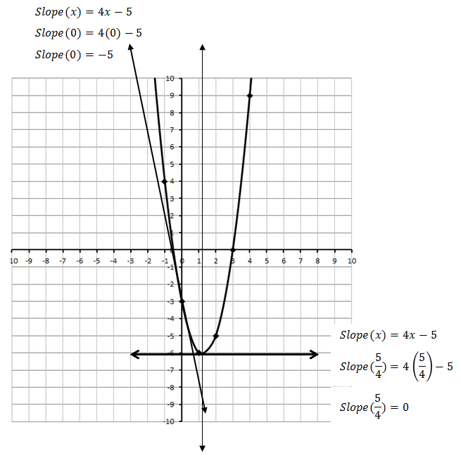
$y=2x^{2}-5x-3$
$y=2{\left(\frac{5}{4}\right)}^{2}-5\left(\frac{5}{4}\right)-3$
$y=2\left(\frac{25}{16}\right)-5\left(\frac{5}{4}\right)-3$
$y=\frac{25}{8}-\frac{25}{4}-3$
$y=-\frac{49}{8}$
So the vertex is along the axis of symmetry, located at $\left(\frac{5}{4},-\frac{49}{8}\right)$, or approximately (1.25, -6.125).

