L10 – Worksheet – 3.2 Investigating Quadratic Functions in Standard Form
Pg 174 #1abd: Which functions are quadratic? Explain.
$f\left(x\right)=2x^{2}+3x$ $f\left(x\right)=5-3x$ $f\left(x\right)=(2x-5)(3x-2)$

Pg 174 #2: Complete the table for each graph:
Graph: | Coordinates of the vertex | Equation of the axis of symmetry | x- and y- intercepts | Maximum or minimum value | Domain and Range
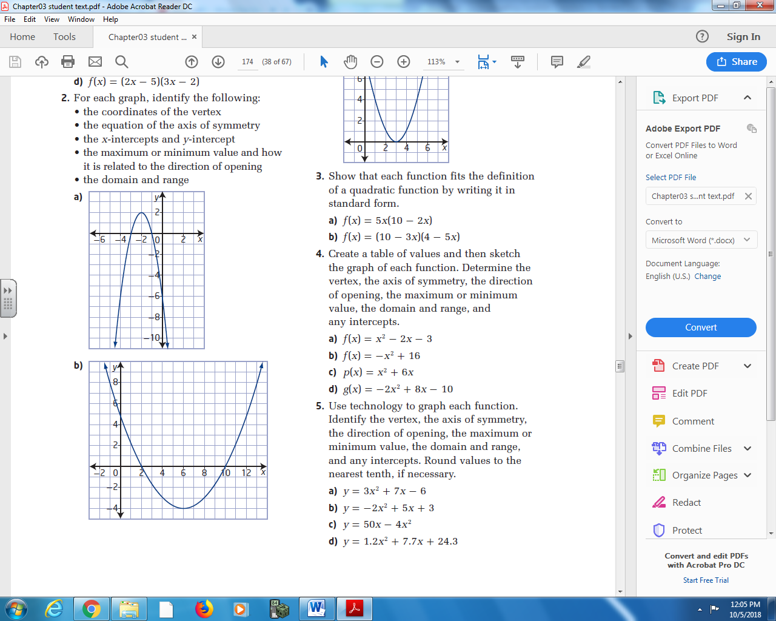
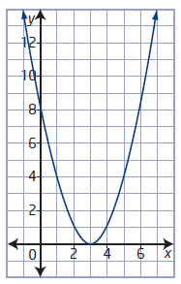
Pg 174 #4ab: Create a table of values and then sketch the graph of each function. Determine thee vertex, the axis of symmetry, the direction of opening, the maximum or minimum value, the domain and range, and any intercepts.
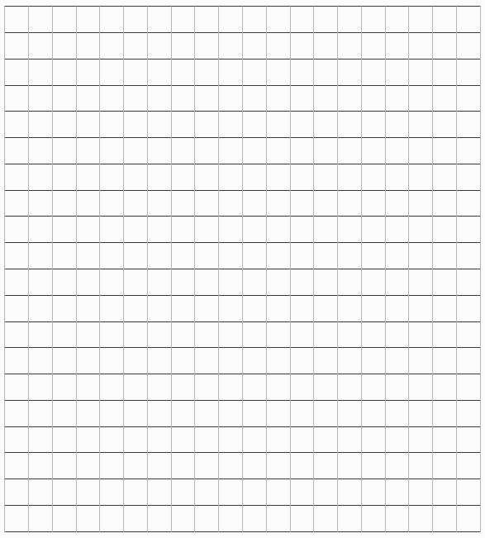
- $f\left(x\right)=x^{2}-2x-3$

- $f\left(x\right)=-x^{2}+16$

Pg 174 #4cd: Create a table of values and then sketch the graph of each function. Determine thee vertex, the axis of symmetry, the direction of opening, the maximum or minimum value, the domain and range, and any intercepts.
- $p\left(x\right)=x^{2}+6x$

- $g\left(x\right)=-2x^{2}+8x-10$

Pg 174 #5: Use technology to graph each function. Identify the vertex, the axis of symmetry, the direction of opening, the maximum or minimum value, the domain and range, and any intercepts. Round values to the nearest tenth, if necessary.

To find the vertex:
- 2ND, CALC
- Min (3) or Max (4)
- Set left/right bounds
To find the Zeroes:
- 2ND, CALC
- Zero (2)
- Set left/right bounds
To find the y-intercept:
- 2ND, CALC
- Value (1)
- X=0

 | Sketch | Vertex | Zeroes | Y-Intercept
$$f\left(x\right)=3x^{2}+7x-6$$
$$f\left(x\right)=-2x^{2}+5x+3$$
$$f\left(x\right)=50x-4x^{2}$$
$$f\left(x\right)=1.2x^{2}+7.7x+24.3$$
Pg 174 #7: A siksik, and Arctic ground squirrel, jumps from a rock, travels through the air, and then lands on the tundra. The graph shows the height of its jump as a function of time. Use the graph to answer each of the following, and identify which characteristic(s) of the graph you used in each case.
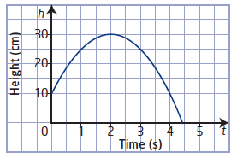
 | Answer | Graph Characteristics
a. What is the height of the rock that the siksik jumped from?
b. What is the maximum height of the siksik? When did it reach that height?
c. How long was the siksik in the air?
d. What are the domain and range in this situation?
e. Would this type of motion be possible for a siksik in real life? Use your answers to parts (a) and (d) to answer why or why not.

Pg 174 #11: Satellite dish antennas have the shape of a parabola. Consider a satellite dish that is 80 cm across. Its cross-sectional shape can be described by the function $\left(x\right)=0.0125x^{2}-x$ , where d is the depth, in centimeters, of the dish at a horizontal distance of x centimeters from one edge of the dish.
- What is the domain of this function?

- Graph the function to show the cross-sectional shape of the satellite dish.

- What is the maximum depth of the dish? Does this correspond to the maximum value of the function? Explain.

- What is the range of the function?

- How deep is the dish at a point 25 cm from the edge of the dish?
Pg 174 #12: A jumping spider jumps from a log onto the ground below. Its height, h, in centimeters, as a function of time, t, in seconds, since it jumped can be modelled by the function
$h\left(t\right)=-490t^{2}+75t+12$ . Where appropriate, answer the following questions to the nearest tenth.
- Graph the function.

- What does the h-intercept represent?

- When does the spider reach its maximum height? What is its maximum height?

Pg 174 #15: a. Write a function to represent the area of the rectangle. Show that the function fits the definition of a quadratic function.
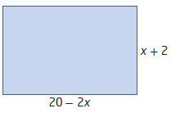
- Graph the function.

- What do the x-intercepts represent in this situation? How do they relate to the dimensions of the rectangle?

- What information does the vertex give about this situation?

- What are the domain and range? What do they represent in this situation?

