L11 – FQ – 3.2 Standard Form
Use the following information to answer Q1-Q4:
$$f\left(x\right)=-\frac{1}{2}x^{2}-2x+6$$

Q1: The function opens __i__, and has a y-intercept of __ii__.
 | i | ii
A. | Up | -6
B. | Up | +6
C. | Down | -6
D. | Down | +6

Q2: The zeroes of the function are x = -a, x = b, where a and b are ___ and ___.
(Record your two-digit answer in the Numerical Response boxes below)

Q3: Determine the coordinates of the vertex. (2 marks)
Q4: Sketch the graph, labelling (a) Vertex, (b) Zeroes, (c) y-Intercept, and (d) Axis of Symmetry.
(1/2 mark each; 2 marks total)
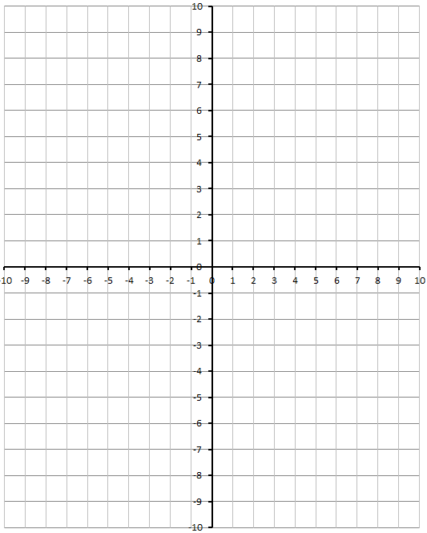

MARKING:
Beginning 0.0 – 2.5
Progressing 3.0 – 4.0
Competent 4.5 – 5.5
Exemplary 6.0

