L11 – 3.1 Vertex Form
Key Ideas
Definitions:
- Vertex Form uses the Vertex (p,q) to quickly build the equation. Similar to “Slope-Point Form” in Math 10C
- Vertex Form $y=a{\left(x-p\right)}^{2}+q$ is easier to sketch than Standard Form $y=ax^{2}+bx+c$
- In Math 20-2, the vertex is labelled (h,k), making the equation $y=a{\left(x-h\right)}^{2}+k$
Part 1 – Vertex Form Transformations
In the equation $f\left(x\right)=a{\left(x-p\right)}^{2}+q$, what do adjusting a, p, and q actually do to the graph?
https://phet.colorado.edu/sims/html/graphing-quadratics/latest/graphing-quadratics_en.html
a –
p –
q –

$f(x)=1{(x-0)}^{2}+0$ $g\left(x\right)=1{(x-5)}^{2}-2$
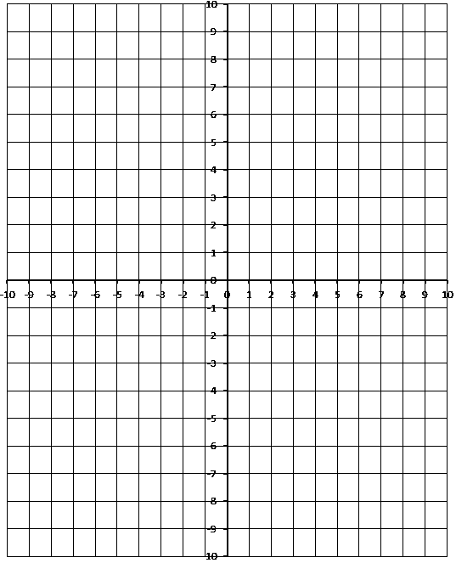

$h\left(x\right)=-1{(x-0)}^{2}+0$ $k\left(x\right)=2{(x-0)}^{2}+0$

$m\left(x\right)=0.5{(x-0)}^{2}+0$ $n\left(x\right)=0.5{(x+2)}^{2}+3$
Part 2 – Building an Equation using Vertex and a Point
Q1: A parabola has a vertex at (3,5) and passes through the point (1,9). Determine the equation of the line in Vertex Form.

Q2: A parabola has a vertex at (-4,6) and passes throught the point (-2,2). Determine the equation of the line in Vertex Form.

Q3: A parabola has a vertex at (0,6) and passes through the point (3,3). Determine the equation of the line in Vertex Form.

Part 3 – Converting to Standard Form, $f\left(x\right)=ax^{2}+bx+c$
Q4: Convert $y=2{\left(x-3\right)}^{2}+6$ into Standard Form.

Q5: Convert $f(x)=\frac{1}{2}{\left(x+2\right)}^{2}-8$ into Standard Form.

Q6: Convert $g\left(x\right)=3{\left(x-1\right)}^{2}+12$ into Standard Form.

Part 4 – Finding the Vertex, Axis of Symmetry, and Zeroes using Vertex Form
Use the following information to answer Q7-Q10:
$$f\left(x\right)=4{\left(x+\frac{1}{4}\right)}^{2}-\frac{81}{4}$$

Q7: Determine the coordinate of the Vertex.

Q8: Determine the equation of the Axis of Symmetry.

Q9: Convert to Standard Form to find the y-Intercept.

Q10: Determine the zeroes.
From Vertex Form From Standard Form

Use the following information to answer Q11-Q15:
$$g\left(x\right)=1{\left(x-1\right)}^{2}-9$$

Q11: Determine the coordinate of the Vertex.

Q12: Determine the equation of the Axis of Symmetry.

Q13: Convert to Standard Form to find the y-Intercept.

Q14: Determine the zeroes.
From Vertex Form From Standard Form

Q15: Sketch the function g(x) below.
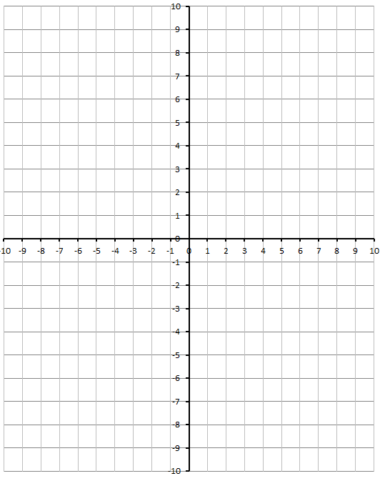

Part 5 – Projectile Motion using Vertex Form
Q16: A frog is standing on a 30cm tall rock. It jumps through the air, reaching a maximum height of 50cm when it is a horizontal distance of 15cm from the rock. How far from the base of the rock does the frog land?
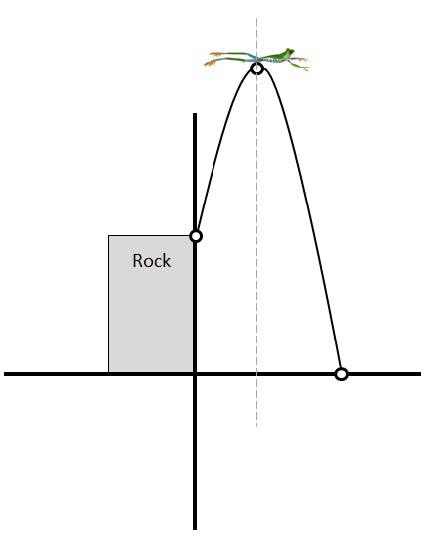

Q17: State the Domain and Range of the function.

