L11 – 5.1 Multiplying Polynomials
Part 1 – Polynomial Terminology
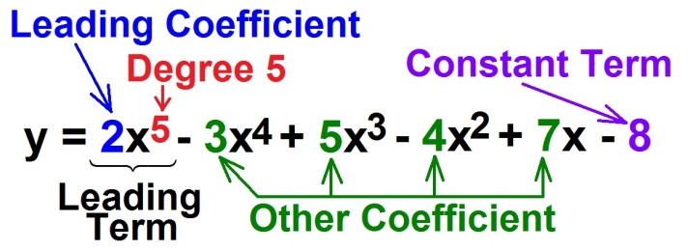
Q1: Complete the following table:
Polynomial | Leading Coefficient | Degree | Constant | Number of Terms | Type of Polynomial
$$2x^{2}-5x+6$$
$$x^{2}-49$$
$${-2x}^{3}+6x^{2}-8$$

Part 2 – Modelling Polynomials with Tiles
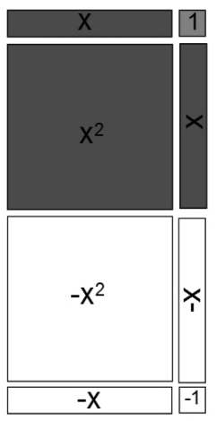
Q2: Model the following polynomials:
$x^{2}+3x+1$ ${2x}^{2}+5$ $x^{2}+x+2$

${-x}^{2}+2x+1$ $x^{2}-3x+1$ ${-2x}^{2}-3x-2$

Part 3 – Adding and Subtracting Polynomials with Tiles
Q3: Simplify $\left(x^{2}+5x+2\right)+\left({2x}^{2}-3x-5\right)$ Q4: Simplify $\left({2x}^{2}-2x+6\right)-\left(x^{2}+3x-2\right)$

Part 4 – Adding and Subtracting Polynomials without Tiles
Q5: Simplify $\left(x^{2}+5x+2\right)+\left({2x}^{2}-3x-5\right)$ Q6: Simplify $\left({2x}^{2}-2x+6\right)-\left(x^{2}+3x-2\right)$

Q7: Simplify $\left(2x-5\right)-\left(x^{2}-3\right)+\left(x^{2}+6\right)$ Q8: Simplify $\left({2x}^{2}\right)+\left(5x-2y\right)-\left(x^{2}-3x\right)$
Part 5 – Multiplying Polynomials with Tiles
Q9: Simplify $2x\left(3x+1\right)$ Q10: Simplify $\left(3x\right)\left(2x-1\right)$

Q11: Simplify $\left(x+1\right)\left(x+2\right)$ Q12: Simplify $\left(2x+1\right)\left(x-3\right)$

Q13: Simplify $\left(2x+1\right)\left(3x-1\right)$ Q14: Simplify $\left(3x+2\right)\left(2x-3\right)$

Part 6 – Multiplying Polynomials without Tiles
Q15: Simplify $2x\left(3x+1\right)$ Q16: Simplify $\left(3x\right)\left(2x-1\right)$

Q17: Simplify $\left(x+1\right)\left(x+2\right)$ Q18: Simplify $\left(2x+1\right)\left(x-3\right)$

Q19: Simplify $\left(2x+1\right)\left(3x-1\right)$ Q20: Simplify $\left(3x+2\right)\left(2x-3\right)$

Part 7 – Harder Questions
Q21: Simplify $\left(x+2\right)\left(x^{2}-2x+5\right)$ Q22: Simplify ${\left(x+5\right)}^{2}$

Q23: Simplify ${\left(a-3\right)}^{2}+\left(a+4\right)\left(2a-3\right)$

Part 8 – Textbook Practice
Pg 209 #1ace, 2, 3acef, 4acef, 6ab

