L11 – Worksheet – 3.1 Investigating Quadratic Functions in Vertex Form
Pg 157 #2ab: Describe how the graphs of the functions in each pair are related. Then, sketch the graph of the second function in each pair, and determine the vertex, the equation of the axis of symmetry, the domain and range, and any intercepts.
Equations | Graph of Second Function | Vertex | Equation of the Axis of Symmetry | Domain and Range | Intercepts
$$y=x^{2}$$  $$y=x^{2}+1$$ | 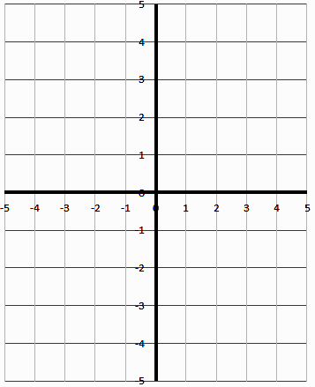
$$y=x^{2}$$
$$y={\left(x-2\right)}^{2}$$

Pg 157 #2cd: Describe how the graphs of the functions in each pair are related. Then, sketch the graph of the second function in each pair, and determine the vertex, the equation of the axis of symmetry, the domain and range, and any intercepts.
Equations | Graph of Second Function | Vertex | Equation of the Axis of Symmetry | Domain and Range | Intercepts
$$y=x^{2}$$
$$y=x^{2}-4$$
$$y=x^{2}$$
$$y={\left(x+3\right)}^{2}$$
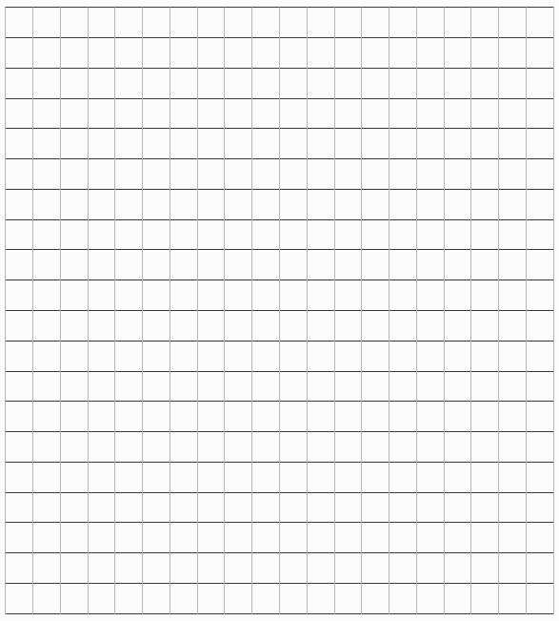
Pg 157 #4ab: Sketch the graph of each function. Identify the vertex, the axis of symmetry, the direction of opening, the maximum or minimum value, the domain and range, and any intercepts.
- $y=-{\left(x-3\right)}^{2}+9$

- $y=0.25{\left(x+4\right)}^{2}+1$
Pg 157 #4cd: Sketch the graph of each function. Identify the vertex, the axis of symmetry, the direction of opening, the maximum or minimum value, the domain and range, and any intercepts.
- $y=-{3\left(x-1\right)}^{2}+12$

- $y=\frac{1}{2}{\left(x-2\right)}^{2}-2$
Pg 157 #5: Given each parabola in the graph below:
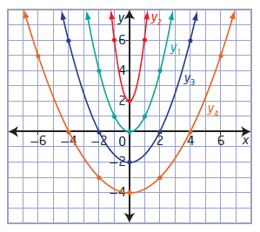
 | a) Write a quadratic function in vertex form for each parabola in the graph. | b) Suppose four new parabolas open downward instead of upward but have the same shape and vertex as each parabola in the graph. Write a quadratic function in vertex form for each new parabola. | c) Write the quadratic functions in vertex form of four parabolas that are identical to the four in the graph but translated 4 units to the left. | d) Suppose the four parabolas in the graph are translated 2 units down. Write a quadratic function in vertex form for each new parabola.
y₁
y₂
y₃
y₄

Pg 157 #8: Determine the quadratic function in vertex form for each parabola.
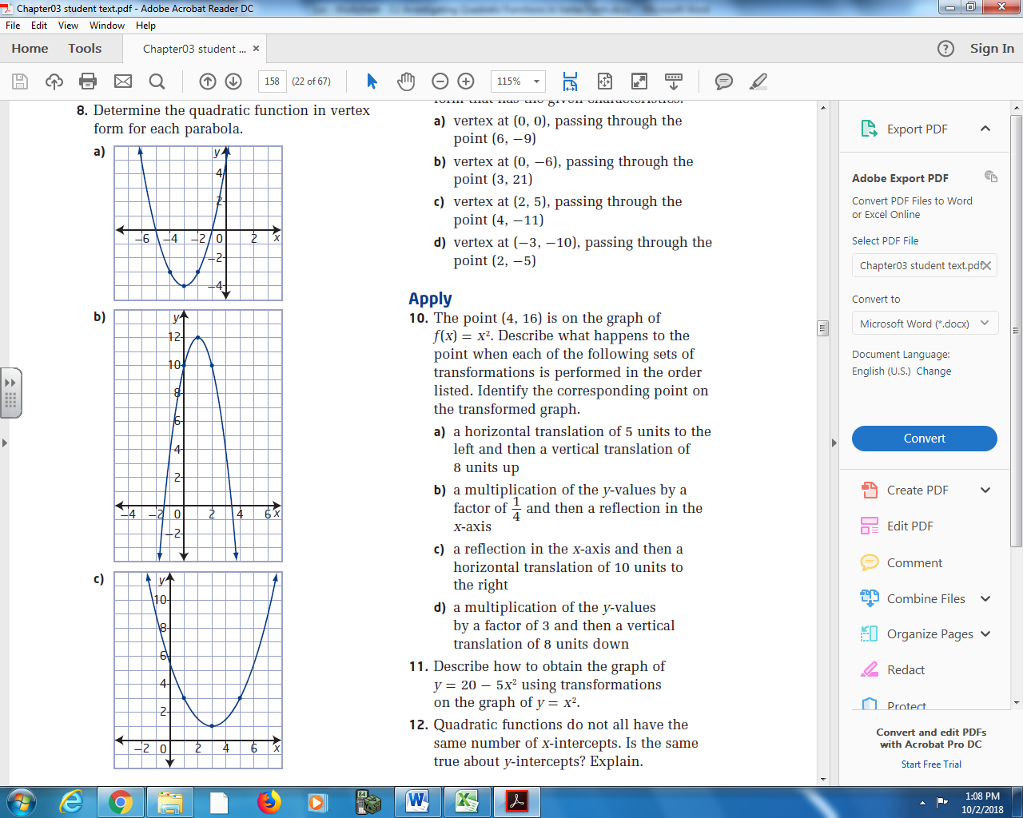
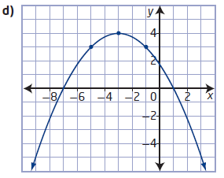

Pg 157 #9abc: Determine a quadratic function in vertex form that has the given characteristics.
Vertex as (0,0), passing through the point (6,-9) | Vertex at (0,-6), passing through the point (3,21) | Vertex at (2,5), passing through the point (4,-11)

Pg 157 #10ac: The point (4,16) is on the graph of $f\left(x\right)=x^{2}$. Describe what happens to the point when each of the following sets of transformations is performed in the order listed. Identify the corresponding point on the transformed graph.
- A horizontal translation of 5 units to the left and then a vertical translation of 8 units up.

- A reflection in the x-axis and then a horizontal translation of 10 units to the right.

Pg 157 #14: The finance team at an advertising company is using the quadratic function
$N\left(x\right)=-2.5{\left(x-36\right)}^{2}+20,000$ to predict the effectiveness of a TV commercial for a certain product, where N is the predicted number of people who buy the product if the commercial is aired x times per week.
- Explain how you could sketch the graph of the function, and identify its characteristics.
- According to this model, what is the optimal number of times the commercial should be aired?
- What is the maximum number of people that this model predicts will buy the product?

Pg 157 #16: See next page.
Pg 157 #19: The function $y=x^{2}+4$ represents a translation of 4 units up, which is the positive direction. The function $y={\left(x+4\right)}^{2}$ represents a translation of 4 units to the left, which is the negative direction. How can you explain this difference?

Pg 157 #16ab: The main section of the suspension bridge in Parc de la Gorge de Coaticook, Quebec, has cables in the shape of a parabola. Suppose that the points on the tops of the towers where the cables are attached are 168m apart and 24m vertically above the minimum height of the cables.
- Determine the quadratic function in vertex form that represents the shape of the cables. Identify the origin you used.
- Choose two other locations for the origin. Write the corresponding quadratic function for the shape of the cables for each.
