First Name: ___________________________ Last Name: ___________________________

L12 – FQ – 3.1 Vertex Form

Use the following information to answer Q1-4:
An equation of a quadratic, in Vertex Form, is $f\left(x\right)=2{\left(x-\frac{5}{2}\right)}^{2}-\frac{9}{2}$

Q1: The equation, written in Standard Form, is $f\left(x\right)=ax^{2}-bcx+d$, where a, b, c, and d are ___, ___, ___, and ___.
(Record your four-digit answer in the Numerical Response boxes below)

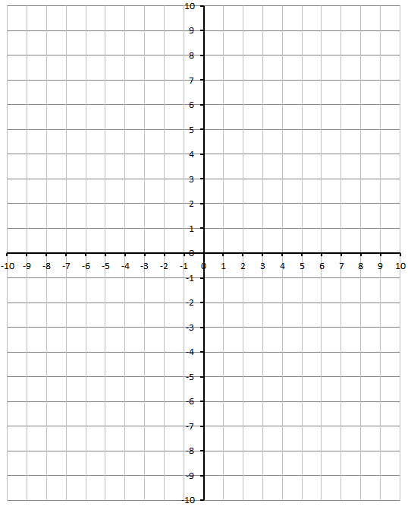
Q2: Graph the equation, clearly showing the following items (1/2 mark each; 2 marks)
- Axis of Symmetry
- Vertex
- Y-Intercept
- Direction of opening

MARKING
Beginning 0.0 – 1.0
Progressing 1.5
Competent 2.0 – 2.5
Exemplary 3.0

