L12 – 3.3 Completing the Square
Key Ideas
Definitions:
- Used for converting between Standard Form and Vertex Form
- Steps:
- Group first two terms (ax² + bx)
- Factor a-value out of the first two terms (ax² becomes 1x²)
- Divide the x-term by two and then square it. Write this value as a third term in the brackets.
- Multiply “a” by this third term, then subtract that amount from your constant term.
- Factor the term in the brackets and simplify the constant terms.
Part 1 – Completing the Square Practice
Q1: Convert the following into Vertex Form (a=1):
$$f(x)=x^{2}+8x+7$$

$$g\left(x\right)=x^{2}+2x-3$$

$$h\left(x\right)= x^{2}+8x+15$$

$$k\left(x\right)=x^{2}+12x+32$$

Q2: Convert the following into Vertex Form (a>1, No Fractions):
$f\left(x\right)=2x^{2}-4x-6$

$$g\left(x\right)=3x^{2}+36x+105$$

$h\left(x\right)=4x^{2}+72x+320$

$$k\left(x\right)=\frac{1}{2}x^{2}+4x+8$$

Q3: Convert the following into Vertex Form (with Fractions):
$$f\left(x\right)=x^{2}+3x+1000$$

$$g\left(x\right)=x^{2}-5x+1000$$

$$h\left(x\right)=2x^{2}+9x+1000$$

$$k\left(x\right)=3x^{2}+7x+1000$$

Part 2 – Modelling with Algebra Tiles
Q4: Complete the square for the following using Algebra Tiles:
$$x^{2}+6x+10$$
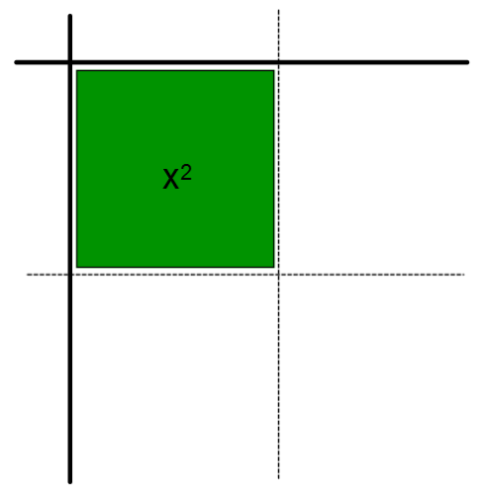

$$x^{2}+4x-5$$

Part 3 – Back and Forth
Q5: Convert ${f\left(x\right)=-x}^{2}+8x-12$ Q6: Convert $f\left(x\right)=-1{\left(x-4\right)}^{2}+4$
to Vertex Form. to Standard Form.

Q7: For the function $f\left(x\right)=-x^{2}+8x-12$, identify:
- Coordinates of the Vertex
- Y-Intercept
- Equation for Axis of Symmetry
- Zeroes
Part 4 – Working with Standard Form and Vertex Form
Use the following information to answer Q8-Q10:
A diver jumps off of a 8m tall diving board. The equation that models their height, h, as a function of horizontal distance, x, is given by:
$$h\left(x\right)=-x^{2}+2x+8$$
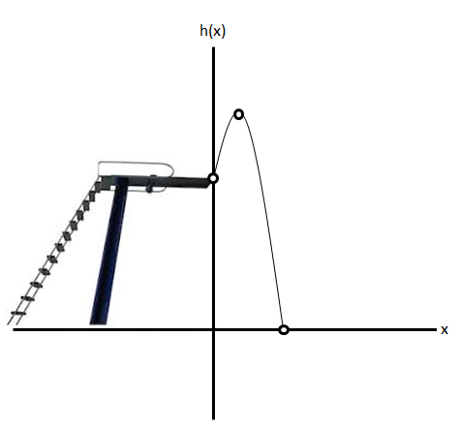

Q8: Working with Standard Form…
- Factor to find the zeroes. Which one is significant, and why?
- Determine the y-intercept. What is the significance?
- Use the zeroes to find the axis of symmetry.
- Use the axis of symmetry to find the Vertex. What is the significance?

Use the following information to answer Q8-Q10:
A diver jumps off of a 8m tall diving board. The equation that models their height, h, as a function of horizontal distance, x, is given by:
$$h\left(x\right)=-x^{2}+2x+8$$

Q9: Working with Vertex Form…
- Convert the function to Vertex Form.
- Find the zeroes. Which one is significant, and why?
- Find the Vertex. What is the significance?

Use the following information to answer Q8-Q10:
A diver jumps off of a 8m tall diving board. The equation that models their height, h, as a function of horizontal distance, x, is given by:
$$h\left(x\right)=-x^{2}+2x+8$$

Q10: Working with your Calculator…
- Find the zeroes. Which one is significant, and why?
- Find the Vertex. What is the significance?

