L12 - 5.1 Multiplying Polynomials - Going Deeper

Part 1: Multiplying Monomials and Binomials

Q1: $2x\left(x+3\right)$ Q2: $3x^{2}y^{3}\left(5x^{2}+1\right)$

Part 2: Multiplying Binomials and Binomials

Q3: $(x-3)(x+4)$ Q4: $(x+1)(2x+5)$

Q5: $(x-2)(x-2)$ Q6: $(3x+1)(2x-1)$

Part 3: Harder Questions

Q7: ${\left(x+5\right)}^{2}$ Q8: $(x+1)(x+5)(x-4)$

Q9: $2(3x-2) - (4x+7)(2x-5)$ Q10:$3{\left(x+1\right)}^{2} - (x-4)(2x+5)$

Part 4: Perimeters and Areas

Use the following information to answer Q11-Q13:

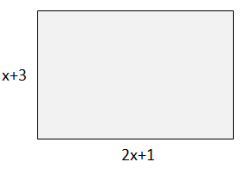

Q11: (Long Answer) Write an expression for the perimeter of the object.

Q12: The area of the object can be written as $ax^{2}+bx+c$, where a, b, and c are ___, ___, and ___.
(Record your three digit answer in the Numerical Response boxes below)

Q13: If the object has a perimeter of 32 meters, what is the area of the object, in m²?

(Record your two digit answer in the Numerical Response boxes below)

Use the following information to answer Q14-Q17:

You are building a skateboard ramp. You have a piece of plywood with dimensions of 4 ft by 8 ft. You cut x ft from length and width.
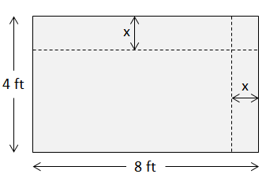

Q14: (Long Answer) Draw a diagram of the remaining piece of plywood, and label its dimensions.

Q15: (Long Answer) Write an expression for the perimeter of the remaining plywood.

Q16: (Long Answer) Write an expression for the area of the remaining plywood.

Q17: If $x=1.5$, what is the area of the remaining plywood, in ft²?

(Record your three digit answer in the Numerical Response boxes below)

Use the following information to answer Q18-Q21:

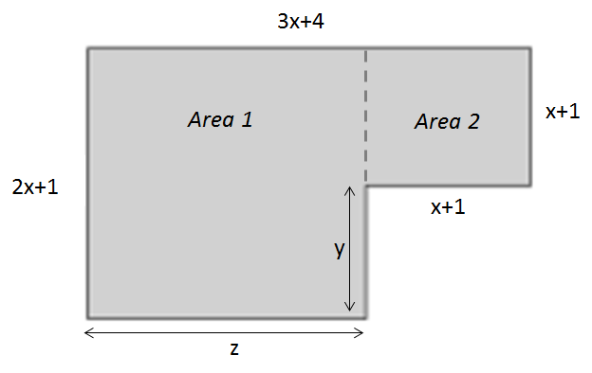

Q18: (Long Answer) Write an expression to describe the length of y in terms of x.

Q19: (Long Answer) Write an expression to describe the length of z in terms of x.

Q20: (Long Answer) Write an expression to determine the area of Area 1 in terms of x.

Q21: (Long Answer) Write an expression to determine the area of Area 2 in terms of x.

Part 5: Still remember Exponents and Radicals?

Use the following information to answer Q22-Q23:

The mixed radical $5x^{2}\sqrt[3]{5x}$ can be written in different forms.

Q22: The mixed radical can be written as an entire radical in the form $\sqrt[3]{abcx^{d}}$, where a, b, c, and d are ___, ___, ___, and ___.

(Record your four digit answer in the Numerical Response boxes below)

Q23: The mixed radical can be written as a power in the form $5^{\frac{a}{b}}x^{\frac{c}{d}}$ , where a, b, c, and d are ___, ___, ___, and ___.

(Record your four digit answer in the Numerical Response boxes below)

Part 6: Textbook Practice

Pg 210 #6bdef, 7, 9- 13, 17

