L12 – Worksheet – 3.3 Completing the Square
PART 1 – Textbook Questions
Pg 192 #1: Use a model to determine the value of c that makes each trinomial expression a perfect square. What is the equivalent binomial square expression for each?
$x^{2}+6x+c$ $x^{2}-4x+c$
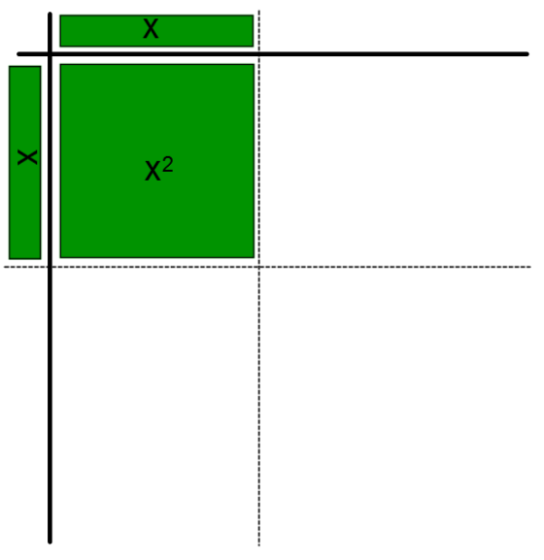

$x^{2}+14x+c$ $x^{2}-2x+c$

Pg 192 #2: Write each function in vertex form by completing the square. Use your answer to identify the vertex of the function.
$y=x^{2}+8x$ $y=x^{2}-18x-59$

$y=x^{2}-10x+31$ $y=x^{2}+32x-120$

Pg 192 #6ab: Determine the maximum or minimum value of each function and the value of x at which it occurs.
$y=x^{2}+6x-2$ $y={3x}^{2}-12x+1$

Pg 192 #6cd: Determine the maximum or minimum value of each function and the value of x at which it occurs.
$y={-x}^{2}-10x$ $y={-2x}^{2}+8x-3$

Pg 192 #8ac: Convert each function to vertex form.
$y=x^{2}+\frac{3}{2}x-7$ $y={2x}^{2}-\frac{5}{6}x+1$

Pg 192 #15: Sandra is practicing at an archery club. The height, h, in feed, of the arrow on one of her shots can be modelled as a function of time, t, in seconds, since it was fired using the function
$h\left(t\right)=-16t^{2}+10t+4$.
- What is the maximum height of the arrow, in feet, and when does it reach that height?
- Verify your solution in two different ways.

Pg 192 #18ab: A concert promoter is planning the ticket price for an upcoming concert for a certain band. At the last concert, she charged $70 per ticket and sold 2000 tickets. After conducting a survey, the promoter has determined that for every $1 decrease in ticket price, she might expect to sell 50 more tickets.
- What maximum revenue can the promoter expect.? What ticket price will give that revenue?
- How many tickets can the promoter expect to sell at that price?

Pg 192 #23: Use a quadratic function model to solve each problem.
- Two numbers have a sum of 29 and a product that is a maximum. Determine the two numbers and the maximum product.

- Two numbers have a difference of 13 and a product that is a minimum. Determine the two numbers and the minimum product.

PART 2 – Additional Practice (Easy)
Q1: Convert each function to vertex form.
$f\left(x\right)=x^{2}+12x+1000$ $f\left(x\right)=x^{2}-6x+1000$

Q2: Convert each function to vertex form (using decimals).
$f\left(x\right)=x^{2}+5x+1000$ $f\left(x\right)=x^{2}-3x+1000$

Q3: Convert each function to vertex form (using fractions).
$f\left(x\right)=x^{2}+5x+1000$ $f\left(x\right)=x^{2}-3x+1000$

Q4: Convert each function to vertex form (using fractions).
$f\left(x\right)={2x}^{2}+6x+1000$ $f\left(x\right)={3x}^{2}-5x+1000$

Q5: Convert the function $f\left(x\right)=3x^{2}+9x+1000$ to vertex form.
Using Decimals Using Fractions

Q6: Convert the function $f\left(x\right)=2x^{2}+10x+1000$ to vertex form.
Using Decimals Using Fractions
PART 3 – Additional Practice (Word Problems)
Q7: A farmer decides to build a fenced pasture on the side of a cliff. If the farmer has 32 yards of fencing, what are the dimensions of the pasture that give the maximum area?
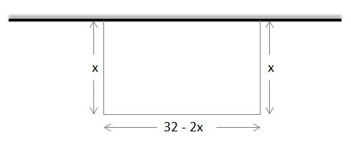
- Determine the area of the pasture as a quadratic function in Standard Form, y = $ax^{2}+bx+c$.

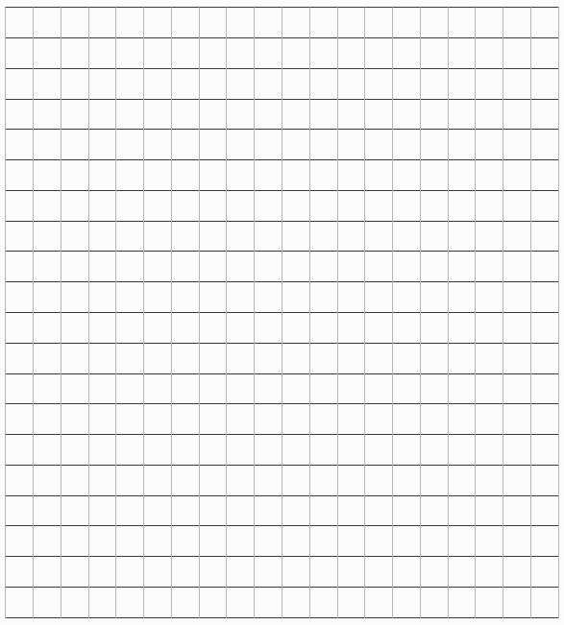
- Create a table of values for the function and graph it.

- Convert the equation to Vertex Form, $=a{\left(x-p\right)}^{2}+q$ , and explain what the vertex (p,q) represents.

- Determine the dimensions necessary to maximize the area of the pasture.

