First Name: ___________________________ Last Name: ___________________________

L13 – FQ – 3.3 Completing the Square

Q1: Convert the equation $f\left(x\right)=x^{2}-3x+6$ into Vertex Form. (2 marks)

Use the following information to answer Q2:
A home owner wishes to create a fenced in “dog run” on the side of their house. They have 16m of fencing. What dimensions would allow them to fence in the maximum area?
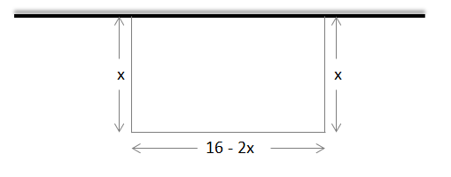

Q2: To have the maximum amount of area fenced in, the value of x must be:
(Record your three-digit answer in the Numerical Response boxes below)

Q3: Determine the zeroes of the function are x₁ = a and x₂ = b, where a and b are ___ and ___.
(Record your two-digit answer in the Numerical Response boxes below)

Q4: Sketch a graph of the function A(x), and label the following: (2 marks)
- Axis of Symmetry
- Vertex
- Zeroes
- Y-Intercept
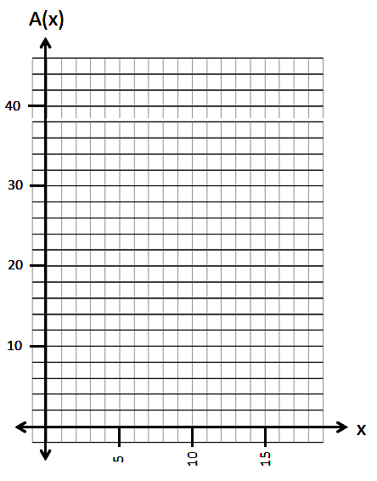

MARKING
Beginning 0.0 – 2.5
Progressing 3.0 – 4.0
Competent 4.5 – 5.5
Exemplary 6.0

