L13 – 3.3 Checking Vertex via Other Methods
Key Ideas
The vertex of a function can be determined a number of ways:
- Using Standard Form, find (a) the zeroes, then (b) the axis of symmetry halfway between them. Use the x-coordinate from the axis of symmetry to find the y-coordinate of the vertex.
- Convert from Standard Form to Vertex Form by “Completing the Square”.
- Use “Partial Factoring” (taught in Math 20-2) to find two points (non-zeroes) equidistant from the axis of symmetry. Find the x-coordinate from the axis of symmetry to find the y-coordinate of the vertex.
- Use the first derivative (taught in Math 31) to find the slope equation. Set the slope equal to zero to find the x-coordinate of the vertex. Use the x-coordinate to find the y-coordinate of the vertex.
- Graph the function and use “2nd Calc – Minimum/Maximum” to find the coordinates of the vertex.
Today we will be practicing all five methods using the same function.
Use the following information to answer all of the following questions:
A student has a bedroom on the top floor of his house. Because he is running late, rather than go through the house, he decides to jump off his roof on his way to school.
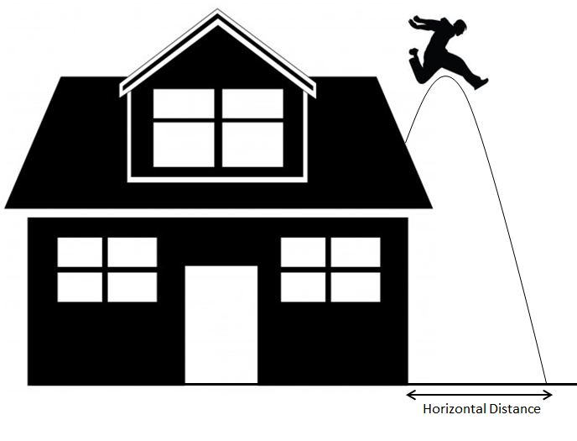
The equation that models the student’s parabola is give by $h\left(x\right)=-\frac{1}{2}x^{2}+2x+16$ , where x and h(x) are both measured in ft.

Part 1 – Using Standard Form
Use the following information to answer Q1-Q3:
$$h\left(x\right)=-\frac{1}{2}x^{2}+2x+16$$

Q1: Factor to find the zeroes.

Q2: Find the equation for the Axis of Symmetry.

Q3: Determine the coordinates of the vertex.

Part 2 – Using Vertex Form
Use the following information to answer Q4-Q6:
$$h\left(x\right)=-\frac{1}{2}x^{2}+2x+16$$

Q4: Convert to Vertex Form.

Q5: Determine the coordinate of the vertex.

Q6: Using Vertex Form, find the zeroes.

Part 3 – Using Partial Factoring (Optional)
Use the following information to answer Q7-Q9:
$$h\left(x\right)=-\frac{1}{2}x^{2}+2x+16$$

Q7: Partial factor to find two symmetric points.

Q8: Find the equation for the Axis of Symmetry.

Q9: Determine the coordinates of the Vertex.

Part 4 – Using the First Derivative (Optional)
Use the following information to answer Q10-Q12:
$$h\left(x\right)=-\frac{1}{2}x^{2}+2x+16$$

Q10: Take the first derivate to get the slope equation.

Q11: Find the x-coordinate where the slope is zero.

Q12: Determine the coordinates of the Vertex.

Part 5 – Using a Graphing Calculator
Use the following information to answer Q13-Q14:
$$h\left(x\right)=-\frac{1}{2}x^{2}+2x+16$$

Q13: Graph the function, and use “2nd – Calc – Maximum” to find the coordinates of the vertex.

Q14: Use “2nd – Calc – Zeroes” to find the coordinates of the vertex.

