L14 – 5.3 Factoring Trinomials (a=1)

If a polynomial takes the form ${ax}^{2}+bx+c$ then today we are looking at a=1.
Part 1: What are the Missing Numbers?

Determine what numbers fulfill the following equations:

□ + □ = 5 □ + □ = 7 □ + □ = -1
□ x □ = 6 □ x □ = 12 □ x □ = -6

Part 2: Factoring using the “Box Method”

Factor the following questions:

$x^{2}+5x+6$ $x^{2}+7x+12$ $x^{2}-x-6$

$x^{2}-9x+20$ $x^{2}+0x-25$ $x^{2}-16$

Part 3: Factoring using the “Box Method” and Common Factors

Factor the following questions:

${3x}^{2}+6x+3$ $x^{2}+0x-25$

$2x^{3}-12x^{2}+16x$ $3x^{3}y^{2}-6x^{2}y^{2}-45xy^{2}$

$2x^{3}-18x$ $3x^{3}y+6x^{2}y+12xy$

Part 4: Factoring using Algebra Tiles (Easy)

Factor the following questions using Algebra Tiles:

$x^{2}+3x+2$ $x^{2}+x-6$

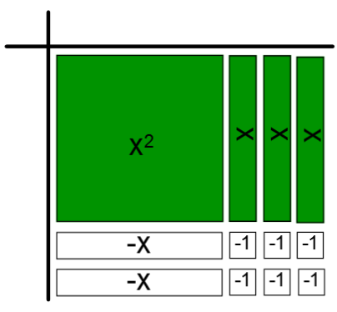
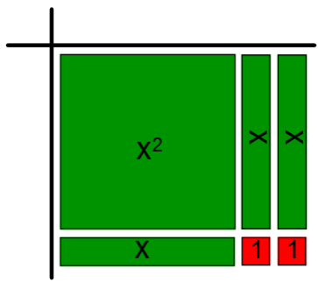

Factor the following questions using Algebra Tiles:

$x^{2}+5x+6$ $x^{2}+5x+4$

$x^{2}-4x+3$ $x^{2}-6x+8$

Part 5: Factoring using Algebra Tiles (Hard) – Adding plus/minus pairs

$x^{2}-x-6$

Option #1 Option #2

$x^{2}+x-12$

Option #1 Option #2 Option #3

