L16 – 4.1 Graphical Solutions of Quadratic Equations
Key Ideas
To solve for the solutions of an equation in the form $ax^{2}+bx+c=0$, you can graph the equation $y=ax^{2}+bx+c$, check where y=0 (the x-intercepts, or “zeroes”), and find the values of x that satisfy the original equation.
In other words…
$ax^{2}+bx+c=0$
$0=ax^{2}+bx+c$
Graph $y=ax^{2}+bx+c$ and solve for the x-intercepts (zeroes)
Quadratic functions can have (a) one, (b) two, or (c) no solutions.
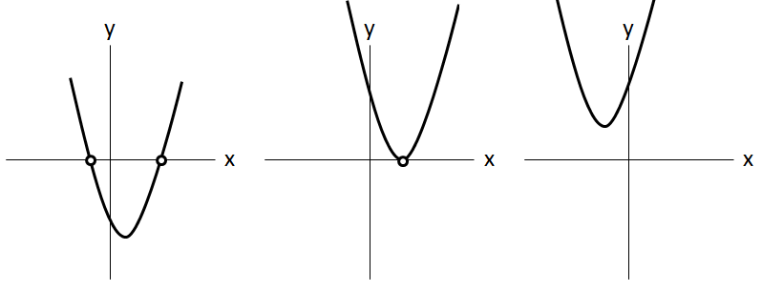
Two x-Intercept s One real x-Intercept No real x-Intercepts
Two real zeroes One real zero No real zeroes
Two real roots One real root No real roots
Zeroes of multiplicity 1 Zero of multiplicity 2

Part 1 – Roots and Zeroes ($ax^{2}+bx+c=0)$
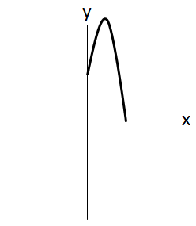
Q1: A grasshopper is sitting on a rock when it decides to jump off, as depicted to the right. The height of a grasshopper, h(x), as a function of horizontal position, x, is given by the equation $h\left(x\right)=-2x^{2}+4x+6$. Both variables are measured in centimeters.

Create a table of values to graph the function.
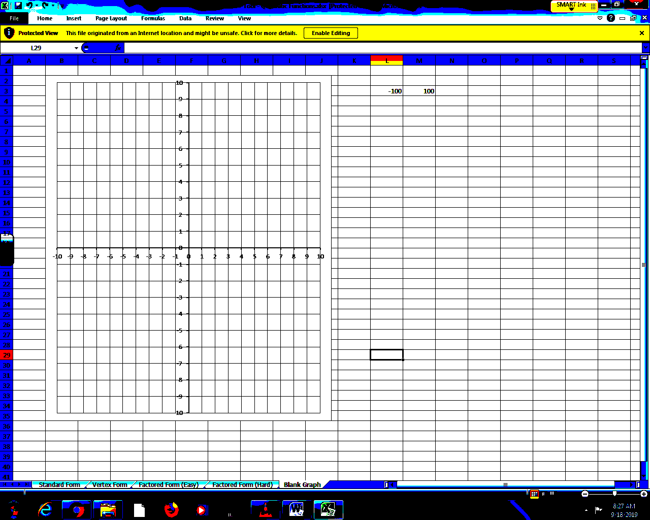
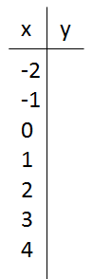

What horizontal distance did the grasshopper travel before landing?

Q2: Solve the equation $x^{2}+13x+40=0$ graphically.
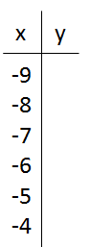

Q3: Solve the equation $-2x^{2}+4x+1=0$ graphically.
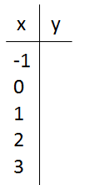

Part 2 – Roots and Zeroes ($ax^{2}+bx+c=d)$
Q4a: Solve the equation $x^{2}-8x+16=4$ graphically (Recommended method)
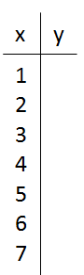

Q4b: Solve the equation $x^{2}-8x+16=4$ graphically (Intersection of 2 Lines)

Part 3 – TI Smartview Graphing (Equation, Window, Zeroes)
- With your calculator, graph $f\left(x\right)=x^{2}-3x+4$
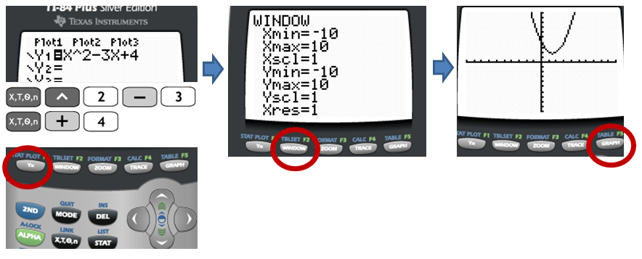
- Find the Zeroes
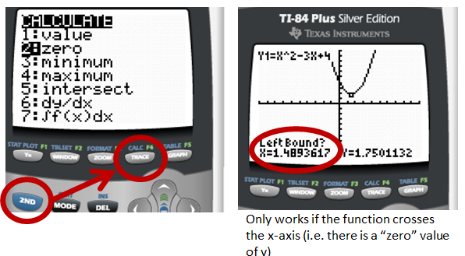
Q4c: Solve the equation $x^{2}-8x+16=4$ using your T.I. Calculator.

Part 4 – Alternate Methods
L17 – Solving quadratic equations using factoring
L18 – Solving quadratic equations by completing the square
L20 – Solving quadratic equations by using the “Quadratic Formula”

