L16 – 5.3 Factoring Trinomials (a>1)

If a polynomial takes the form ${ax}^{2}+bx+c$ then today we are looking at a>1.
Part 1: Step #1: Finding the missing numbers

Determine what numbers fulfill the following equations:

$2x^{2}+7x+3$ $2x^{2}+11x+15$ $6x^{2}-11x-10$

□ + □ = 7 □ + □ = 11 □ + □ = -11
□ x □ = 6 □ x □ = 30 □ x □ = -60

Part 2: Step #2: Factoring using Decomposition

$2x^{2}+7x+3$ $2x^{2}+11x+15$ $6x^{2}-11x-10$

$3x^{2}+7x-20$ (Option #1) $3x^{2}+7x-20$ (Option #2)

Part 3: Alternate Method: Factoring using Guess and Check

$2x^{2}+7x+3$ $3x^{2}+7x-20$

Part 4: Alternate Method: Factoring using Algebra Tiles

$$2x^{2}+7x+3$$

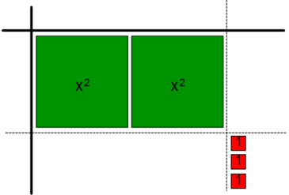
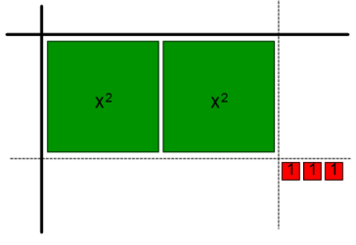
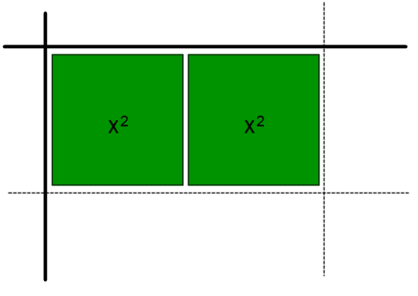

$$6x^{2}-11x-10$$
What are our different possible configurations?
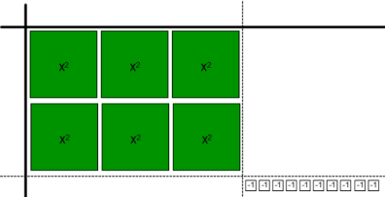
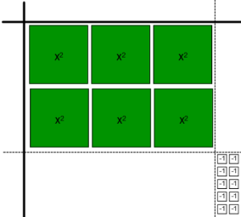
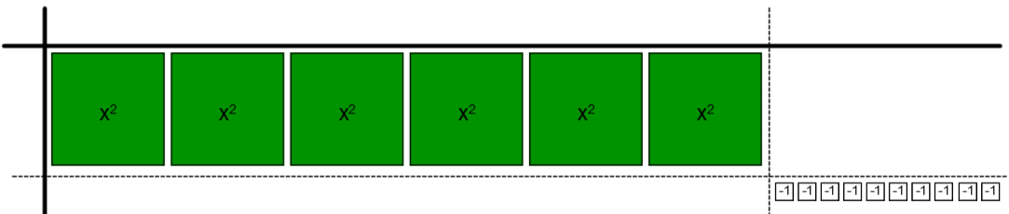
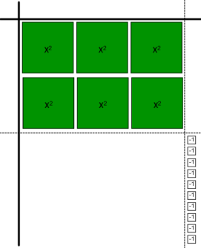
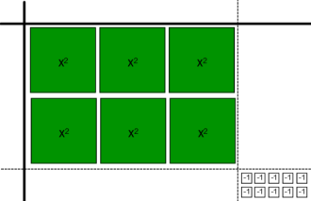
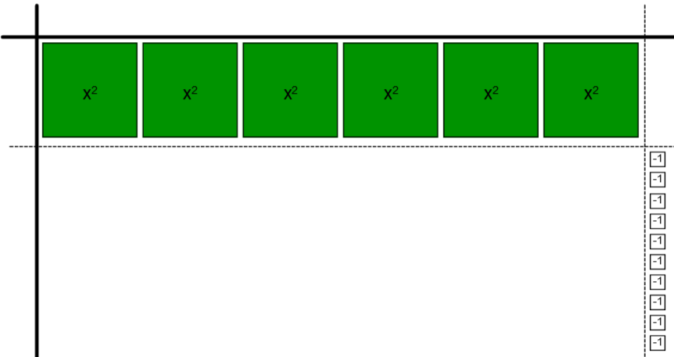
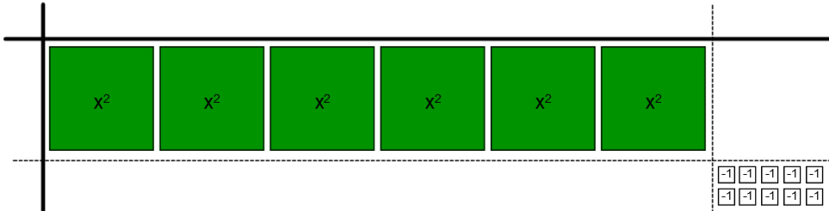
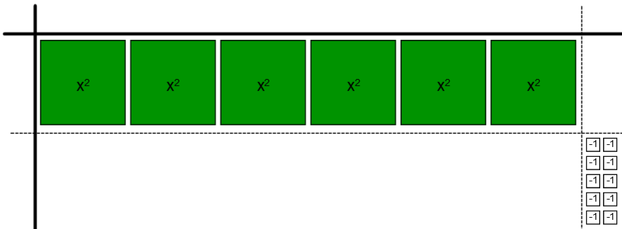

Part 5: (Harder) Factoring with both Common Factors and Decomposition

$${4x}^{3}+14x^{2}+6x$$

$$18x^{3}y+39x^{2}y-15xy$$

