L16 – Worksheet – 4.1 Graphical Solutions of Quadratic Equations
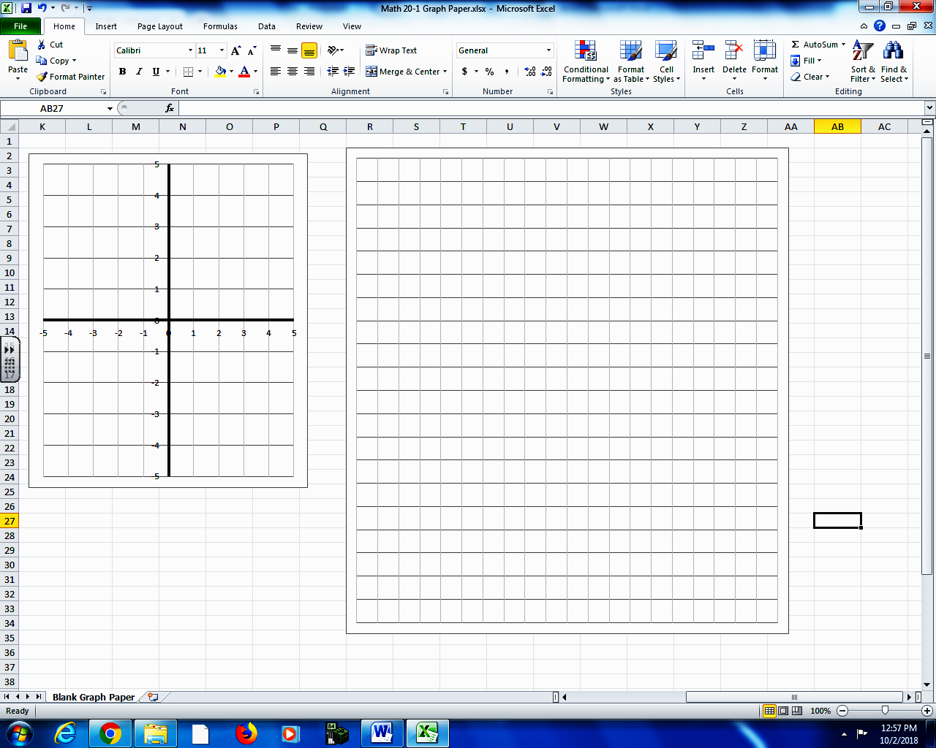
Pg 215 #3ac: Solve each equation by graphing the corresponding function.
y
x
x y
- $0=x^{2}-5x-24$

y
x
x y
- $x^{2}+2x+5=0$

Pg 215 #3e: Solve each equation by graphing the corresponding function.
y
x
x y
- $-x^{2}+4x=4$

Pg 215 #3e: Solve each equation by graphing the corresponding function. (Alternate Method)
y
x
x y
- $-x^{2}+4x=4$

Pg 215 #5: In a Canadian Football League game, the path of the football at one particular kick-off can be modelled using the function $h\left(d\right)=-0.02d^{2}+2.6d-66.5$ , where h is the height of the ball and d is the horizontal distance from the kicking team’s goal line, both in yards. A value of $h\left(d\right)=0$ represents the height of the ball at ground level. What horizontal distance does the ball travel before it hits the ground?

Pg 215 #6: Two numbers have a sum of 9 and a product of 20.
- What single-variable quadratic equation in the form $ax^{2}+bx+c=0$ can be used to represent the product of the two numbers?

- Determine the two numbers by graphing the corresponding quadratic function.
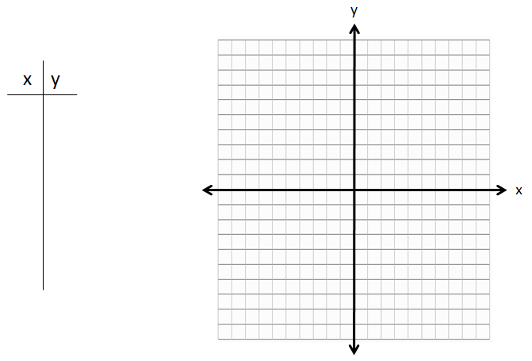
Pg 215 #8: The path of a stream of water coming out of a fire hose can be approximated using the function $h\left(x\right)=-0.09x^{2}+x+1.2$ , where h is the height of the water stream and x is the horizontal distance from the firefighter holding the nozzle, both in meters.
- What does the equation $-0.09x^{2}+x+1.2=0$ represent in this situation?

- At what maximum distance from the building could a firefighter stand and still reach the base of the fire with the water? Express your answer to the nearest tenth of a meter.

- What assumptions did you make when solving this problem?

Pg 215 #11: Émilie Heymans is a three-time Canadian Olympic diving medalist. Suppose that for a dive off the 10-m tower, her height, h, in meters, above the surface of the water is given by the function
$h\left(t\right)=-2d^{2}+3d+10$ , where d is the horizontal distance from the end of the tower platform, in meters.
- Write a quadratic equation to represent the situation when Émilie enters the water.

- What is Émilie’s horizontal distance from the end of the tower platform when she enters the water? Express your answer to the nearest tenth of a meter.

Pg 215 #12: Matthew is investigating the old Borden Bridge, which spans the North Saskatchewan River about 50km west of Saskatoon. The three parabolic arches of the bridge can be modelled using quadratic functions, where h is the height of the arch above the bridge deck and x is the horizontal distance of the bridge deck from the beginning of the first arch, both in meters.
First arch: $h\left(x\right)=-0.01x^{2}+0.84x$
Second arch: $h\left(x\right)=-0.01x^{2}+2.52x-141.12$
Third arch: $h\left(x\right)=-0.01x^{2}+4.2x-423.36$
- What are the zeroes of each quadratic function?
- What is the significance of the zeroes in this situation?
- What is the total span of the Borden Bridge?
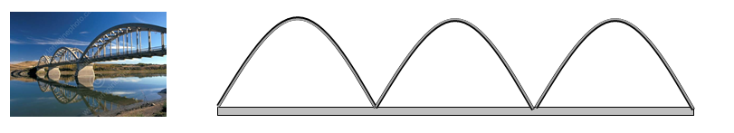
Pg 215 #13: For what values of k does the equation $x^{2}+6x+k=0$ have
- One real root?
- Two distinct real roots?
- No real roots?
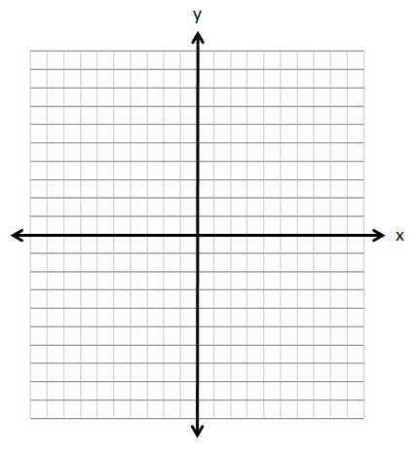

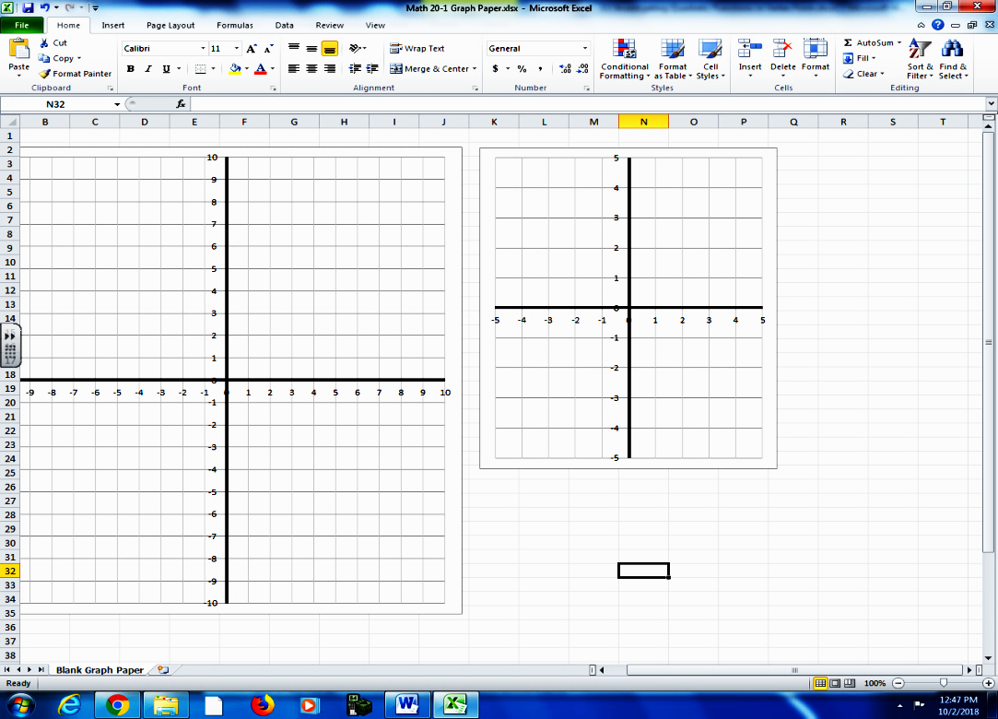
Pg 215 #17: The equation of the axis of symmetry of a quadratic function is $x=0$ and one of the x-intercepts is -4. What is the other x-intercept? Explain using a diagram.

