First Name: ___________________________ Last Name: ___________________________

L17 – FQ – 4.1 Graphical Solutions of Quadratic Equations

Q1: Solve the equation $-{1x}^{2}-4x+5=0$ graphically. (3 marks)
(Table of values – 1 mark, Graphed function – 1 mark, Final statement – 1 mark)
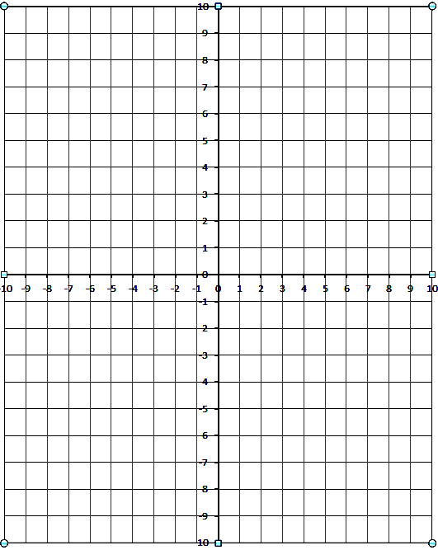

MARKING:
Beginning 0 – 1.0
Progressing 1.5
Competent 2.0 – 2.5
Exemplary 3.0

