L17 – 4.2 Factoring Quadratic Equations
Key Ideas
- Quadratic equations can be solved by factoring.
- The solutions to a quadratic equation are called the roots of the equation.
- You can factor polynomials in quadratic form.
$$4x^{2}+12x+9$$
$$(2x+3)(2x+3)$$
$${(2x+3)}^{2}$$
- You can also factor more complicated expressions using substitution:
$2{(x+3)}^{2}-11\left(x+3\right)+15$ Let $r=(x+3)$
$$2r^{2}-11r+15$$
$$\left[2r-5\right][r-3]$$
$$\left[2\left(x+3\right)-5\right][\left(x+3\right)-3]$$
$$\left[2x+6 -5\right][x+3 -3]$$
$$\left[2x+1\right][x]$$
- You can factor a difference of squares $P^{2}-Q^{2}$ as $(P+Q)(P-Q)$.
$$\frac{4}{9}x^{2}-16y^{2}$$
$$\left(\frac{2}{3}x+4y\right)\left(\frac{2}{3}x-4y\right)$$

Part 1 – Factoring Practice
Q1: Factor the following:
$x^{2}+12x+35$ $x^{2}-8x+12$

Q2: Factor the following:
$\frac{1}{2}x^{2}+7x+\frac{45}{2}$ $-\frac{1}{4}x^{2}+\frac{5}{4}x+6$

Q3: Factor the following:
${(x-2)}^{2}+5\left(x-2\right)-6$ $\frac{1}{2}{(x+3)}^{2}+\frac{1}{2}\left(x+3\right)-10$

Part 2 – Solving Quadratic Equations by Factoring
Q4: Solve for x.
$2x^{2}+5x+2=0$ $2x^{2}+9x+9=0$

$2x^{2}+12x=-10$ $x^{2}=-8x-15$

Part 3 – Quadratic Equations Word Problems
Use the following information to answer Q5:
In Physics 20, we learn that the height of an object is dependent on the time it is in the air. The equation that governs this relationship is given by
$$∆d=v_{i}t+\frac{1}{2}at^{2}$$
Where $∆d=d_{f}-d_{i}$
$$d_{f}-d_{i}=v_{i}t+\frac{1}{2}at^{2}$$
And we can add $d_{i}$ to both sides
$$d_{f}=\frac{1}{2}at^{2}+v_{i}t+d_{i}$$
Where the acceleration due to gravity is approximately -10 m/s². In Math 20-1, we can write this function as follows:
$$h\left(t\right)=-5t^{2}+v_{i}t+h_{i}$$
Where $h_{i}$ is our initial height, or y-intercept.

Q5: For a given grasshopper, it is sitting on a 50cm tall ledge when it jumps off with an initial velocity of 15m/s. The equation governing its height, as a function of time, is
$$h\left(t\right)=-5t^{2}+15t+50$$
- Algebraically determine the zeroes of the function by factoring. What do they represent?

- Algebraically determine the coordinates of the vertex, and explain what it represents.

- Sketch the function below.
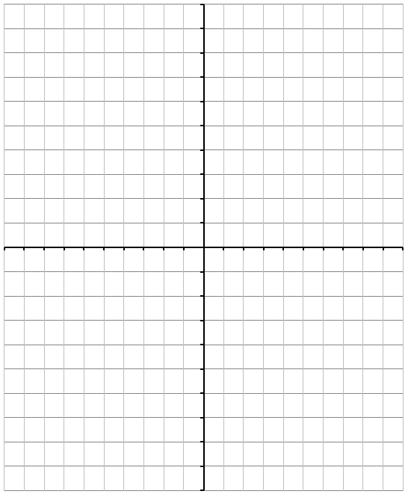
- State the Domain and Range of the function.

