First Name:__________________________ Last Name:__________________________
L19 - FQ – 5.5 Polynomials Review
Part 1: Multiplying Polynomials
Q1: The expression $\left(2x-3\right)(x+4)$ simplifies to ${ax}^{2}+bx-cd$ , where a, b, c, and d are ___, ___, ___, and ___.
(Record your four digit answer in the Numerical Response boxes below)

Q2: (Long Answer) Simplify the expression $\left(x-3\right)\left(x+4\right)-{\left(x-2\right)}^{2}$ (2 marks)

Part 2: Factoring Polynomials
Q3: (Long Answer) Factor the following expressions. (3 marks)
$x^{2}-2x-15$ $6x^{2}-7x+2$ $-x^{2}y+9y$

Part 3: Polynomial Word Problems
Use the following information to answer Q4-Q6:
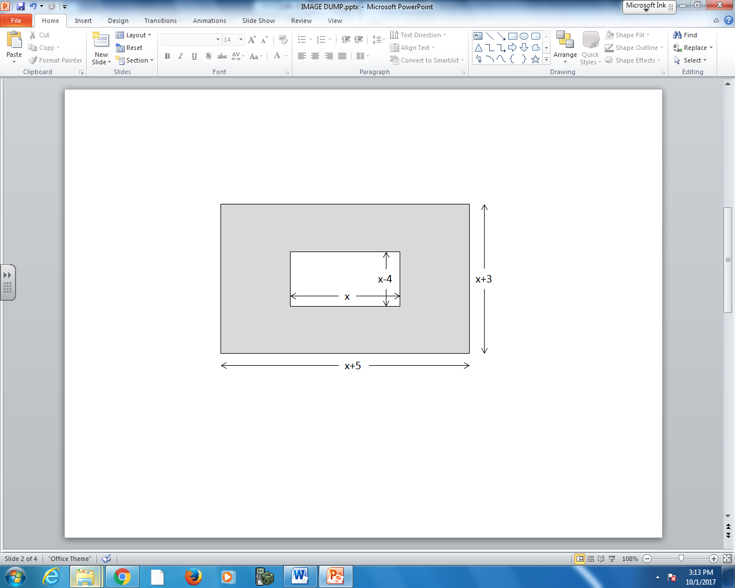

Q4: The perimeter of the larger rectangle is $x+bc$ , where a, b, and c is ___, ___, and ___.
(Record your three digit answer in the Numerical Response boxes below)

Q5: The shaded area, in factored form, is $\left(bx+c\right)$ , where a, b, and c are ___, ___, and ___.
(Record your three digit answer in the Numerical Response boxes below)

MARKING:
Beginning 0.0 – 3.5
Progressing 4.0 – 5.5
Competent 6.0 – 7.5
Exemplary 8.0

