L19 – Worksheet – 3.1-3.3 and 4.1-4.3 /40 marks
3.1 – Vertex Form (L11)
Use the following information to answer Q1-Q2:
The function, f(x), is graphed below:
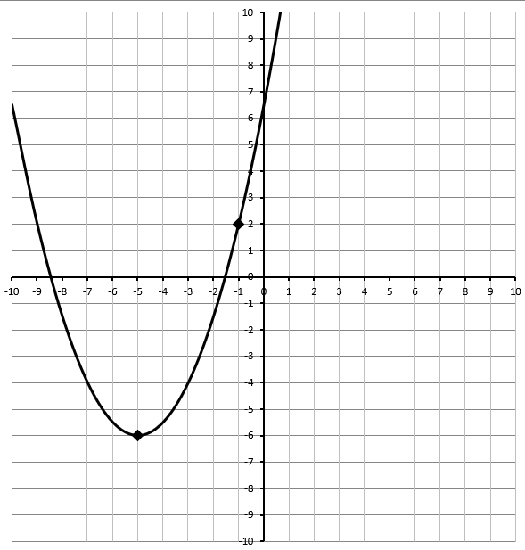
Q1: The equation of the function can be written in Vertex Form as $f\left(x\right)=\frac{a}{b}{(x+c)}^{2}-d$ , where a, b, c, and d are ___, ___, ___, and ___.
(Record your answer in the Numerical Response boxes below)

Q2: Determine the exact values of the x-intercepts. (2 marks)

Use the following information to answer Q3-Q5:
$$g\left(x\right)=-2{\left(x-3\right)}^{2}+8$$
Q3: The vertex of the function is located at
- (3,8)
- (-3,8)
- (3,-8)
- (-3,-8)

Q4: Algebraically determine the location of the zeroes. (2 marks)

Q5: The y-intercept has a value of
- -10
- -8
- 8
- 10

3.2 – Standard Form (L10)
$$g\left(x\right)=3x^{2}-2x-8$$
Use the following information to answer Q6-Q9:
Q6: Determine the value of the y-intercept. (1 mark)

Q7: Algebraically determine the values of the zeroes by factoring. (2 marks)

Q8: Determine the coordinates of the Vertex by using the Zeroes. (2 marks)

Q9: Determine the coordinates of the Vertex by converting to Vertex Form. (2 marks)

3.3 – Completing the Square (L12)
$$f\left(x\right)=-x^{2}-2x+6$$
Use the following to answer Q10-Q12:
Q10: Convert the function to Vertex Form. (2 marks)

Q11: Complete the table below, using the method of your choice. (1/2 mark each; 2 marks total)
Vertex Coordinates | Y-Intercept | Zeroes (Decimal Approximation) | Equation for Axis of Symmetry

Q12: Graph the function. (1 mark)
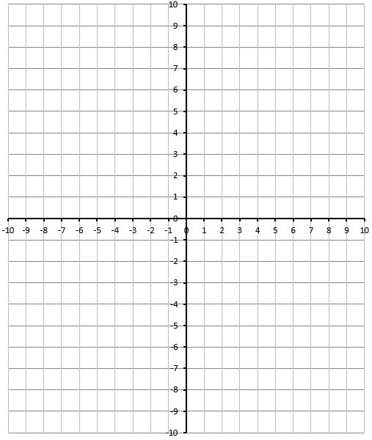

Q13: Convert $y=2x^{2}+6x-5$ to Vertex Form. (2 marks)

Q14: Convert $f\left(x\right)=-\frac{1}{4}x^{2}+4x-10$ to Vertex Form. (2 marks)
4.1 – Graphical Solutions of Quadratic Equations (L16)
Q15: Solve the equation $\frac{1}{2}x^{2}=2x+6$ by graphing. Label all relevant points. State the solution clearly. (2 marks)

4.2 – Factoring Quadratic Equations (L17)
Q16: Solve $\frac{1}{2}x^{2}-2x=6$ using factoring. (2 marks)

Q17: Solve $3x^{2}+30x+72=0$ using factoring. (2 marks)

Q18: Solve $\frac{1}{4}x^{2}=\frac{1}{2}x+\frac{35}{4}$ using factoring. (2 marks)

4.3 – Solving Quadratic Equations by Completing the Square (L18)
Q19: Solve $\frac{1}{2}x^{2}+2x-5=0$ by completing the square. Give your answer as an exact value. (3 marks)

Q20: Solve $6=2x^{2}+5x$ by completing the square. Give your answer as an exact value. (3 marks)

Q21: Solve $\frac{1}{3}x^{2}+2x=4$ by completing the square. Give your answer as an exact value. (3 marks)

