L20 – 4.4 The Quadratic Formula
Key Ideas
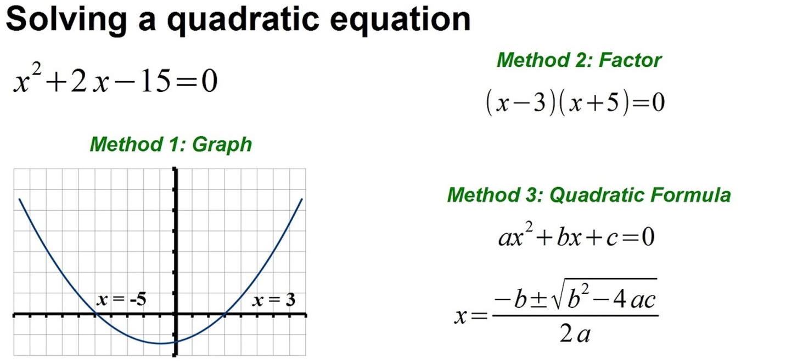

While in Standard Form, $y=ax^{2}+bx+c$, the zeroes of the function can be solved using the Quadratic Formula:
$$x=\frac{-b±\sqrt{b^{2}-4ac}}{2a}$$
This gives you two possible solutions:
$x_{1}=\frac{-b+\sqrt{b^{2}-4ac}}{2a}$ $x_{2}=\frac{-b-\sqrt{b^{2}-4ac}}{2a}$
Use this to solve for the x-intercepts of a quadratic function that cannot be factored easily.
Note: Discriminate: The value under the root, $b^{2}-4ac$
- If the discriminate is greater than 0, there are two x-intercepts.
- If the discriminate is equal to 0, there is one x-intercept.
- If the discriminate is less than 0, and cannot be square-rooted, there are no x-intercepts.

Part 1 – Derivation of the Quadratic Formula (2 marks out of 12 on next SQ; Marked with Rubric)
Step #1: Switch to Vertex Form
$$y=ax^{2}+bx+c$$
$$y=\left(ax^{2}+bx\right)+c$$
$$y=a\left(x^{2}+\frac{b}{a}x\right)+c$$
$$y=a\left(x^{2}+\frac{b}{2a}x+\frac{b}{2a}x\right)+c$$
$$y=a\left(x^{2}+\frac{b}{2a}x+\frac{b}{2a}x+\frac{b^{2}}{4a^{2}}\right)+c-\frac{b^{2}}{4a}$$
$$y=a{\left(x+\frac{b}{2a}\right)}^{2}+c-\frac{b^{2}}{4a}$$
Step #2: Solve for the Zeroes
$$0=a{\left(x+\frac{b}{2a}\right)}^{2}+c-\frac{b^{2}}{4a}$$
$$\frac{b^{2}}{4a}-c=a{\left(x+\frac{b}{2a}\right)}^{2}$$
$$\frac{b^{2}}{4a}-\frac{4ac}{4a}=a{\left(x+\frac{b}{2a}\right)}^{2}$$
$$\frac{b^{2}-4ac}{4a}=a{\left(x+\frac{b}{2a}\right)}^{2}$$
$$\frac{b^{2}-4ac}{4a^{2}}={\left(x+\frac{b}{2a}\right)}^{2}$$
$$±\sqrt{\frac{b^{2}-4ac}{4a^{2}}}=x+\frac{b}{2a}$$
$$±\frac{\sqrt{b^{2}-4ac}}{2a}=x+\frac{b}{2a}$$
$$-\frac{b}{2a}±\frac{\sqrt{b^{2}-4ac}}{2a}=x$$
$$\frac{-b±\sqrt{b^{2}-4ac}}{2a}=x$$
$$x=\frac{-b±\sqrt{b^{2}-4ac}}{2a}$$
Part 2 – When would we use it?
This is ideally used for a quadratic that isn’t factorable.
Q1: Solve $x^{2}+13x+40=0$ using each method.
Factoring Converting to Vertex Form Quadratic Formula

Q2: Solve $x^{2}+4x-4=0$ using each method
Factoring Converting to Vertex Form Quadratic Formula

Part 3 – The Discriminate
Note: Discriminate: The value under the root, $b^{2}-4ac$
- If the discriminate is greater than 0, there are two x-intercepts.
- If the discriminate is equal to 0, there is one x-intercept.
- If the discriminate is less than 0, and cannot be square-rooted, there are no x-intercepts.
Q3: For each of the following functions, determine the discriminate, and how it relates to the number of zeroes.
$x^{2}-8x+16=0$ $x^{2}-2x-8=0$ $x^{2}+4x+6=0$
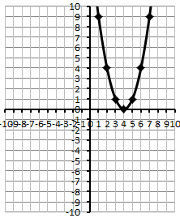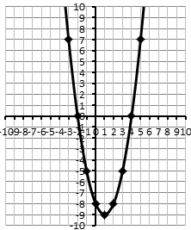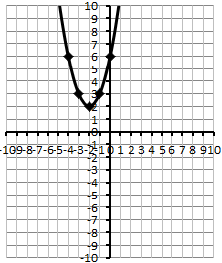

Part 4 – Examples from Word Problems
Use the following information to answer Q4-Q5:
An object is shot vertically off the edge of a 20m tall cliff at 4m/s [up]. The height of the object, as a function of time, is given by the equation
$$h\left(t\right)=-5t^{2}+4t+20$$
where h(t) is measured in meters, and t is measured in seconds.

Q4: Use the quadratic equation to determine how long it takes the object to reach the ground.

Q5: Convert the function to Vertex Form. Determine the maximum height of the object.

