L20 – Worksheet – 4.4 The Quadratic Formula
Pg 254 #1ace: Use the discriminant to determine the nature of the roots for each equation. Do not solve the equations. Check your answers graphically.
$x^{2}-7x+4=0$ $r^{2}+9r+6=0$ $7y^{2}+3y+2=0$

Pg 254 #2ace: Without graphing, determine the number of zeroes for each function.
$f\left(x\right)=x^{2}-2x-14$ $f\left(x\right)=\frac{1}{4}x^{2}-3x+9$ $f\left(x\right)=\frac{1}{2}x^{2}-x+\frac{5}{2}$

Pg 254 #3ab: Use the quadratic formula to solve each quadratic equation. Express your answer as exact roots.
$7x^{2}+24x+9=0$ $4p^{2}-12p-9=0$

Pg 254 #3cd: Use the quadratic formula to solve each quadratic equation. Express your answer as exact roots.
$3q^{2}+5q=1$ $2m^{2}+4m-7=0$

Pg 254 #4ab: Use the quadratic formula to solve each equation. Express your answers to the nearest hundredth.
$3x^{2}+14x+5=0$ $4x^{2}-7x-1=0$

Pg 254 #4cd: Use the quadratic formula to solve each equation. Express your answers to the nearest hundredth.
$-5x^{2}+16x-2=0$ $8x^{2}+12x=-1$

Pg 254 #5ab: Determine the roots of each quadratic equation. Express your answers as exact values and to the nearest hundredth.
$3x^{2}+6x+1=0$ $x^{2}+\frac{x}{6}-\frac{1}{2}=0$

Pg 254 #8: To save materials, Choma decides to build a horse corral using the barn for one side. He has 30 m of fencing materials and wants the corral to have an area of 100 m². What are the dimensions of the corral?
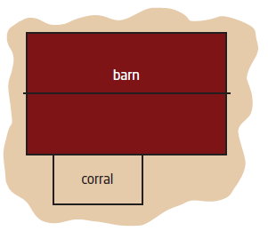

Pg 254 #10: Subtracting a number from half its square gives a result of 11. What is the number? Express your answers as exact values and to the nearest hundredth.

Pg 254 #12: An open-topped box is being made for a piece of cardboard measuring 12 in. by 30 in. The sides of the box are formed when four congruent squares are cut from the corners, as shown in the diagram. The base of the box has an area of 208 sq. in.
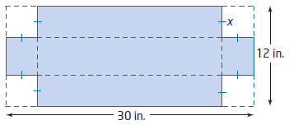
- What equation represents the surface area of the base of the box?
- What is the side length, x, of the square cut from each corner?
- What are the dimensions of the box?

Pg 254 #16: Two guy wires are attached to the top of a telecommunications tower and anchored to the ground on opposite sides of the tower, as shown. The length of the guy wire is 20 m more than the height of the tower. The horizontal distance from the base of the tower to where the guy wire is anchored to the ground is one-half the height of the tower. How tall is the tower, to the nearest tenth of a meter?
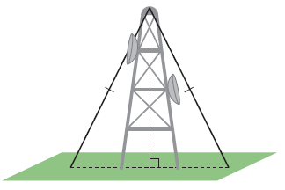

Pg 254 #20: Two small private planes take off from the same airport. One plane flies north at 150 km/h. Two hours later, the second plane flies west at 200 km/h. How long after the first plane takes off will the two planes be 600 km apart? Express your answer to the nearest tenth of an hour.

